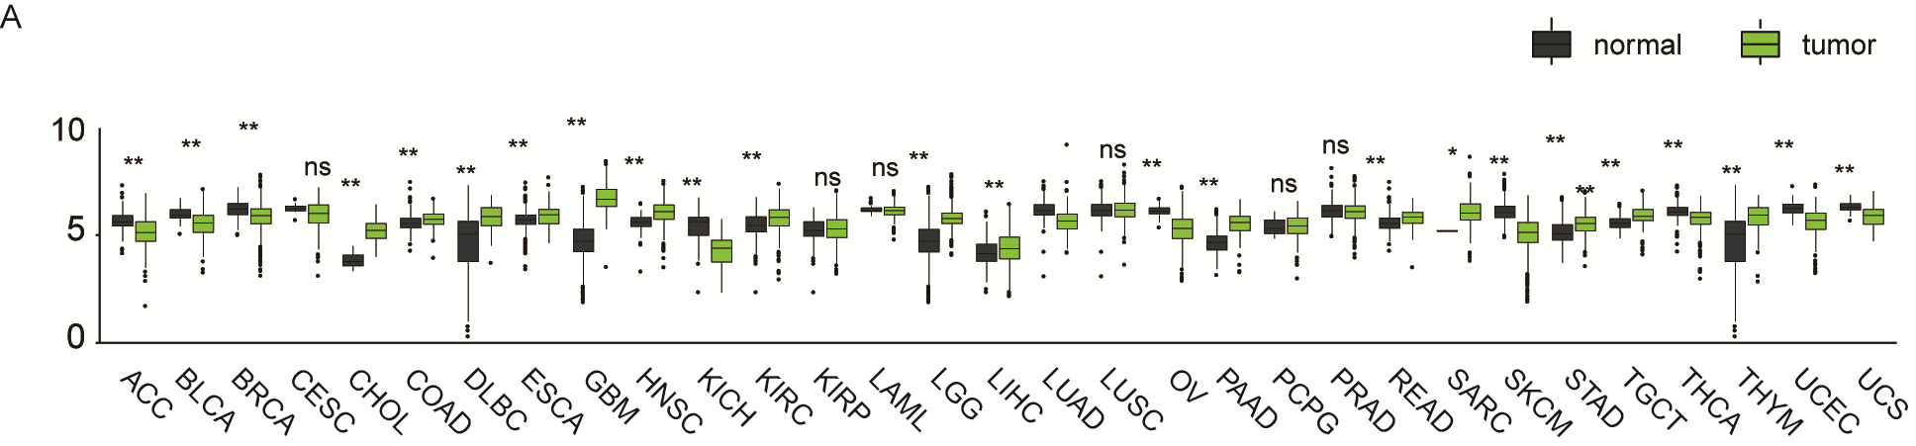

Supplementary Figure 1. CLK3 expression is frequently dysregulated in various cancers.
CLK3 mRNA expression was analyzed in various cancers based on the dataset from TCGA and GTEX pancancer database. CLK3 was up-regulated in tumor tissues of cholangiocarcinoma (CHOL), Colon cancer (COAD), DLBC (Lymphoid Neoplasm Diffuse Large B-cell Lymphoma), Esophagus cancer (ESCA), Glioblastoma multiforme (GBM), Head and Neck squamous cell carcinoma (HNSC), Renal cancer (KIRC), Brain Lower Grade Glioma (LGG), Liver cancer (LIHC), Pancreatic adenocarcinoma (PAAD), Rectal cancer (READ), Sarcoma (SARC), Stomach cancer (STAD), Testicular Germ Cell Tumors (TGCT) and Thymoma (THYM), while low down-regulated in Adrenocortical carcinoma (ACC), Bladder urothelial carcinoma (BLCA), Breast cancer (BRCA), Kidney Chromophobe (KICH), Lung cancer (LUAD), Ovarian serous cystadenocarcinoma (OV), Skin Cutaneous Melanoma (SKCM), Thyroid cancer (THCA) and Uterine Carcinosarcoma (UCS). *p < 0.05, **p < 0.01.

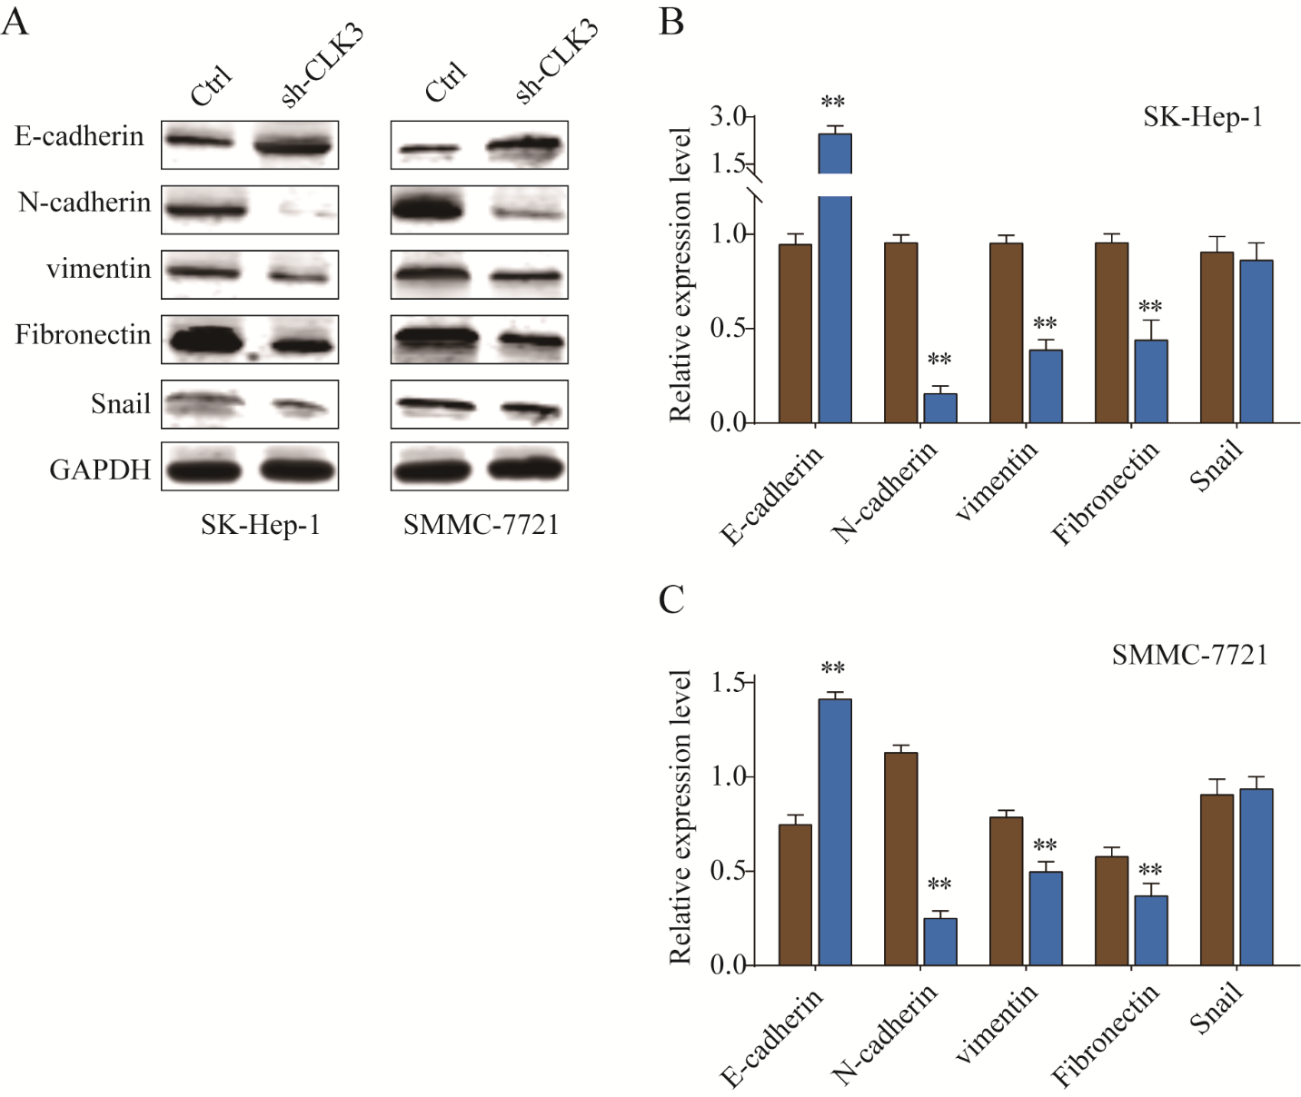

Supplementary Figure 2. CLK3 promotes HCC progression and metastasis via regulating EMT. (A) Western blot analysis of E-cadherin, N-cadherin, Vimentin, Fibronectin and Snail expression in SK-hep-1 or SMMC-7721 cells transfected with negative control or sh-CLK3. (B, C) Western blot experiments were repeated for three times and relative quantification analysis was based on grayscale values. *p < 0.05, **p < 0.01, unpaired Student’s t-test.

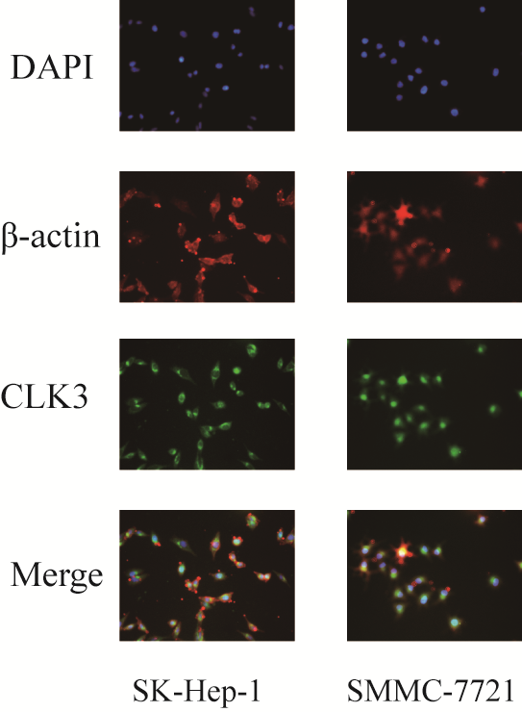

Supplementary Figure 3. CLK3 mainly distributes in the cytosol of HCC cells. Immunofluorescence staining was performed in SK-Hep-1 or SMMC-7721 cells to examine the localization of CLK3. DAPI and β-actin were stained to show the cell nucleus and skeleton.

