Supplementary Materials

Supplementary Data: Canadian medication cost savings associated with combinatorial pharmacogenomic guidance for psychiatric medications

Supplementary Table 1. Prescription drug refill matching by drug name, according to United States medication therapeutic chapters.

United States therapeutic chapter | Chapter description | Number of prescription refills matched | Total number of prescription refills | Proportion of prescription refills matched
1 | Anti-Infectives | 8,757 | 8,923 | 98.1%
2 | Anti-Neoplastic | 689 | 689 | 100.0%
3 | Central Nervous System | 69,946 | 86,923 | 80.5%
4 | Cardiovascular Disease | 21,984 | 23,433 | 93.8%
5 | Dermatology | 3,017 | 3,663 | 82.4%
6 | ENT | 44 | 787 | 5.6%
7 | Diabetes | 10,012 | 12,131 | 82.5%
8 | Gastroenterology | 6,128 | 8,606 | 71.2%
9 | Immunology | 0 | 157 | 0.0%
10 | Rheumatology | 879 | 1,191 | 73.8%
11 | Obstetrician-Gynecology | 3,244 | 4,023 | 80.6%
12 | Ophthalmology | 1,206 | 1,495 | 80.7%
13 | Allergy | 2,155 | 5,596 | 38.5%
14 | Urologicals | 2,780 | 3,092 | 89.9%
15 | Vitamins | 2,534 | 3,026 | 83.7%
16 | Diagnostics | 1,021 | 1,659 | 61.5%
- | Total | 134,396 | 165,394 | 81.3%

Supplementary Table 2. Congruent and incongruent cohort matching statistics before and after matching on age, gender, drug class, and diagnosis.
 | Before Matching |  |  | After Matching
 | Congruent (N=1301) | Incongruent (N=361) | p-value | Congruent (N=989) | Incongruent (N=352) | p-value
Age, mean (+SD)
 | 52.3(16.97) | 55.35(16.63) | 0.002 | 54.04(16.27) | 54.81(16.34) | 0.446
Sex, n (%) |  |  | 0.684 |  |  | 0.669
F | 904( 69.5) | 247( 68.4) |  | 692( 70.0) | 242( 68.8)
M | 396( 30.5) | 114( 31.6) |  | 297( 30.0) | 110( 31.3)
Antipsychotics, n (%) |  |  | 0.385 |  |  | 0.999
No | 949( 72.9) | 255( 70.6) |  | 708( 71.6) | 252( 71.6)
Yes | 352( 27.1) | 106( 29.4) |  | 281( 28.4) | 100( 28.4)
SNRIs, n (%) |  |  | <.001 |  |  | 0.01
No | 873( 67.1) | 184( 51.0) |  | 595( 60.2) | 184( 52.3)
Yes | 428( 32.9) | 177( 49.0) |  | 394( 39.8) | 168( 47.7)
SSRIs, n (%) |  |  | <.001 |  |  | 0.057
No | 305( 23.4) | 124( 34.3) |  | 273( 27.6) | 116( 33.0)
Yes | 996( 76.6) | 237( 65.7) |  | 716( 72.4) | 236( 67.0)
Tricyclic, n (%) |  |  | 0.864 |  |  | 0.893
No | 1,149( 88.3) | 320( 88.6) |  | 882( 89.2) | 313( 88.9)
Yes | 152( 11.7) | 41( 11.4) |  | 107( 10.8) | 39( 11.1)
Norepinephrine, n (%) |  |  | <.001 |  |  | 0.036
No | 581( 44.7) | 105( 29.1) |  | 356( 36.0) | 105( 29.8)
Yes | 720( 55.3) | 256( 70.9) |  | 633( 64.0) | 247( 70.2)
Anxiety Disorder, n (%) |  |  | 0.115 |  |  | 0.989
No | 639( 71.0) | 182( 76.2) |  | 508( 75.6) | 177( 75.6)
Yes | 261( 29.0) | 57( 23.8) |  | 164( 24.4) | 57( 24.4)
Bipolar Disorder, n (%) |  |  | 0.568 |  |  | 0.762
No | 831( 92.3) | 218( 91.2) |  | 616( 91.7) | 213( 91.0)
Yes | 69( 7.7) | 21( 8.8) |  | 56( 8.3) | 21( 9.0)
MDD, n (%) |  |  | 0.919 |  |  | 0.847
No | 538( 59.8) | 142( 59.4) |  | 404( 60.1) | 139( 59.4)
Yes | 362( 40.2) | 97( 40.6) |  | 268( 39.9) | 95( 40.6)

Supplementary Figure 1. Flow chart depicting the prescription medication cost translation process. U.S.: United States, MOHLTC: Ministry of Health and Long-Term Care, ODB: Ontario Drug Benefit.

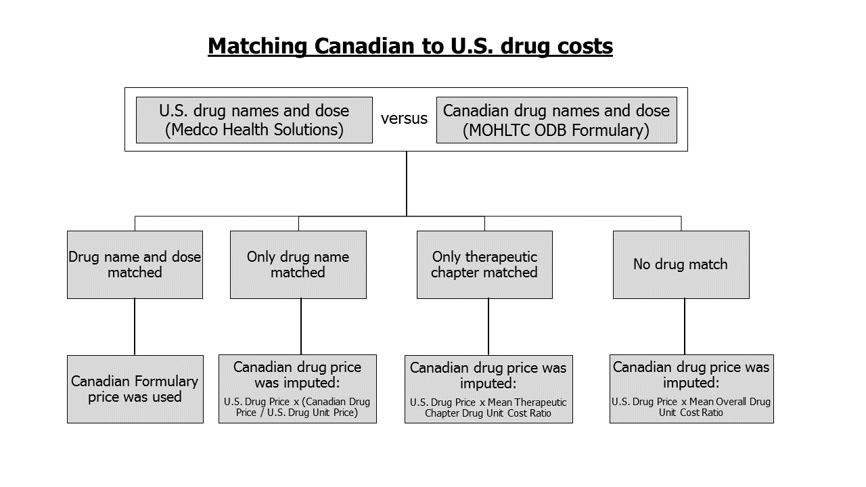
Supplementary Figure 2. Annual medication costs in each therapeutic drug chapter and stratified by congruence with combinatorial pharmacogenomic test report recommendations. (A) Overall cohort. (B) <65 and ≥65 age groups.

