Table. S1 Stock solution preparation recipe
Reagent | Concentration (mM)
NaCl | 1000
KCl | 5
CaCl2 | 25
MgCl2 | 5
NaH2PO4 | 10

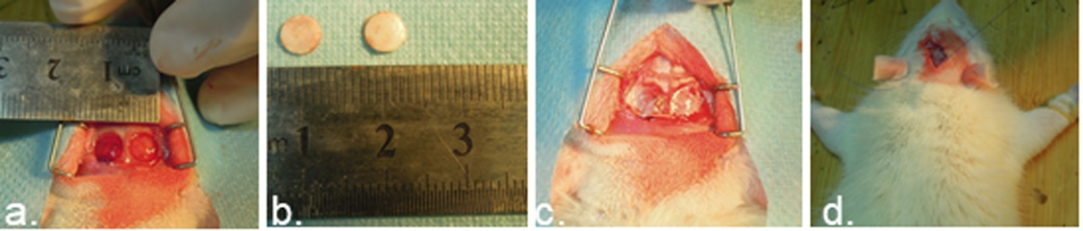
Fig. S1. Preparation of the critical-sized cranial bone defect model and surgical transplantation. (a, b) Expose the cranium and prepare 6-mm-dimaeter circular defects. (c) Implant membranes in the defects. (d) Close the wound.
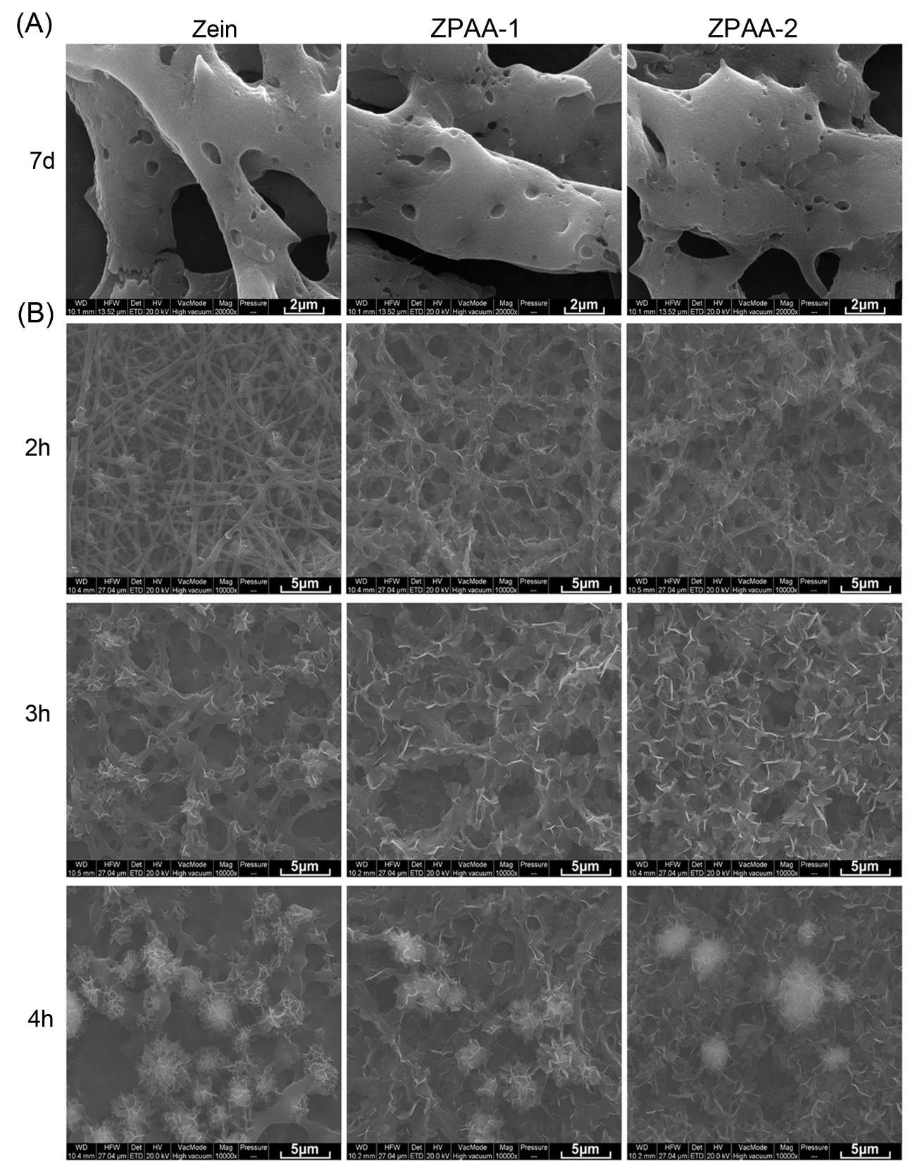
Figure. S2 (A) SEM images of zein, ZPAA-1 and ZPAA-2 membranes after 7 days of biodegradability. (B) SEM images of zein, ZPAA-1 and ZPAA-2 membranes immersed in SBF after 2 h, 3 h and 4 h.

