Supplementary appendix

Critical error frequency and the impact of training with inhalers commonly used for maintenance treatment in chronic obstructive pulmonary disease
David J Collier, Pascal Wielders, Job van der Palen, Logan Heyes, Dawn Midwinter, Kathryn Collison, Andy Preece, Neil Barnes, Raj Sharma

Contents

Table S1 Correct-use checklist for the ELLIPTA DPI Page 2
Table S2 Correct-use checklist for the Turbuhaler DPI Page 4
Table S3 Correct-use checklist for the DISKUS DPI Page 6
Table S4 Correct-use checklist for the HandiHaler DPI Page 8
Table S5 Correct-use checklist for the Breezhaler DPI Page 10
Table S6 Percentage of patients making ≥1 overall error with their prescribed
DPI(s) at V1 Page 13
Table S7 Percentage of patients making ≥1 overall error with their prescribed
DPI(s) at V2 Page 17
Figure S1 Of those patients making ≥1 overall error at V1, percentage who made
each specific error with their primary DPI Page 21

Table S1 Correct-use checklist for the ELLIPTA DPI
Protocol Identifier |  | Participant Identifier |  |  |  | ELLIPTA checklist
204981 |  |  |  |  |  | Visit #
Date of Assessment: |  |  | DAY |  | MONTH YEAR
Attempt Number: |  |  | PIL (1) |  | HCP (2) |  |  | HCP (3)
PIL  Step | PIL Wording  (Relvar, Incruse and Anoro ELLIPTA™ June 2016) |  |  | Error  (Underlined text indicates a critical error) |  |  | Completed Correctly |  | Not Completed Correctly
2 | Prepare a dose  Wait to open the cover until you are ready to take your dose.  Do not shake the inhaler.  - Slide the cover down until you hear a click. |  |  | Failed to open cover
2 |  |  |  | Shook the device after dose preparation
3 | Inhale your medicine  - While holding the inhaler away from your mouth, breathe out as far as is comfortable.  Do not breathe out into the inhaler.  - Put the mouthpiece between your lips, and close your lips firmly around it.  Do not block the air vent with your fingers.  - Take one long, steady, deep breath in. Hold this breath for as long as possible (at least 3-4 seconds).  - Remove the inhaler from your mouth.  - Breathe out slowly and gently. |  |  | No exhalation before an inhalation
3 |  |  |  | Exhaled directly into mouthpiece
3 |  |  |  | No seal by the lips round the mouthpiece during the inhalation
3 |  |  |  | Inhalation manoeuvre was not:  - long  - steady  - deep
3 |  |  |  | Blocked air inlet during inhalation manoeuvre
3 |  |  |  | Did not hold breath
4 | - Close the inhaler |  |  | Did not close the device (Note: this is an error but one which does not affect the medication that is inhaled)
Other comments:

Abbreviations: DPI, dry-powder inhaler; HCP, healthcare professional; PIL, patient information leaflet.

Table S2 Correct-use checklist for the Turbuhaler DPI
Protocol Identifier |  | Participant Identifier |  |  |  | Turbuhaler checklist
204981 |  |  |  |  |  | Visit #
Date of Assessment: |  |  | DAY |  | MONTH YEAR
Attempt Number: |  |  | PIL (1) |  | HCP (2) |  |  | HCP (3)
PIL | PIL Wording |  |  | Error |  |  | Completed |  | Not
Step | (Symbicort Turbuhaler October 2015) |  |  | (Underlined text indicates a critical |  |  | Correctly |  | Completed Correctly
 |  |  |  | error)
1 | - Unscrew the cover and lift it off. You may hear a rattling sound |  |  | Failed to remove cap
2 | - Hold your Inhaler upright with the red grip |  |  | Did not hold device
 | at the bottom. |  |  | upright (± 45° OK)
 |  |  |  | during dose
 |  |  |  | preparation
3 | - Do not hold the mouthpiece when you load your inhaler. To load your inhaler with a dose, turn the red grip as far as it will go in one direction. Then turn it as far as it will go in the other direction (it does not matter which way you turn it first).  - You should hear a click sound. Your inhaler is now loaded and ready to use. Only load your inhaler when you need to use it. |  |  | Base not twisted fully backwards and forwards, no click heard
3 |  |  |  | Device tipped downwards after dose preparation
3 |  |  |  | Shook the device after dose preparation
4 | - Hold your inhaler away from your mouth. Breathe out gently (as far as is comfortable).  - Do not breathe out through your inhaler |  |  | No exhalation before inhalation
4 |  |  |  | Exhaled directly into mouthpiece
5 | - Place the mouthpiece gently between your teeth. Close your lips.  - Breathe in as deeply and as hard as you can through your mouth. Do not chew or |  |  | No seal by the lips round the mouthpiece during inhalation

 | bite on the mouthpiece. | Inhalation manoeuvre  was not:  - forceful  - deep  Note to HCP: it is important that the inhalation is forceful and deep from the start for this inhaler
 | bite on the mouthpiece. | Blocked air inlet during inhalation manoeuvre
6 | - Remove the inhaler from your mouth.  - Breathe out gently.  The amount of medicine that is inhaled is very small. This means you may not be able to taste it after inhalation. If you have followed instructions, you can still be confident that you have inhaled the dose and the medicine is now in your lungs. | Did not hold breath
7 | - If you are to take a second inhalation, repeat steps 2 to 6. |  | NOT REQUIRED
8 + 9 | - Replace cover tightly after use | Did not close the device (Note: this is an error but one which does not affect the medication that is inhaled)
Other comments:

Abbreviations: DPI, dry-powder inhaler; HCP, healthcare professional; PIL, patient information leaflet.

Table S3 Correct-use checklist for the DISKUS DPI
Protocol Identifier |  | Participant Identifier |  |  |  | DISKUS checklist
204981 |  |  |  |  |  | Visit #
Date of Assessment: |  |  | DAY |  | MONTH YEAR
Attempt Number: |  |  | PIL (1) |  | HCP (2) |  |  | HCP (3)
PIL | PIL Wording |  |  | Error |  |  | Completed |  | Not
Step | (Seretide DISKUS™ March 2015) |  |  | (Underlined text indicates a critical |  |  | Correctly |  | Completed Correctly
 |  |  |  | error)
1 | - Hold the outer case in one hand and put thumb of your other hand on the thumbgrip.  - Push your thumb away from you as far as it will go  - You will hear a click. This will open a small hole in the mouthpiece |  |  | Failed to open cover
2 | - Hold your inhaler with the mouthpiece towards you (You can hold it in either your right or left hand).  - Slide the lever away from you as far as it will go (you will hear a click). This places dose in the mouthpiece. |  |  | Lever is not pushed back
2 |  |  |  | Shook the device after dose preparation
3 | - Hold the inhaler away from your mouth, breathe out as far as is comfortable.  - Do not breathe into the inhaler. |  |  | No exhalation before an inhalation
3 |  |  |  | Exhaled directly into mouthpiece
4 | - Put the mouthpiece between your lips.  - Breathe in, steadily and deeply through |  |  | No seal by the lips round the mouthpiece during the inhalation

 | the inhaler, not through your nose.  - Remove the inhaler from your mouth.  - Hold your breath for about 10 seconds or for as long as is comfortable  - Breathe out slowly. | Inhalation manoeuvre  was not:  - steady  - deep
 |  | Did not hold breath
5 | After use, rinse your mouth with water and spit it out, and/or brush your teeth. |  | NOT REQUIRED
6 | - To close the inhaler, slide the thumbgrip back towards you, as far as it will go. You will hear a click. | Did not close the device (Note: this is an error but one which does not affect the medication that is inhaled)
Other comments:

Abbreviations: DPI, dry-powder inhaler; HCP, healthcare professional; PIL, patient information leaflet.

Table S4 Correct-use checklist for the Handihaler DPI
Protocol Identifier |  | Participant Identifier |  |  |  | Handihaler checklist
204981 |  |  |  |  |  | Visit #
Date of Assessment: |  |  | DAY |  | MONTH YEAR
Attempt Number: |  |  | PIL (1) |  | HCP (2) |  |  | HCP (3)
PIL | PIL Wording |  |  | Error |  |  | Completed |  | Not
Step | (Spiriva HandiHaler November 2014) |  |  | (Underlined text indicates a critical |  |  | Correctly |  | Completed Correctly
 |  |  |  | error)
3 | - Remove capsule from blister pack (only immediately before use, see blister handling) and place it in the centre chamber, as illustrated.  It does not matter which way the capsule is placed in the chamber. |  |  | Failed to remove capsule
3 |  |  |  | Failed to insert capsule into the chamber
4 | - Close the mouthpiece firmly until you |  |  | Did not completely
 | hear a click, leaving the dust cap open. |  |  | close device capsule
 |  |  |  | chamber (heard click
 |  |  |  | when satisfactory)
5 | - Hold the inhaler device with the mouthpiece upwards and press the piercing button completely in only once, and release  This makes holes in the capsule and allows the medication to be released when you breathe in. |  |  | Did not pierce the capsule (HCP should check capsule was pierced)
5 |  |  |  | Shook the device after dose preparation
6 | - Breathe out completely.  - Please avoid breathing into the mouthpiece at any time |  |  | No exhalation before an inhalation
6 |  |  |  | Exhaled directly into mouthpiece
7 | - Raise the inhaler to your mouth and close your lips tightly around the mouthpiece.  - Keep your head in an upright position and breathe in slowly and deeply but at a rate sufficient to hear or feel the capsule vibrate. |  |  | No seal by the lips round the mouthpiece during the inhalation
7 |  |  |  | Inhalation manoeuvre  was not:  - slow

 | - Breathe until your lungs are full; then hold your breath as long as comfortable and at the same time take the inhaler out of your mouth.  - Resume normal breathing. Repeat steps 6 and 7 once, in order to empty capsule completely. | - deep
 |  | Capsule did not rattle
 |  | Blocked air inlet during inhalation manoeuvre
 |  | Did not hold breath
 |  | Did not check inside the capsule chamber if powder was left/ did not make second inhalation
Other Comments:

Abbreviations: DPI, dry-powder inhaler; HCP, healthcare professional; PIL, patient information leaflet.

Table S5 Correct-use checklist for the Breezhaler DPI
Protocol Identifier |  | Participant Identifier |  |  |  | Breezhaler checklist
204981 |  |  |  |  |  | Visit #
Date of Assessment: |  |  | DAY |  | MONTH YEAR
Attempt Number: |  |  | PIL (1) |  | HCP (2) |  |  | HCP (3)
PIL  Step | PIL Wording  (Seebri and Ultibro Breezhaler October 2015) |  |  | Error  (Underlined text indicates a critical error) |  |  | Completed Correctly |  | Not Completed Correctly
1 | Remove the cap |  |  |  |  |  | NOT REQUIRED
2 | Open inhaler  •Hold the base of the inhaler firmly and tilt the mouthpiece. This opens the inhaler |  |  |  |  |  | NOT REQUIRED
3 | Prepare capsule  - Separate one of the blisters from the blister card by tearing along the perforation. Take one blister and peel away the protective backing to expose the capsule.  •Do not push capsule through foil. |  |  |  |  |  | NOT REQUIRED
4 | Remove a capsule  - Capsules should always be stored in the blister and only removed immediately before use. With dry hands, remove capsule from the blister.  - Do not swallow the capsule. |  |  | Failed to remove capsule
5 | Insert capsule  - Place the capsule into the capsule chamber.  - Never place a capsule directly into the mouthpiece. |  |  | Failed to insert capsule into the chamber
6 | Close the Inhaler |  |  | Did not completely
 | - Close the inhaler until you hear a “click”. |  |  | close device capsule chamber (heard click
 |  |  |  | when satisfactorily)
7 | Pierce the capsule: |  |  | Did not pierce the
 | - Hold the inhaler upright with the |  |  | capsule and failed to
 | mouthpiece pointing up. |  |  | release piercing
 | - Pierce the capsule by firmly pressing |  |  | buttons fully before
 | together both side buttons at the same |  |  | inhalation (HCP to
 | time. |  |  | check that capsule
 | Do this only once. |  |  | was pierced and that
 | - You should hear a “click” as the capsule |  |  | piercing buttons were
 | is being pierced. |  |  | released
8 | Release the side buttons fully, |  |  | Shook the device after dose preparation
9 | Breathe out:  - Before placing the mouthpiece in your mouth, breathe out fully  Do not blow into the mouthpiece |  |  | Exhaled directly into the mouthpiece
10 | Inhale the medicine:  - To breathe the medicine deeply into your airways:  - Hold the inhaler as shown in the picture. The side buttons should be facing left and right. Do not press the side buttons.  - Place the mouthpiece in your mouth and close your lips firmly around it.  - Breathe in rapidly but steadily, as deeply as you can.  Do not press the side buttons. |  |  | No seal by the lips round the mouthpiece during the inhalation
10 |  |  |  | Inhalation manoeuvre  was not:  -Rapid  -Steady  -Deep
11 | If you do not hear a whirring noise: The capsule may be stuck in the capsule chamber. If this happens:  - Open the inhaler and carefully loosen the capsule by tapping the base of the inhaler. Do not press the side buttons.  - Inhale the medicine again by repeating steps 9 and 10. |  |  | Capsule did not rattle
11 |  |  |  | Blocked air inlet during inhalation manoeuvre
12 | Hold breath:  After you have inhaled the medicine:  - Hold your breath for at least 5-10 seconds  or as long as you comfortably can while taking the inhaler out of your mouth.  - Then breathe out.  - Open the inhaler to see if any powder is left in the capsule. |  |  | Did not hold breath
13 | If there is powder left in the capsule: |  |  | Did not check inside
 | - Close the inhaler. |  |  | the capsule chamber if
 | - Repeat steps 9 to 12. |  |  | powder was left / did
 |  |  |  | not make a second
 |  |  |  | inhalation
Other comments:

Abbreviations: DPI, dry-powder inhaler; HCP, healthcare professional; PIL, patient information leaflet.

Table S6 Percentage of patients making ≥1 overall error with their prescribed DPI(s) at V1

DPI inhaler group | Patients making ≥1 overall error, n (%) | Patients making no overall errors, n (%) | OR vs ELLIPTA (95% CI; P-value)
DPI inhaler group | Patients making ≥1 overall error, n (%) | Patients making no overall errors, n (%) | Pre-specified analysesª | Post-hoc sensitivity analyses^{b}
ICS/LABA
ELLIPTA FF/VI (n=50) | 17 (34) | 33 (66) | ‒ | ‒
Turbuhaler BUD/FOR (n=50) | 32 (64) | 18 (36) | 2.40 (1.02‒5.68; 0.045) | 3.36 (1.48‒7.64; 0.004)
DISKUS FP/SAL (n=50) | 30 (60) | 20 (40) | 1.82 (0.77‒4.32; 0.172) | 2.85 (1.26‒6.42; 0.012)
LAMA/LABA or LAMA only
ELLIPTA UMEC or UMEC/VI (n=51) | 19 (37) | 32 (63) | ‒ | ‒
HandiHaler TIO (n=50) | 37 (74) | 13 (26) | 2.99 (1.23‒7.27; 0.016) | 4.63 (1.99‒10.79; <0.001)
Breezhaler IND/GLY or GLY (n=49) | 27 (55) | 22 (45) | 1.75 (0.77‒3.94; 0.179) | 2.04 (0.92‒4.53; 0.081)
ELLIPTA FF/VI alone vs ELLIPTA FF/VI plus LAMA (errors in primary DPI)
ELLIPTA FF/VI (n=50) | 17 (34) | 33 (66) | ‒ | ‒
ELLIPTA FF/VI plus LAMA (n=50) | 17 (34) | 33 (66) | 1.19 (0.51‒2.78; 0.690) | 1.00 (0.44‒2.28; 1.000)
ELLIPTA FF/VI alone vs ELLIPTA FF/VI plus LAMA (errors in both DPIs considered)
ELLIPTA FF/VI (n=50) | 17 (34) | 33 (66) | ‒ | ‒
ELLIPTA FF/VI plus LAMA (n=50) | 23 (46) | 27 (54) | 1.93 (0.84‒4.43; 0.120) | 1.64 (0.73‒3.67; 0.232)
ELLIPTA FF/VI alone vs any ICS/LABA plus LAMA combination (errors in primary DPI)
ELLIPTA FF/VI (n=50) | 17 (34) | 33 (66) | ‒ | ‒
ELLIPTA FF/VI plus LAMA, and Turbuhaler BUD/FOR plus LAMA, and DISKUS FP/SAL plus LAMA (n=150) | 85 (57) | 65 (43) | 1.93 (0. 95‒3.92; 0.067) | 2.52 (1.28‒4.96; 0.007)
ELLIPTA FF/VI alone vs any ICS/LABA plus LAMA combination (errors in both DPIs considered)
ELLIPTA FF/VI (n=50) | 17 (34) | 33 (66) | ‒ | –
ELLIPTA FF/VI plus LAMA, and Turbuhaler BUD/FOR plus LAMA, and DISKUS FP/SAL plus LAMA (n=150) | 107 (71) | 43 (29) | 4.22 (2.02‒8.81; <0.001) | 5.41 (2.66‒11.00; <0.001)
ELLIPTA FF/VI alone or plus LAMA vs other ICS/LABA DPIs alone or plus LAMA (errors in primary DPI)
ELLIPTA FF/VI, and ELLIPTA FF/VI plus LAMA (n=100) | 34 (34) | 66 (66) | ‒ | ‒
Turbuhaler BUD/FOR, and Turbuhaler BUD/FOR plus LAMA (n=100) | 67 (67) | 33 (33) | 2.40 (1.25‒4.60; 0.008) | 3.84 (2.14‒6.90; <0.001)
DISKUS FP/SAL, and DISKUS FP/SAL plus LAMA (n=100) | 63 (63) | 37 (37) | 1.81 (0.93‒3.54; 0.082) | 3.23 (1.81‒5.77; <0.001)
ELLIPTA FF/VI alone or plus LAMA vs other ICS/LABA DPIs alone or plus LAMA (errors in both DPIs considered)
ELLIPTA FF/VI, and ELLIPTA FF/VI plus LAMA (n=100) | 40 (40) | 60 (60) | ‒ | ‒
Turbuhaler BUD/FOR, and Turbuhaler BUD/FOR plus LAMA (n=100) | 72 (72) | 28 (28) | 2.48 (1.27‒4.82; 0.007) | 3.90 (2.13‒7.12; <0.001)
DISKUS FP/SAL, and DISKUS FP/SAL plus LAMA (n=100) | 74 (74) | 26 (26) | 2.75 (1.33‒5.68; 0.006) | 4.78 (2.51‒9.10; <0.001)

Notes: ªPre-specified analyses were performed with the covariate of time on primary DPI included in the logistic regression model. ^{b}Post-hoc sensitivity analyses excluded the covariate of time on primary DPI from the model due to confounding with DPI type (ELLIPTA and Breezhaler users were more likely to have used their inhaler for a shorter time than Turbuhaler, DISKUS and HandiHaler users).
Abbreviations: BUD, budesonide; CI, confidence interval; DPI, dry-powder inhaler; FF, fluticasone furoate; FOR, formoterol; FP, fluticasone propionate; GLY, glycopyrronium; ICS, inhaled corticosteroid; IND, indacaterol; LABA, long acting β₂-agonist; LAMA, long-acting muscarinic antagonist;OR, odds ratio; SAL, salmeterol; TIO, tiotropium; UMEC, umeclidinium; VI, vilanterol; V1, Visit 1.

Table S7 Percentage of patients making ≥1 overall error with their prescribed DPI(s) at V2

DPI inhaler group | Patients making ≥1 overall error, n (%) | Patients making no overall errors, n (%) | OR vs ELLIPTA (95% CI; P-value)
DPI inhaler group | Patients making ≥1 overall error, n (%) | Patients making no overall errors, n (%) | Pre-specified analysesª | Post-hoc sensitivity analyses^{b}
ICS/LABA
ELLIPTA FF/VI (n=50) | 6 (12) | 44 (88) | ‒ | ‒
Turbuhaler BUD/FOR (n=48) | 17 (35) | 31 (65) | 3.48 (1.22‒9.96; 0.020) | 3.80 (1.37‒10.54; 0.010)
DISKUS FP/SAL (n=45) | 12 (27) | 33 (73) | 2.28 (0.76‒6.90; 0.143) | 2.55 (0.89‒7.37; 0.083)
LAMA/LABA or LAMA only
ELLIPTA UMEC or UMEC/VI (n=50) | 4 (8) | 46 (92) | ‒ | ‒
HandiHaler TIO (n=47) | 17 (36) | 30 (64) | 5.27 (1.62‒17.19; 0.006) | 5.93 (1.89‒18.61; 0.002)
Breezhaler IND/GLY or GLY (n=47) | 15 (32) | 32 (68) | 4.66 (1.48‒14.67; 0.009) | 4.93 (1.56‒15.61; 0.007)
ELLIPTA FF/VI alone vs ELLIPTA FF/VI plus LAMA (errors in primary DPI)
ELLIPTA FF/VI (n=50) | 6 (12) | 44 (88) | ‒ | ‒
ELLIPTA FF/VI plus LAMA (n=49) | 7 (14) | 42 (86) | 1.27 (0.41‒4.01; 0.679) | 1.21 (0.39‒3.79; 0.746)
ELLIPTA FF/VI alone vs ELLIPTA FF/VI plus LAMA (errors in both DPIs considered)
ELLIPTA FF/VI (n=50) | 6 (12) | 44 (88) | ‒ | ‒
ELLIPTA FF/VI plus LAMA (n=49) | 8 (16) | 41 (84) | 1.51 (0.49‒4.63; 0.472) | 1.40 (0.46‒4.28; 0.553)
ELLIPTA FF/VI alone vs any ICS/LABA plus LAMA combination (errors in primary DPI)
ELLIPTA FF/VI (n=50) | 6 (12) | 44 (88) | ‒ | ‒
ELLIPTA FF/VI plus LAMA, and Turbuhaler BUD/FOR plus LAMA, and DISKUS FP/SAL plus LAMA (n=144) | 27 (19) | 117 (81) | 1.50 (0.58‒3.90; 0.404) | 1.59 (0.63‒4.05; 0.330)
ELLIPTA FF/VI alone vs any ICS/LABA plus LAMA combination (errors in both DPIs considered)
ELLIPTA FF/VI (n=50) | 6 (12) | 44 (88) | ‒ | –
ELLIPTA FF/VI plus LAMA, and Turbuhaler BUD/FOR plus LAMA, and DISKUS FP/SAL plus LAMA (n=144) | 42 (29) | 102 (71) | 2.52 (0.99‒6.41; 0.052) | 2.76 (1.11‒6.86; 0.029)
ELLIPTA FF/VI alone or plus LAMA vs other ICS/LABA DPIs alone or plus LAMA (errors in primary DPI)
ELLIPTA FF/VI, and ELLIPTA FF/VI plus LAMA (n=99) | 13 (13) | 86 (87) | ‒ | ‒
Turbuhaler BUD/FOR, and Turbuhaler BUD/FOR plus LAMA (n=97) | 24 (25) | 73 (75) | 1.74 (0.76‒3.97; 0.189) | 1.95 (0.92‒4.14; 0.082)
DISKUS FP/SAL, and DISKUS FP/SAL plus LAMA (n=91) | 25 (27) | 66 (73) | 2.08 (0.90‒4.80; 0.086) | 2.42 (1.16‒5.02; 0.018)
ELLIPTA FF/VI alone or plus LAMA vs other ICS/LABA DPIs alone or plus LAMA (errors in both DPIs considered)
ELLIPTA FF/VI, and ELLIPTA FF/VI plus LAMA (n=99) | 14 (14) | 85 (86) | ‒ | ‒
Turbuhaler BUD/FOR, and Turbuhaler BUD/FOR plus LAMA (n=97) | 32 (33) | 65 (67) | 2.43 (1.12‒5.28; 0.024) | 2.89 (1.43‒5.82; 0.003)
DISKUS FP/SAL, and DISKUS FP/SAL plus LAMA (n=91) | 31 (34) | 60 (66) | 2.39 (1.06‒5.38; 0.035) | 2.97 (1.46‒6.06; 0.003)

Notes: ªPre-specified analyses were performed with the covariate of time on primary DPI included in the logistic regression model. ^{b}Post-hoc sensitivity analyses excluded the covariate of time on primary DPI from the model due to confounding with DPI type (ELLIPTA and Breezhaler users were more likely to have used their inhaler for a shorter time than Turbuhaler, DISKUS and HandiHaler users).

Abbreviations: BUD, budesonide; CI, confidence interval; DPI, dry-powder inhaler; FF, fluticasone furoate; FOR, formoterol; FP, fluticasone propionate; GLY, glycopyrronium; ICS, inhaled corticosteroid; IND, indacaterol; LABA, long acting β₂-agonist; LAMA, long-acting muscarinic antagonist; OR, odds ratio; SAL, salmeterol; TIO, tiotropium; UMEC, umeclidinium; VI, vilanterol; V2, Visit 2.

Figure S1 Of those patients making ≥1 overall error at V1, percentage who made each specific error with their primary DPI
A: ELLIPTA FF/VI B: Turbuhaler BUD/FOR C: DISKUS FP/SAL
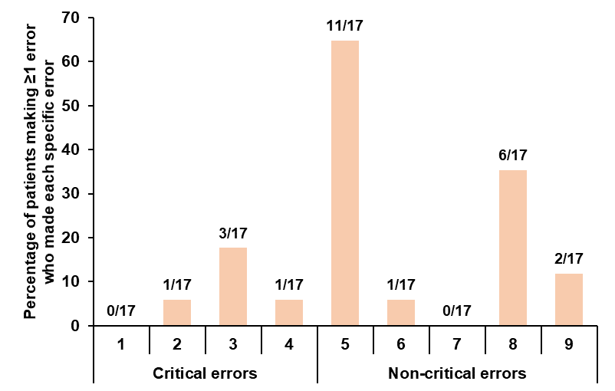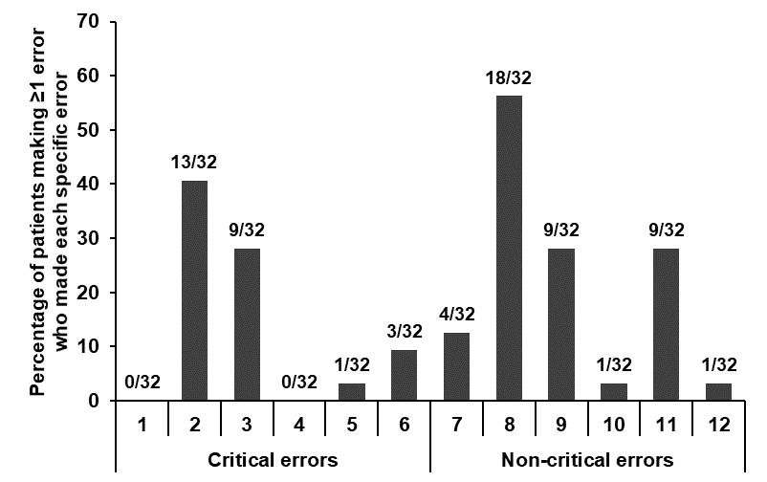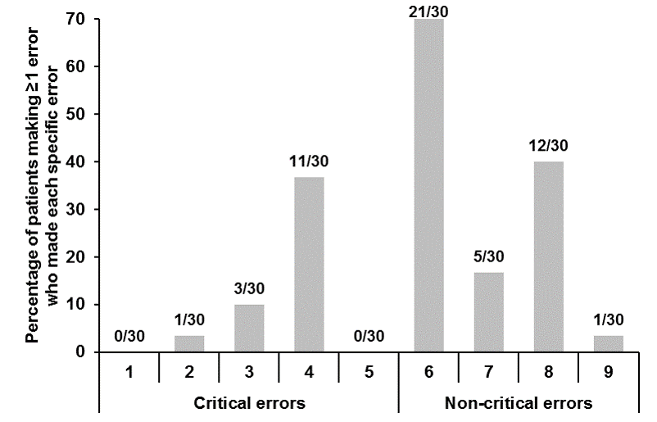
(25 errors by 17/50 [34%] of patients) (68 errors by 32/50 (64%) of patients) (54 errors by 30/50 [60%] of patients)

D: ELLIPTA UMEC/VI or UMEC E: HandiHaler TIO F: Breezhaler IND/GLY or GLY
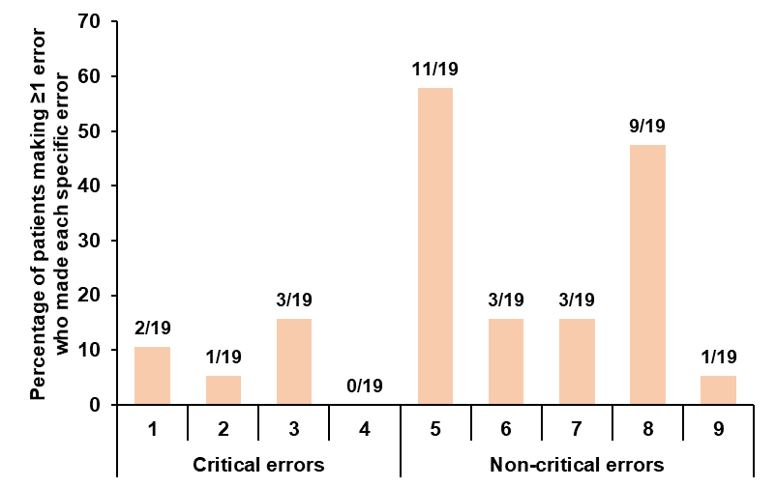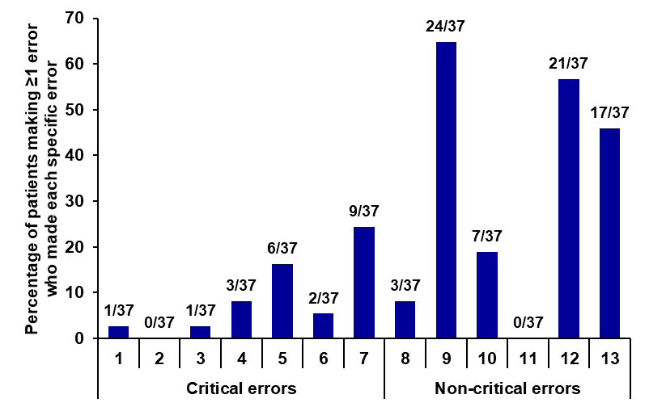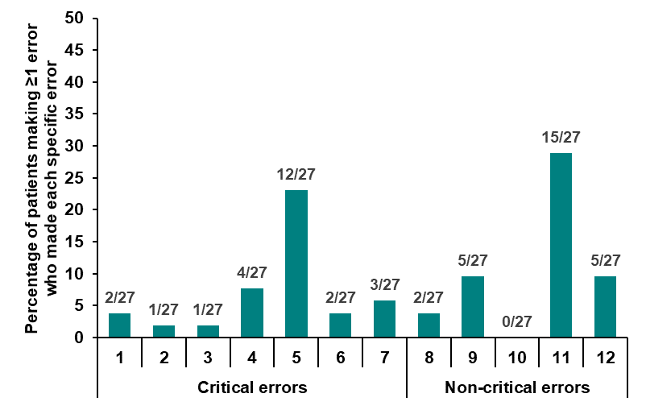
(33 errors by 19/51 [37%] of patients) (94 errors by 37/50 [74%] of patients) (52 errors by 27/49 [55%] of patients)

Notes: Numbers beneath the x-axis of each plot indicate the possible device error, as detailed below, and are ordered according to the correct-use checklist (and steps for device use).
A and D: 1=Failed to open cover; 2=Shook the device after dose preparation; 3=Exhaled directly into mouthpiece; 4=No seal by the lips round the mouthpiece during the inhalation; 5=No exhalation before an inhalation; 6=Inhalation manoeuvre was not long, steady, deep; 7=Blocked air inlet during inhalation manoeuvre; 8=Did not hold breath; 9=Did not close the device (Note: this is an error but one which does not affect the medication that is inhaled). B: 1=Failed to remove cap; 2=Did not hold device upright (± 45° OK) during dose preparation; 3=Base not twisted fully backwards and forwards, no click heard; 4=Shook the device after dose preparation; 5=Exhaled directly into mouthpiece; 6=No seal by the lips round the mouthpiece during inhalation; 7=Device tipped downwards after dose preparation; 8=No exhalation before inhalation; 9=Inhalation manoeuvre was not: forceful, deep; 10=Blocked air inlet during inhalation manoeuvre; 11=Did not hold breath; 12=Did not close the device (Note: this is an error but one which does not affect the medication that is inhaled). C: 1=Failed to open cover; 2=Lever is not pushed back; 3=Shook the device after dose preparation; 4=Exhaled directly into mouthpiece; 5=No seal by the lips round the mouthpiece during the inhalation; 6=No exhalation before an inhalation; 7=Inhalation manoeuvre was not: steady, deep; 8=Did not hold breath; 9=Did not close the device (Note: this is an error but one which does not affect the medication that is inhaled). E: 1=Failed to remove capsule; 2=Failed to insert capsule into the chamber; 3=Did not completely close device capsule chamber (heard click when satisfactory); 4=Did not pierce the capsule (HCP should check capsule was pierced); 5=Exhaled directly into mouthpiece; 6=No seal by the lips round the mouthpiece during the inhalation; 7=Capsule did not rattle; 8=Shook the device after dose preparation; 9=No exhalation before an inhalation; 10=Inhalation manoeuvre was not: slow, deep; 11=Blocked air inlet during inhalation manoeuvre; 12=Did not hold breath; 13=Did not check inside the capsule chamber if powder was left/ did not make second inhalation. F: 1=Failed to remove capsule; 2=Failed to insert capsule into the chamber; 3=Did not completely close device capsule chamber (heard click when satisfactorily); 4=Did not pierce the capsule and failed to release piercing buttons fully before inhalation (HCP to check that capsule was pierced and that piercing buttons were released; 5=Exhaled directly into the mouthpiece; 6=No seal by the lips round the mouthpiece during the inhalation; 7=Capsule did not rattle; 8=Shook the device after dose preparation; 9=Inhalation manoeuvre was not: Rapid, Steady, Deep; 10=Blocked air inlet during inhalation manoeuvre; 11=Did not hold breath; 12=Did not check inside the capsule chamber if powder was left / did not make a second inhalation.
Abbreviations: BUD, budesonide; DPI, dry-powder inhaler; FF, fluticasone furoate; FOR, formoterol; FP, fluticasone propionate; GLY, glycopyrronium; HCP, healthcare professional; IND, indacaterol; SAL, salmeterol; TIO, tiotropium; UMEC, umeclidinium; VI, vilanterol; V1, Visit 1.

