Supplementary material

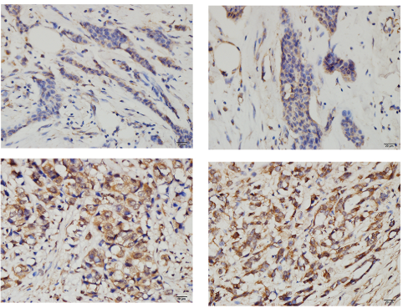
Figure S1 Typical staining image of ZEB2 in four types of breast cancer. ZEB2 mainly showed negative and weak positive staining in luminal A and luminal B breast cancer, weak and moderate positive staining in HER-2 positive breast cancer, and strong positive staining in TNBC breast cancer.

