Supplement
Characterization of patients
In COSYCONET, patients are asked to bring all medication at each visit, and the medication is recorded by the study nurses. For the present analysis, the medication was categorized according to pharmacological compounds and the fact whether combined or single formulations were given. Moreover, it was categorized into either respiratory, cardiovascular, hyperlipidemia, diabetes, or psychological (anxiety/depression). As described previously [14], the presence of a comorbidity was assumed from a patient’s report of a physician-based diagnosis, and additionally if there was disease-specific medication even in the absence of a report. Following common practice, patients were categorized according to either spirometric GOLD grades 1-4 [24] or the former GOLD grade 0 [13], as well as according to GOLD groups A/B/C/D [1] based on exacerbation history and symptoms using the COPD Assessment Test (CAT). For the present analysis patients of GOLD grade 0 were also categorized according to ABCD.
Evaluation of medication data and questionnaires
The investigation focused on a detailed analysis of respiratory medication regarding (a) regular versus irregular intake, (b) the reasons for potential non-adherence, (c) the comparison of combined versus single formulations regarding LABA and LAMA, (d) the dependence on patients’ characteristics. For comparison, the four other disease categories (cardiovascular, hyperlipidemia, diabetes, psychological) were analyzed. To each medication we assigned the corresponding ATC code [25] and categories of pharmacological compounds. In order to facilitate the interpretation of the results we restricted the range of compounds to those shown in table S1 (see supplement) for each disease. Except for the description of prescribed medications (Figure 1), we restricted all comparisons to LABA, LAMA and ICS regarding respiratory medication. In case of diabetes we performed an additional analysis including all anti-diabetes drugs except insulin or insulin-like drugs; this was done as we expected differences in adherence.
Adherence was asked in terms of either regular intake as prescribed, irregular intake, or no intake. In case of irregular intake, patients were asked for the reasons, with the following options: intake forgotten, intake on demand, other. In case of no intake, patients were asked with the options: no more prescribed, afraid of side effects, do not experience effectiveness, in my opinion not necessary. Adherence was expressed relative to those patients who still had the medication prescribed.
Statistical Methods
For patients description mean values and standard deviations were computed. The numbers of patients in different categories were counted. We performed statistical comparisons by chi-square statistics of contingency tables and logistic regression analyses. All computations were performed using either Excel-Sheets or SAS. Statistical significance was assumed for p<0.05.

Figure S1 Adherence to respiratory medication according to GOLD groups A-D
The figure shows the pattern of medication intake according to GOLD groups A-D. The respiratory medication refers to the compounds described in table S1 (LAMA, LABA, ICS). GOLD grade A/B/C/D n=91/396/11/209. In this graph regular, irregular and non-intake are arranged along the horizontal axis, and percentages are given on the vertical axis.
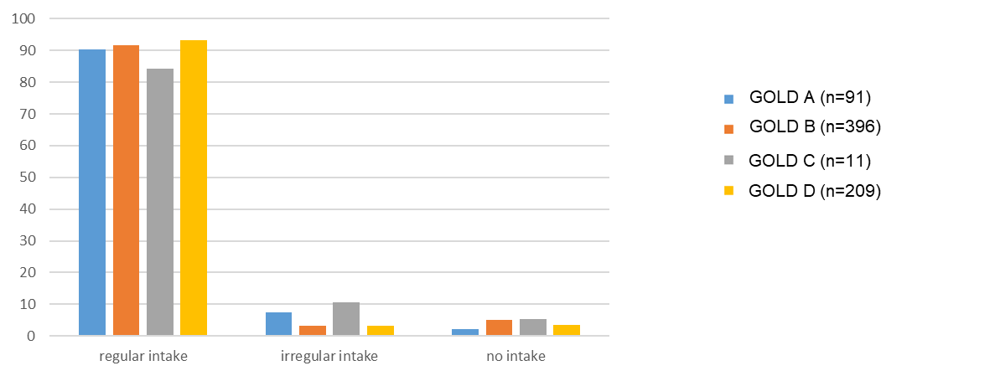

Figure S2 Adherence to respiratory medication according to the diagnosis of depression syndromes
The figure shows the pattern of respiratory medication intake according to the diagnoses of major (n=39) and no depression syndromes (n=657) according to the PhQ-test results for depression. Patients with „other depression syndromes“ were excluded.
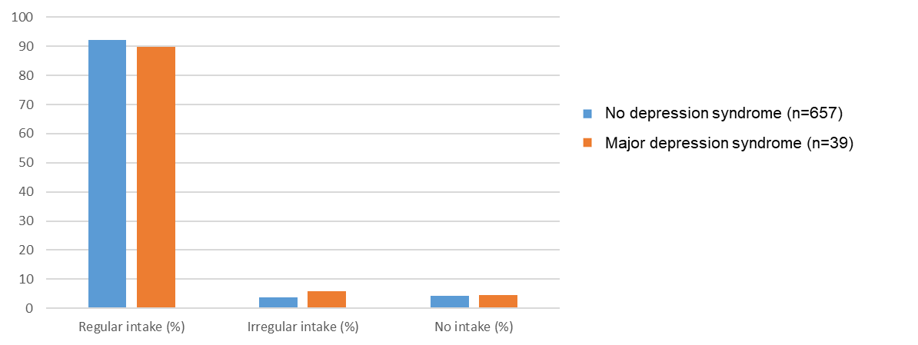

Figure S3 Adherence to respiratory medication according to generic quality of life
The figure shows the pattern of respiratory medication intake according the VAS scale results for generic quality of life from the EQ5D. For analysis VAS values (scaled as 0 to 100) were grouped into quartiles. Again, adherence patterns are grouped along the horizontal axis.
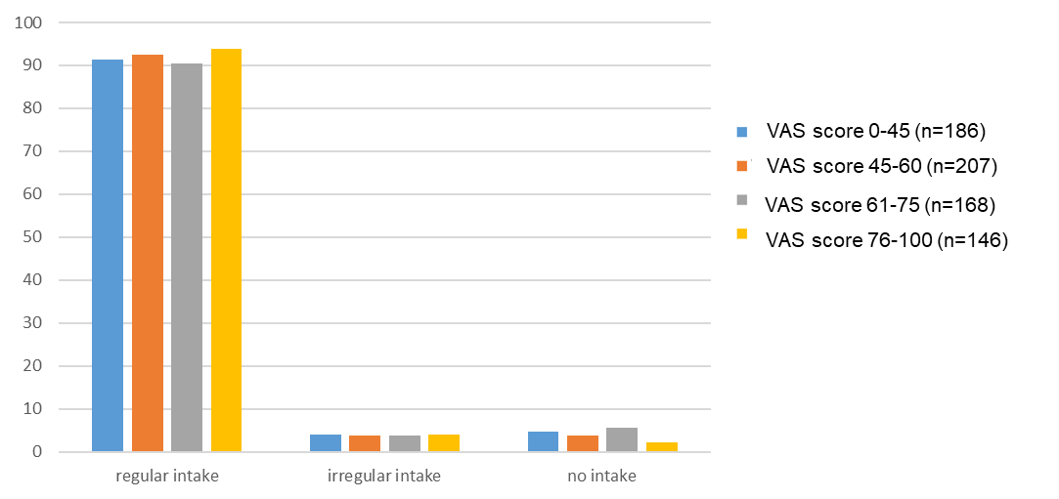

Figure S4 Adherence to respiratory medication according to the educational status
The figure shows the pattern of respiratory medication intake according the educational status (basic, secondary, higher). Again, adherence patterns are grouped along the horizontal axis.
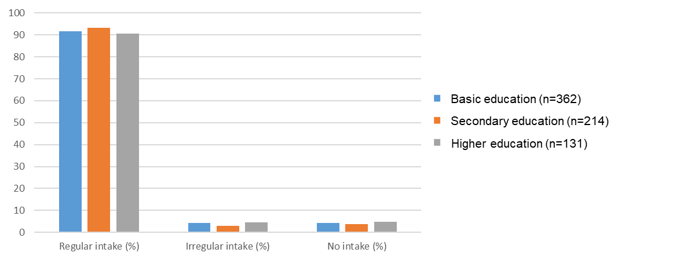

Table S1. Comorbidities and their respective categories of the pharmacological compounds
Disease category | Class of drugs | ATC-Code | Medication
Respiratory drugs | LABA | R03AC12 | Salmeterol
 |  | R03AC13 | Formoterol
 |  | R03AC18 | Indacaterol
 |  | R03AC19 | Olodaterol
 | LABA + ICS | R03AK06 | Salmeterol + Fluticasone
 |  | R03AK07 | Formoterol + Budesonide
 |  | R03AK08 | Formoterol + Beclometasone
 |  | R03AK10 | Vilanterol + Fluticasone furoate
 |  | R03AK11 | Formoterol + Fluticasone
 | LABA + LAMA | R03AL03 | Vilanterol + Umeclidinium bromide
 |  | R03AL04 | Indacaterol + Glycopyronium bromide
 |  | R03AL05 | Formoterol + Aclidinium bromide
 |  | R03AL06 | Olodaterol + Tiotropium bromide
 |  | R03AL09 | Formoterol + Glycopyronium bromide + Beclometasone
 | ICS | R03BA01 | Beclometasone
 |  | R03BA02 | Budesonide
 |  | R01AD04 | Flunisolide
 |  | R03BA05 | Fluticasone
 |  | R03BA08 | Ciclesonide
 | LAMA | R03BB04 | Tiotropium bromide
 |  | R03BB05 | Aclidinium bromide
 |  | R03BB06 | Glycopyronium bromide
 |  | R03BB07 | Umeclidinium bromide
Cardiovascular drugs | Thiazides | C03AA03 | Hydrochlorothiazide
 | Low-ceiling –diuretics, excluding Thiazides | C03BA04 | Chlortalidone
 |  | C03BA10 | Xipamide
 |  | C03BA11 | Indapamide
 | High- ceiling-diuretics | C03CA01 | Furosemide
 |  | C03CA04 | Torasemide
 | Potassium-sparing diuretic | C03DA01 | Spironolactone
 |  | C03DA04 | Eplerenone
 | Combination of potassium-sparing diuretics and diuretics | C03EA21 | Hydrochlorothiazide + Triamterene
 |  | C03ED01 | Spironolactone + Furosemide
 | Beta-adrenergic receptor antagonists | C07AA05 | Propranolol
 |  | C07AB02 | Metoprolol
 |  | C07AB07 | Bisoprolol
 |  | C07AB08 | Celiprolol
 |  | C07AB12 | Nebivolol
 |  | C07AG02 | Carvedilol
 |  | C07CB53 | Atenolol + other diuretics
 |  | C07FB07 | Bisoprolol + Amlodipin
 | ACE-inhibitors | C09AA02 | Enalapril
 |  | C09AA03 | Lisinopril
 |  | C09AA05 | Ramipril
 |  | C09AA07 | Benazepril
 | Combination of ACE-inhibitors and diuretics | C09BA22 | Enalapril + Hydrochlorothiazide
 |  | C09BA23 | Lisinopril + Hydrochlorothiazide
 |  | C09BA25 | Ramipril + Hydrochlorothiazide
 |  | C09BA26 | Quinapril + Hydrochlorothiazide
 | Angiotensin-II-receptor blocker | C09CA01 | Losartan
 |  | C09CA02 | Eprosartan
 |  | C09CA03 | Valsartan
 |  | C09CA04 | Irbesartan
 |  | C09CA06 | Candesartan
 |  | C09CA07 | Telmisatan
 |  | C09CA08 | Olmesartan medoxomil
 | Combination of angiotensin-II-receptor blocker and diuretics | C09DA21 | Losartan + Hydrochlorothiazide
 |  | C09DA22 | Eprosartan + Hydrochlorothiazide
 |  | C09DA23 | Valsartan + Hydrochlorothiazide
 |  | C09DA24 | Irbesartan + Hydrochlorothiazide
 |  | C09DA26 | Candesartan + Hydrochlorothiazide
 |  | C09DA27 | Telmisartan + Hydrochlorothiazide
 |  | C09DB07 | Candesartan + Amlodipin
 |  | C09DX04 | Valsartan + Sacubitril
 | Direct renin inhibitors | C09XA02 | Aliskiren
 |  | C09XA52 | Aliskiren + Hydrochlorothiazide
Lipid modifying agents | Statins and fibrates | C10AA01 | Simvastatin
 |  | C10AA03 | Pravastatin
 |  | C10AA04 | Fluvastatin
 |  | C10AA05 | Atorvastatin
 |  | C10AA07 | Rosuvastatin
 |  | C10AB04 | Gemfibrozil
 |  | C10AB02 | Bezafibrate
 |  | C10AB05 | Fenofibrate
 |  | C10AC04 | Colesevelam
 |  | C10AX06 | Omega-3 fatty acids
 |  | C10AX09 | Ezetimibe
 |  | C10AX14 | Alirocumab
 | Combinations | C10BA02 | Simvastatin + Ezetimibe
 |  | C10BA05 | Atorvastatin + Ezetimibe
Psychoactive drugs | Psycholeptics | N05AD03 | Melperone
 |  | N05AF03 | Chlorprothixene
 |  | N05AH03 | Olanzapine
 |  | N05AH04 | Quetiapine
 |  | N05AN01 | Lithium
 |  | N05AX07 | Prothipendyl
 |  | N05AX08 | Risperidone
 |  | N05AX12 | Aripiprazole
 | Antidepressants | N06AA04 | Clomipramine
 |  | N06AA05 | Opipramole
 |  | N06AA06 | Trimipramine
 |  | N06AA09 | Amitryptiline
 |  | N06AA12 | Doxepin
 |  | N06AB03 | Fluoxetin
 |  | N06AB04 | Citalopram
 |  | N06AB05 | Paroxetine
 |  | N06AB06 | Sertraline
 |  | N06AB10 | Escitalopram
 |  | N06AX03 | Mianserin
 |  | N06AX05 | Trazodone
 |  | N06AX11 | Mirtazapine
 |  | N06AX16 | Venlafaxine
 |  | N06AX21 | Duloxetine
 |  | N06AX22 | Agomelatine
Diabetes drugs | Insulins
 | Rapid-acting insulins and analoga | A10AB01 | Insulin (human)
 |  | A10AB04 | Insulin lispro
 |  | A10AB05 | Insulin aspart
 |  | A10AB06 | Insulin glulisin
 | Intermediate-acting insulins | A10AC01 | Insulin (human)
 | Combinations of rapid-acting and intermediate acting insulins | A10AD01 | Insulin (human)
 |  | A10AD04 | Insulin lispro
 | Long-acting insulins | A10AE04 | Insulin glargine
 |  | A10AE05 | Insulin detemir
 | Anti-diabetic medication excluding insulins
 | Biguanide | A10BA02 | Metformin
 | Sulfonylureas | A10BB01 | Glibenclamide
 |  | A10BB12 | Glimepiride
 | Combinations | A10BD07 | Metformin + Sitagliptin
 |  | A10BD10 | Metformin + Saxagliptin
 | DPP-4-Inhibitors | A10BH01 | Sitagliptin
 | GLP-1-receptor agonists | A10BJ02 | Liraglutide
 |  | A10BJ05 | Dulaglutide
 | SGLT2-Inhibitors | A10BK01 | Dapagliflozin
 |  | A10BK03 | Empagliflozin
 | Others | A10BX02 | Repaglinide

Number of patients  Male/female | Respiratory medication  n=682  n=417/265 | Cardiovascularmedication  n=447  n=292/155 | Lipid modifying agents  n=236  n=170/66 | Anti-diabetes medication (w/o Insulins)  n=64  n=52/12 | Insulins and analogs  n=25  n=22/3 | Psychological  medication  n=86  n=41/45
Prescription (%)  male/female | 96.5  95.9/97.4 | 63.2  67.1/60.0 | 33.4  39.1/24.3 | 9.1  12.0/4.4 | 3.5  5.1/1.1 | 12.2  9.4/16.5
Regular intake (%)  male/female | 92.0  92.8/90.6 | 94.6  94.0/95.8 | 88.5  89.1/87.1 | 93.6  95.2/86.7 | 100  100/100 | 85.1  85.7/84.6
Irregular intake (%)  male/female | 3.9  3.7/4.1 | 2.4  2.6/2.1 | 4.4  3.6/6.5 | 0  0/0 | 0  0/0 | 7.9  2.0/13.5
No intake (%)  male/female | 4.2  3.5/5.4 | 3.0  3.4/2.1 | 7.0  7.3/6.5 | 6.4  4.8/13.3 | 0  0/0 | 6.9  12.2/1.9

S2. Percentages of intake of medication for COPD and the four comorbidities
The table shows the percentages of the intake pattern of medication for the lung disease and the four frequent comorbidities.

