Supplementary Material:
Figure S1. Siglec-5, -7, -9 and -16 are highly expressed in MGMT methylated gliomas.
The expression of Siglec-5, -7, -9 and -16 is higher in MGMT methylated gliomas than unmethylated gliomas in the CGGA (A) and TCGA database (B). ns for non-significance, **p<0.01, ***p<0.001, ****p<0.0001.

Figure S2. The specific expression of Siglec-5, -7, -9 and -16 in IDH-wildtype, MGMT promotor unmethylated and mesenchymal subtype gliomas.
Expression specificity of Siglec-5, -7, -9 and -16 in IDH-wildtype (A, B), MGMT unmethylated (C, D) and mesenchymal subtype gliomas (E, F) was descripted by ROC curve analysis. **** indicates p<0.0001 in all ROC analysis.

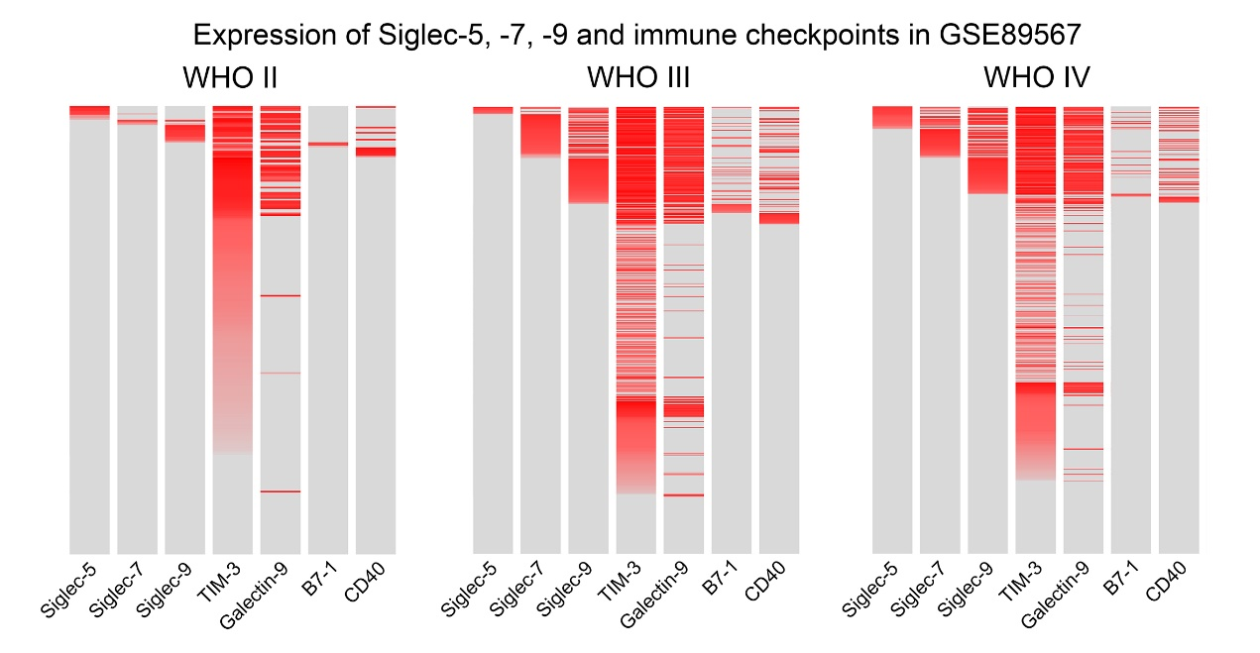
Figure S3. Expression relationship between Siglec-5, -7, -9 and corresponding immune checkpoints.
Expression of Siglec-5, -7, -9 and corresponding immune checkpoints in glioma cells of each WHO grade. The expression level was represented by the shade of red. Gray meant no expression.

Figure S4. Spatial Mapping Bolt of Single Cell Expression of Siglec-5, -7, -9 and -16.
Expression of Siglec-5, -7, -9 and -16 in single cells of an open-access single cell database. The expression was mainly in macrophage cells.

