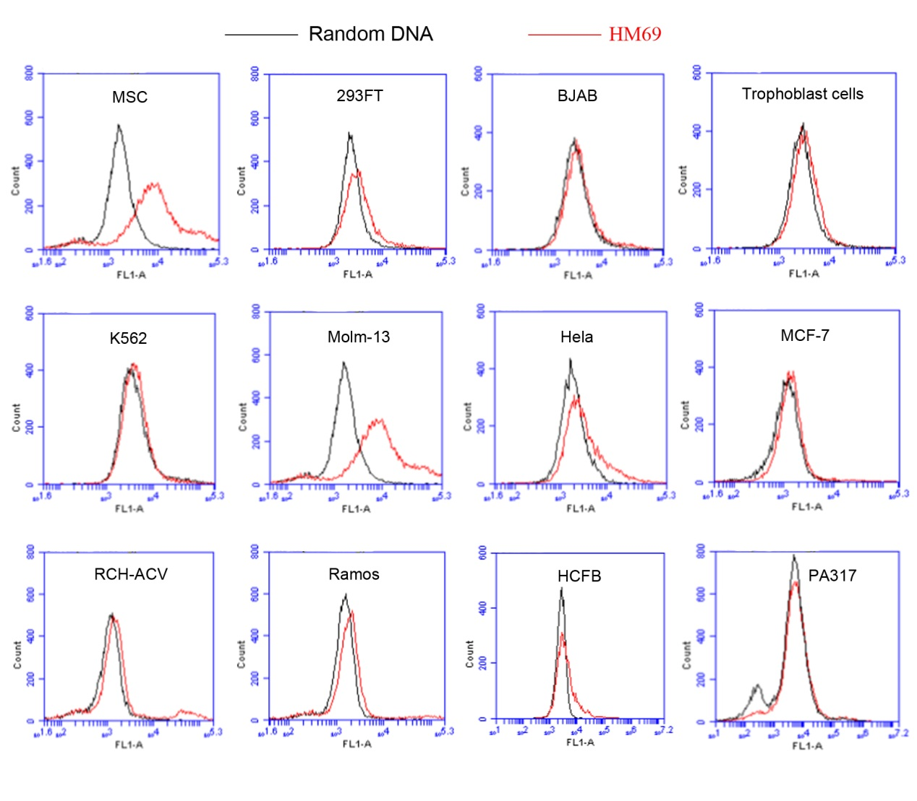
Supplementary Figure 1. Flow cytometric evaluation of the binding specificity to MSCs or other negative cells by FITC-labeled HM69. FITC-labeled HM69 (10 mM) was incubated with either 1×10⁵ MSCs, BJAB cell line, trophoblast cells, K562, Molm-13, Hela, Ramos, MCF-7. RCH-ACV, HCFB or PA317 cells at 37˚C for 30 min. Cells were washed three time and resuspended by PBS. Then, the cells were analyzed by flow cytometry. The black curves represent the control fluorescent signals generated by FITC-labeled random DNA from the library pool.

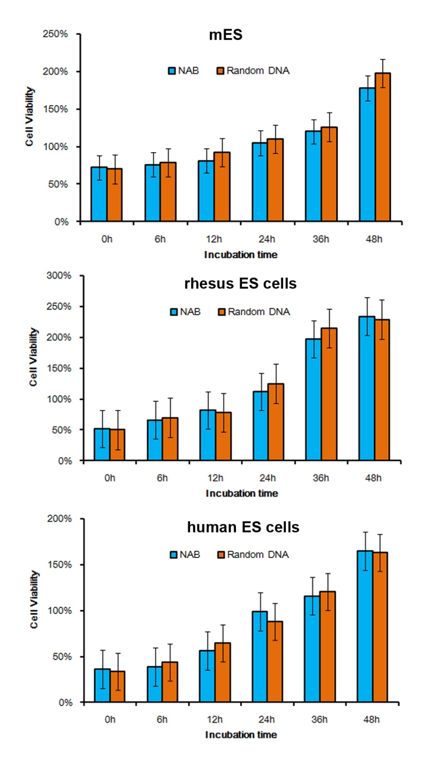
Supplementary Figure 2. Cell Counting Kit-8 assessment of cell proliferation. Cell lines were treated and incubated with NAB or random DNA. The cells were then washed with PBS and cultured further. CCK-8 assay was used to determine cell viability.
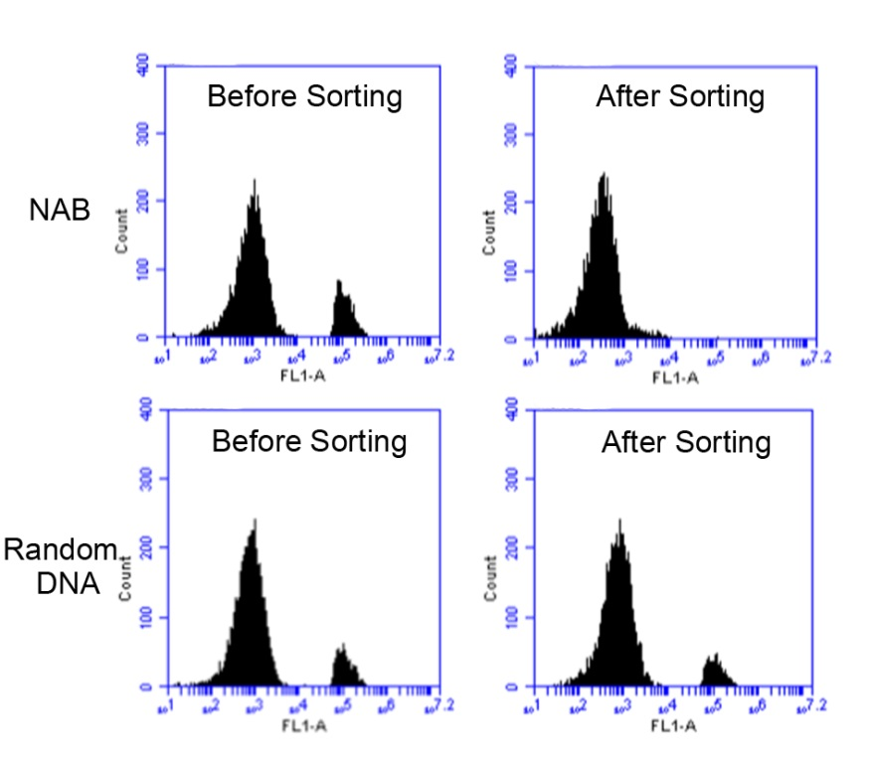
Supplementary Figure 3. The MSCs sorting ability assessment of NAB. NAB or random DNA was fixed on magnetic beads and incubated with a mixture of CFSE labeled MSCs and rat peripheral blood cells. After incubation, magnetic beads were collected under magnetic field. The supernatant were analyzed by flow cytometry.

