Supplementary material

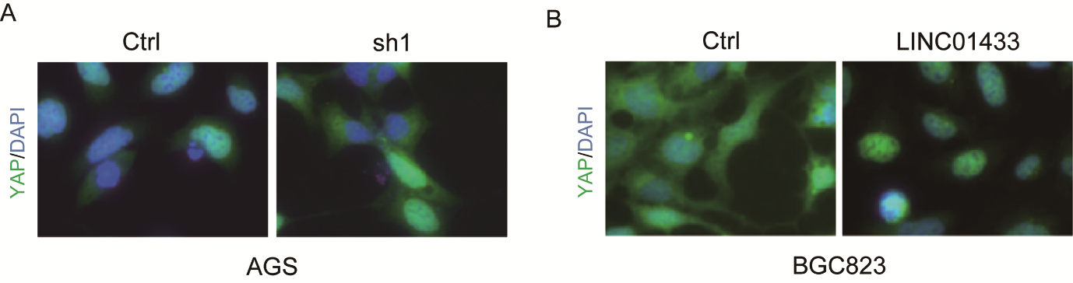

Figure S1 LINC01433 promotes the translocation of YAP into the nucleus.
Notes: A) AGS cells with or without LINC01433 knockdown were immunostained with a YAP-specific antibody (green). DAPI (blue) was used to stain DNA. B) BGC823 cells with or without LINC01433 knockdown were immunostained with a YAP-specific antibody (green). DAPI (blue) was used to stain DNA.

