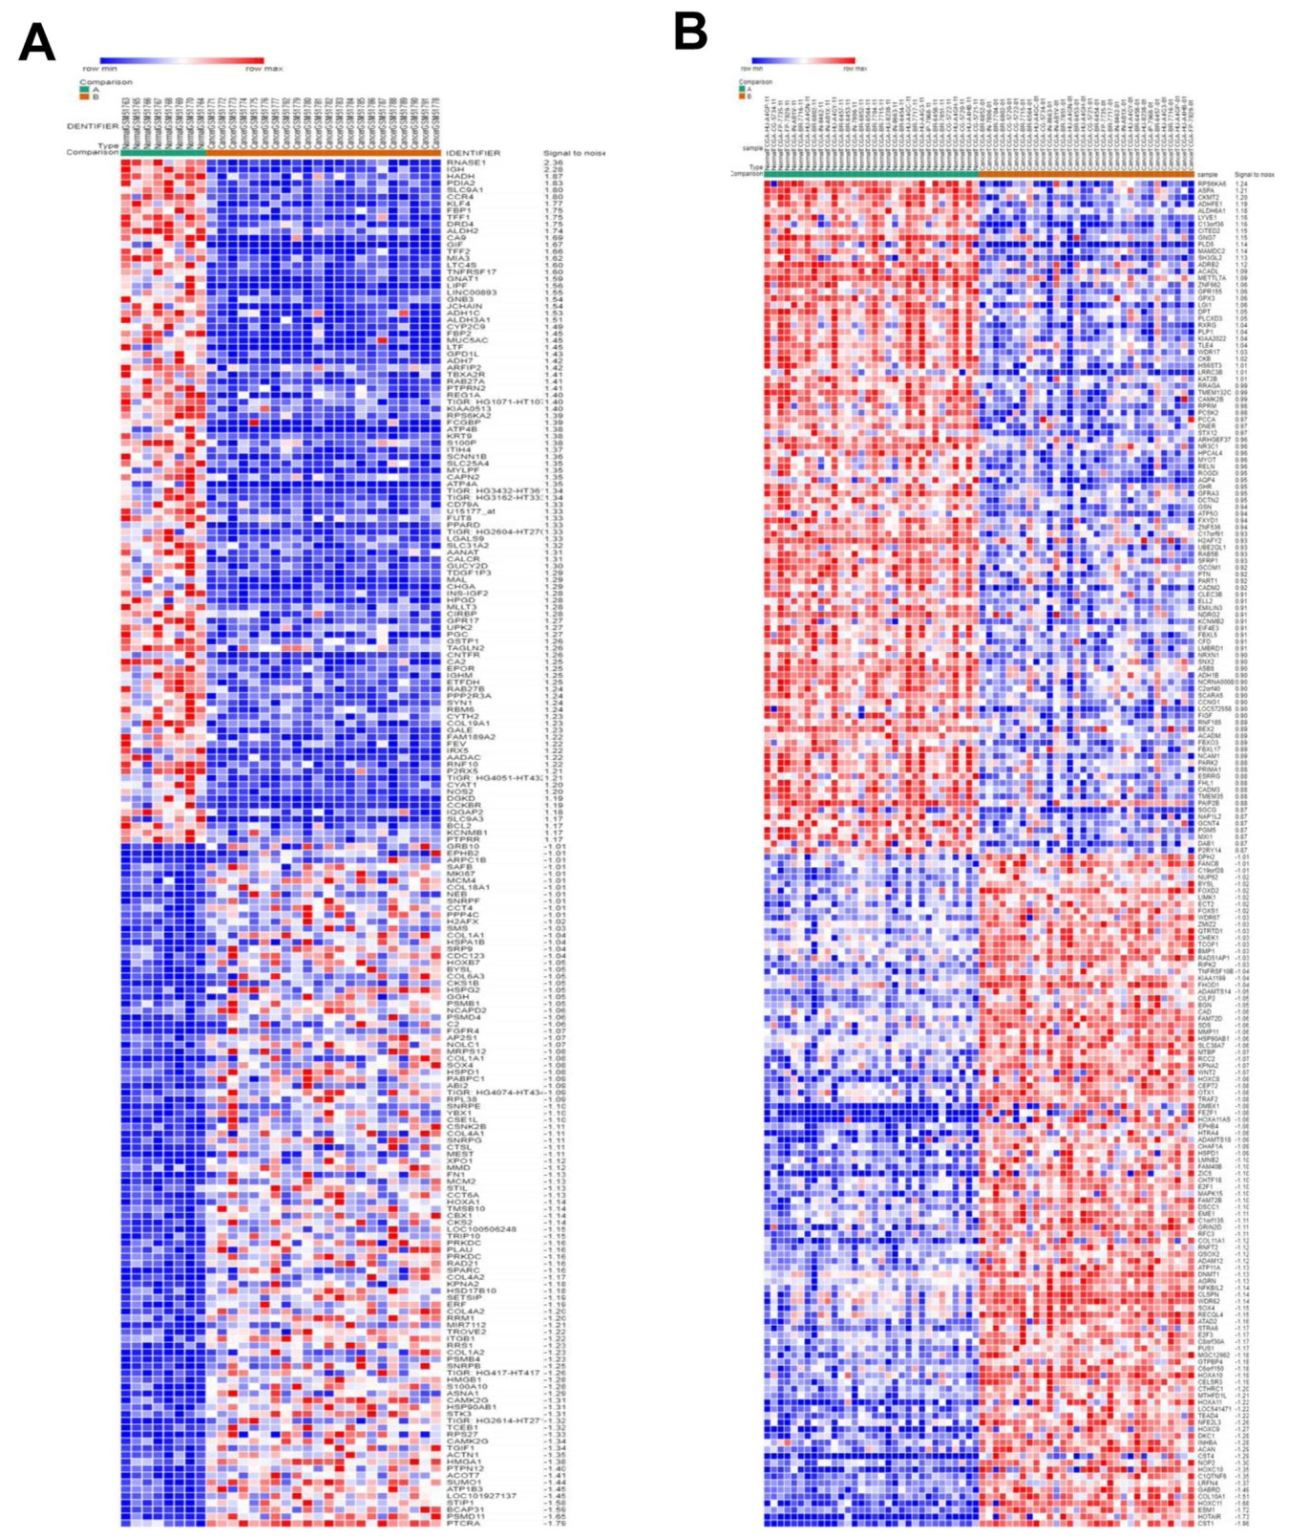

Supplementary Figure 1. Heat map of differentially expressed genes in gastric cancer. The GEO database (A), including 22 gastric cancer samples and 8 normal gastritis epithelial samples, and, the TCGA database (B), including 32 gastric cancer samples and 32 normal gastritis epithelial samples, were used.The blue portion of the figure indicates a gene that is lowly expressed in tumor sample compared to normal sample, and the red portion indicates a gene that is highly expressed in tumor sample as compared with normal sample.

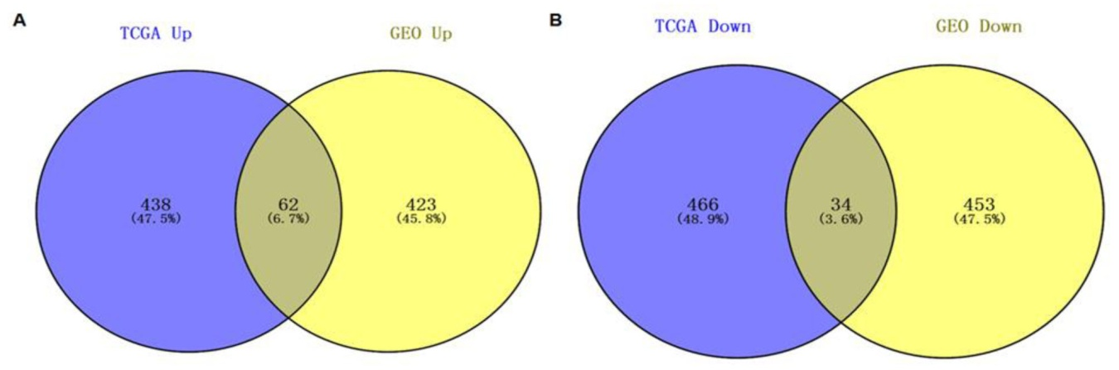
Supplementary Figure 2. Intersection of differentially expressed genes from the GEO database and the TCGA database. (A) The up-regulated genes from the different databases. (B) The down-regulated genes from the different databases.

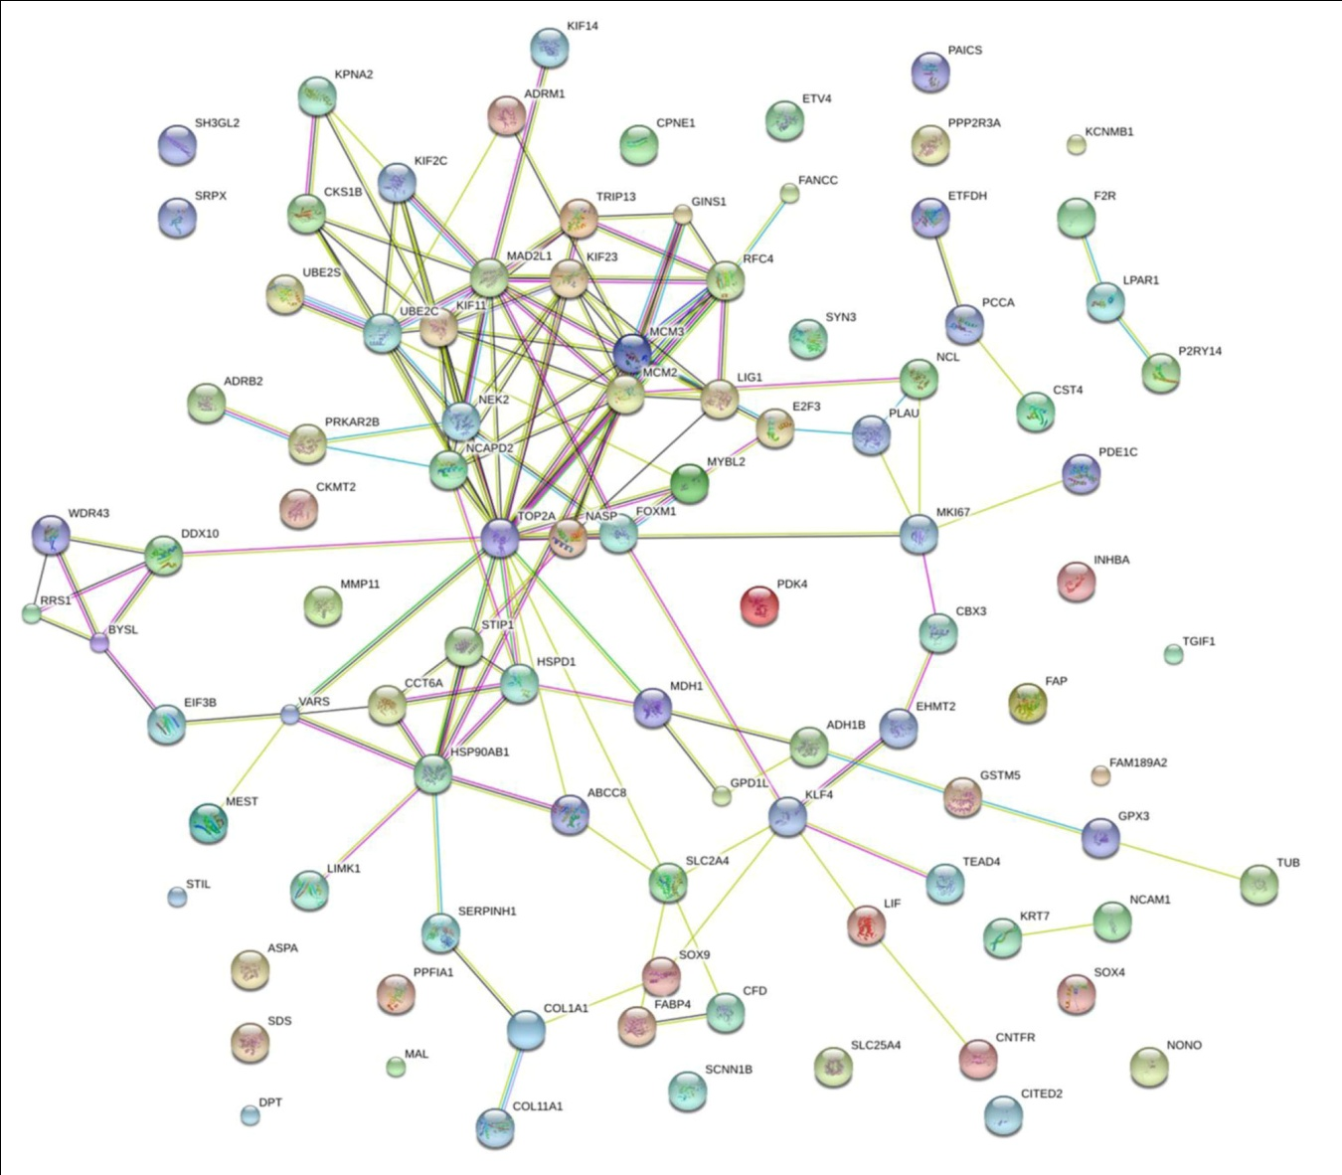
Supplementary Figure 3. PPI network of the 96 differentially expressed genes.

Supplementary Table 1. Clustering analysis of genes in PPI network by MCODE.
Cluster | Score (Density Nodes) | Nodes | Edges | Node IDs
1 | 7 | 7 | 21 | KIF11, NCAPD2, TOP2A, MCM3, MCM2, KIF23, MAD2L1
2 | 4 | 4 | 6 | RRS1, DDX10, BYSL, WDR43
3 | 3 | 3 | 3 | NEK2, KIF2C, UBE2C
4 | 3 | 3 | 3 | GINS1, RFC4, TRIP13
5 | 3 | 3 | 3 | STIP1, CCT6A, HSPD1
6 | 3 | 3 | 3 | PLAU, MKI67, NCL

