Supplementary Table 1. Sequences of primers for PCR amplification of HOXC8 cDNA fragments
Gene | Forward | Reverse
HOXC8(116-bp) | 5′-TAGCTGCCACGGAGACGC-3′ | 5′-CGGAGGATTTACAGTCGGGAT-3′
GAPDH(258-bp) | 5′-AGAAGGCTGGGGCTCATTTG-3′ | 5′-AGGGGCCATCCACAGTCTTC-3′

Supplementary Table2. Three sets of primer sequences for the ASH2L-siRNA
Gene | Forward(5′-3′) | Reverse(5′-3′) | Product length (bp)
Fragment1 | GUCUACUAGUGGGAAUUUATT | UAAAUUCCCACUAGUAGACTT | 741
Fragment2 | GCCAGCACAUACAAAGAUTT | AUCUUUGUAUGUGUCUGGCTT | 1412
Fragment2 | CUCCGAAGGAUCUCACUUATT | UAAGUGAGAUCCUUCGGAGTT | 1664bp
negative control | UUCUCCGAACGUGUCACGUTT | ACGUGACACGUUCGGAGAATT

Supplementary Table3. The primer sequences of ASH2L and HOXC8
Gene | Forward(5′-3′) | Reverse(5′-3′) | Product length (bp)
Homo ASH2L | ATGTAAGCAGCACGAGGAAGG | AGAATGGGAGCAATAGGAAAGC | 91
Homo HOXC8 | CCGCCAATCAAGAACTATGGAGTC | GGAATGTATCACTGCTCTGCCTG | 116
β-Actin | TGACGTGGACATCCGCAAAG | CTGGAAGGTGGACAGCG

Supplementary Table 4a. The primers sequence of HOXC8 promoter region.
Gene | Forward(5-3′) | Reverse(5-3′) | Product length (bp)
Homo HOXC8 | TAGCTGCCACGGAGACGC | CGGAGGATTTACAGTCGGGAT | 116
Homo GAPDH | AGAAGGCTGGGGCTCATTTG | AGGGGCCATCCACAGTCTTC | 258

Supplementary Table 4b. The primers sequence of MLL，BPTF，RBBP5，WDR5 gene.
Gene | Forward(5-3′) | Reverse(5-3′) | Product length (bp)
MLL | TCCCACCTTCCCTGGAGTAA | TCTTTGTGGCTTGCTGAAACG | 134
BPTF | GGCTGTGATCGGTGTCAGAA | GAACGGAGCACCCTCTTCAA | 176
RBBP5 | CGGATGCAGTCCAAACCTCC | GATTGCTCCTCCTGCTTTTGAT | 230
WDR5 | TCTCCCCGAACGGCAAATAC | TGTGGCCAGTGTACGTCTTC | 102

Supplementary Table 4c. The primers of HOXC8 promoter sequences
primer | PCR product sequence
0k | CAGACCTGCCCAGCCCCCAGCCCACCAGCCCAGCCCAGTCCCGGGGAGCCAGCTGATGA
-2k | AGAGTTCTGGGTGTCTAGAGTTTGGGCAGCTCCTGAGATGGGGGTGGGATTCCCCAAATGCAGGGA
-3k | GTAGAGGCGGCGGTGCCCCGGGCCGCCCTGGCCGCACTGACATTTGAGGCCC
1.4k | GGAGCGATAAGCGACAGTTCCGGCGGGGATGGCCCATGATTTATTTGCTGGTCTCCAA

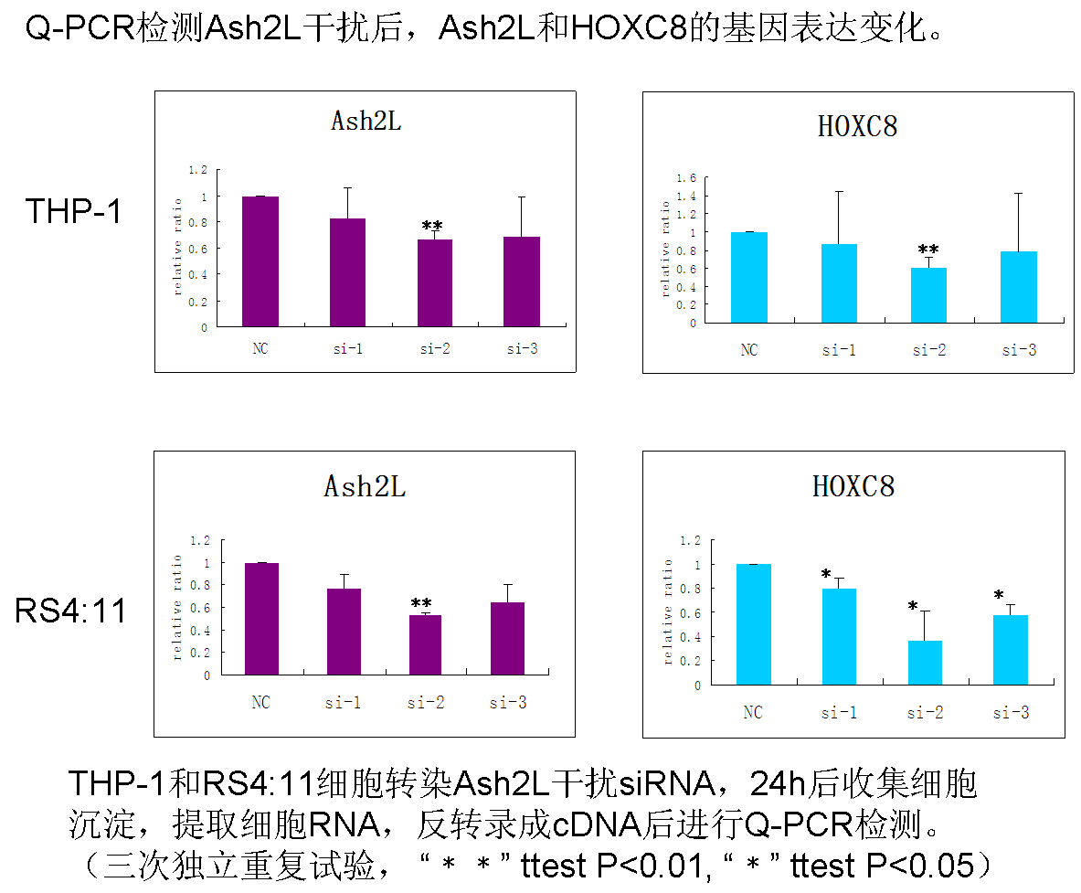
Supplemental figure1. Expression changes of ASH2L and HOXC8 after quantitative PCR detection of ASH2L interference.All three independent trials showed that expressions of both genes were down-regulated. ASH2L was significantly down-regulated in sample No. 2 of THP-1 cells and sample No. 2 of RSH:1 cells (p<0.01); HOXC8 was significantly down-regulated (p<0.01) in sample No. 2 of THP-1 cells and sample No. 1 , 2 and 3 of RSH:1 cells

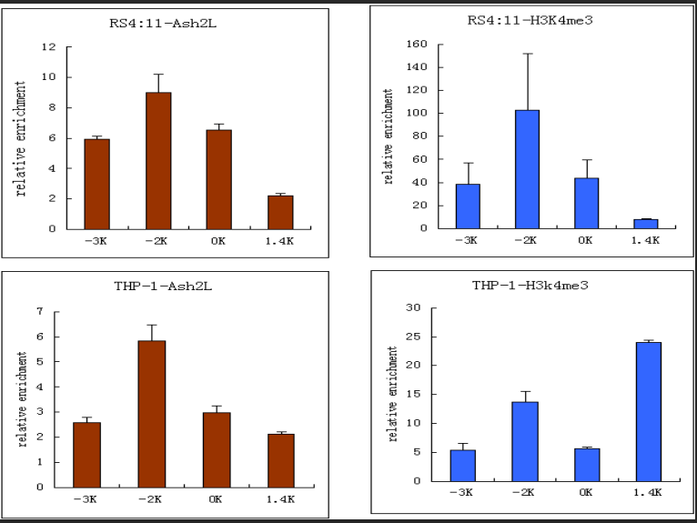

Supplemental figure 2. The expression of HOXC8 promoter region in RS4:11 and THP-1 cells before siRNA-ASH2L

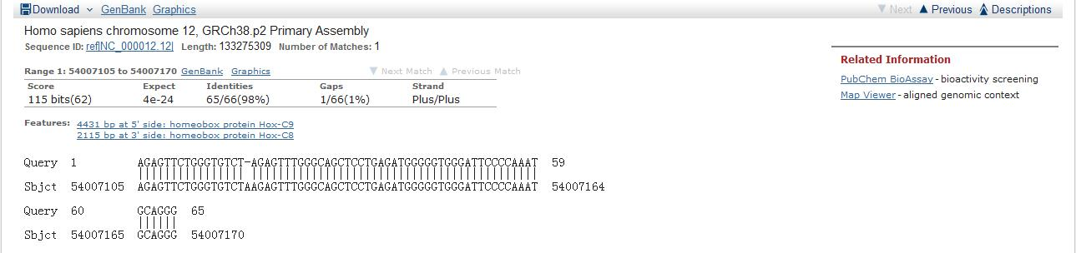
-2k

Supplemental figure 3a. The comparison result of sequencing primers in -2k

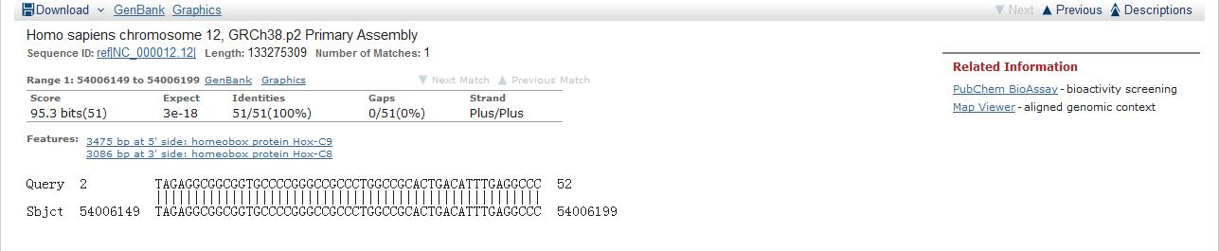
-3k

Supplemental figure 3b. The comparison result of sequencing primers in -2k
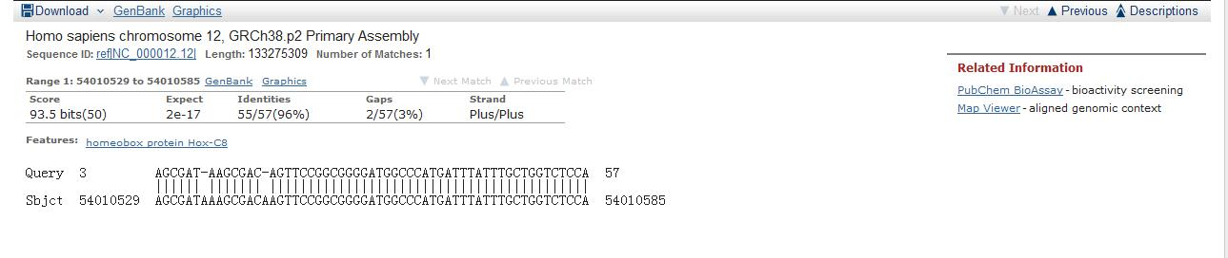
-1.4k

Supplemental figure 3c. The comparison result of sequencing primers in -2k
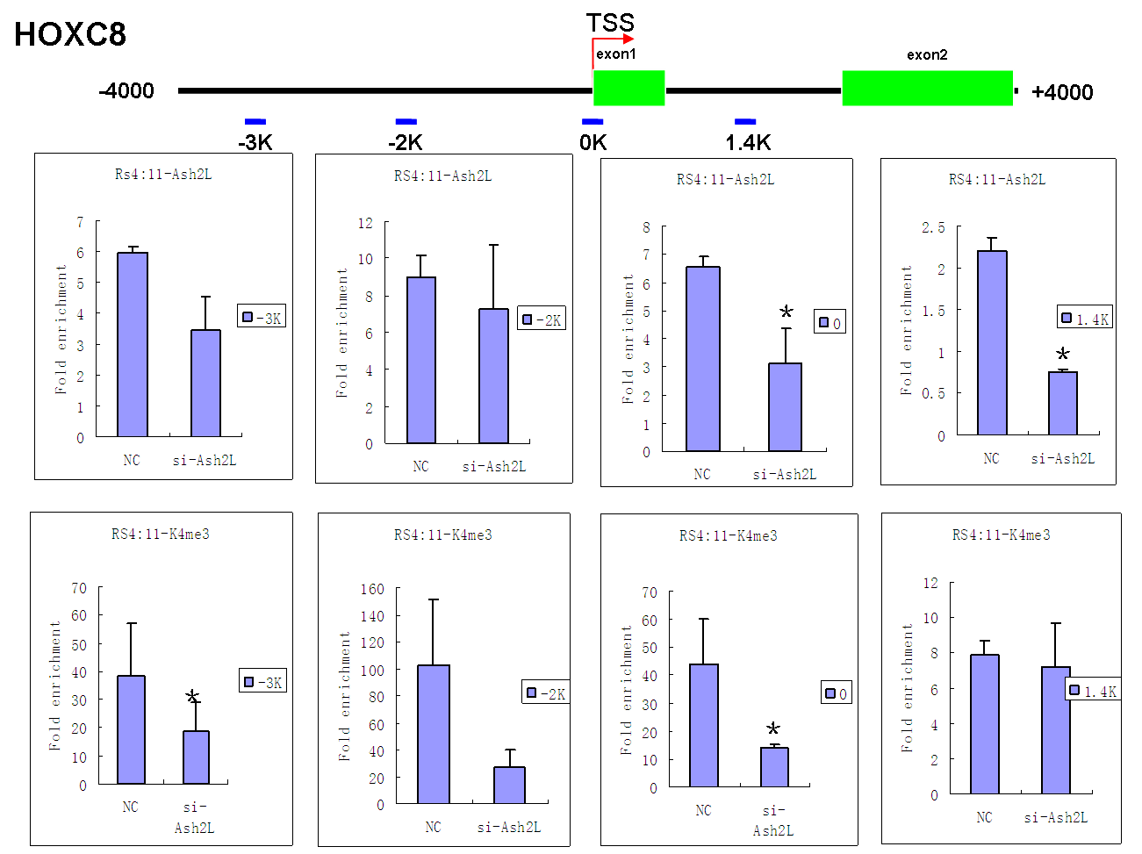
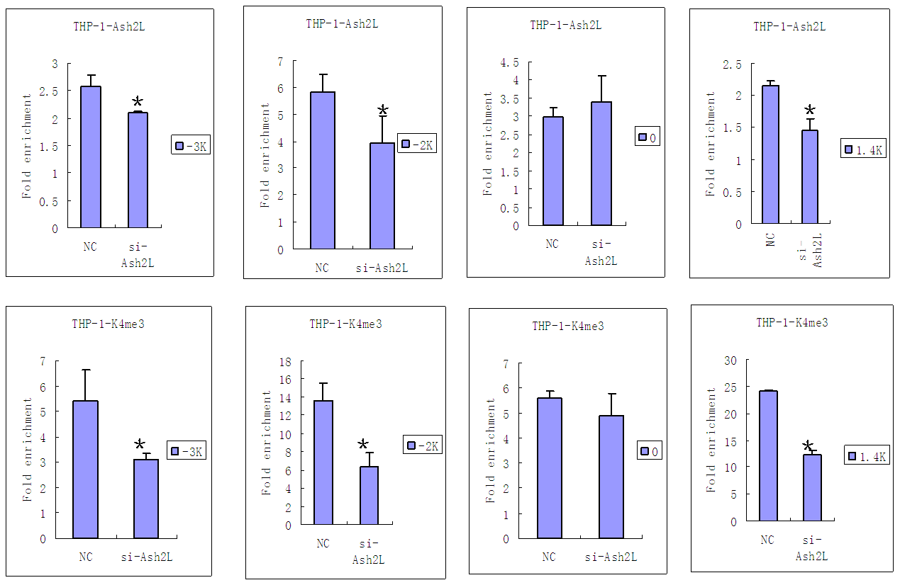
Supplemental Figure 4.The H3K4-me3 Modification in HOXC8 Promoter Region after siRNA -ASH2L
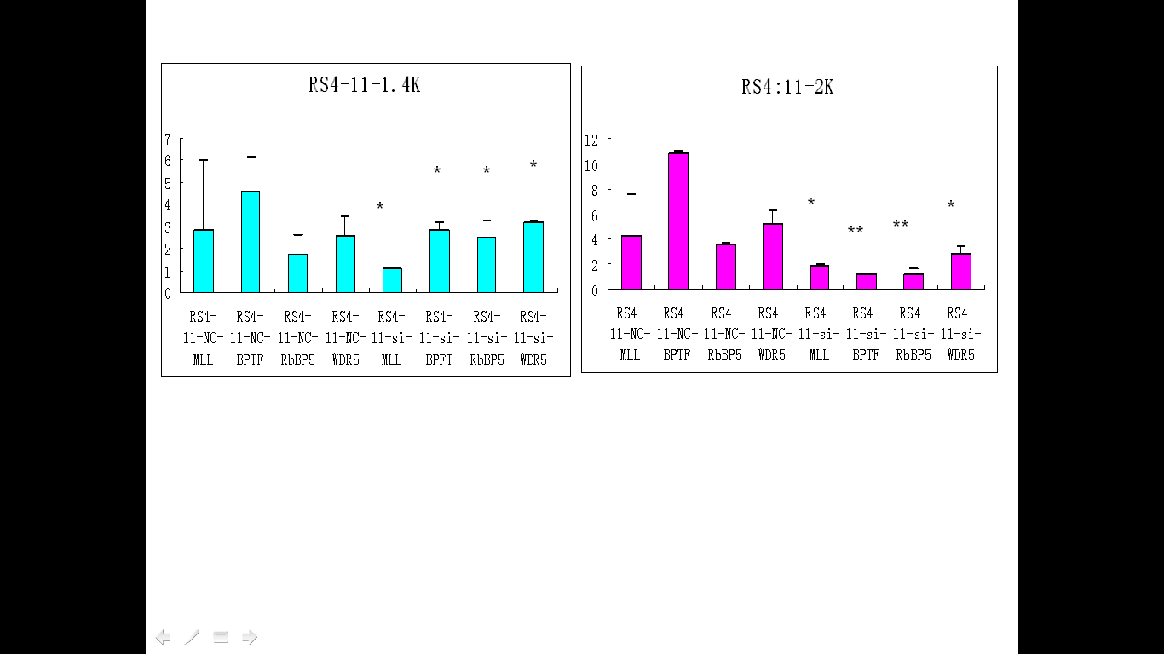
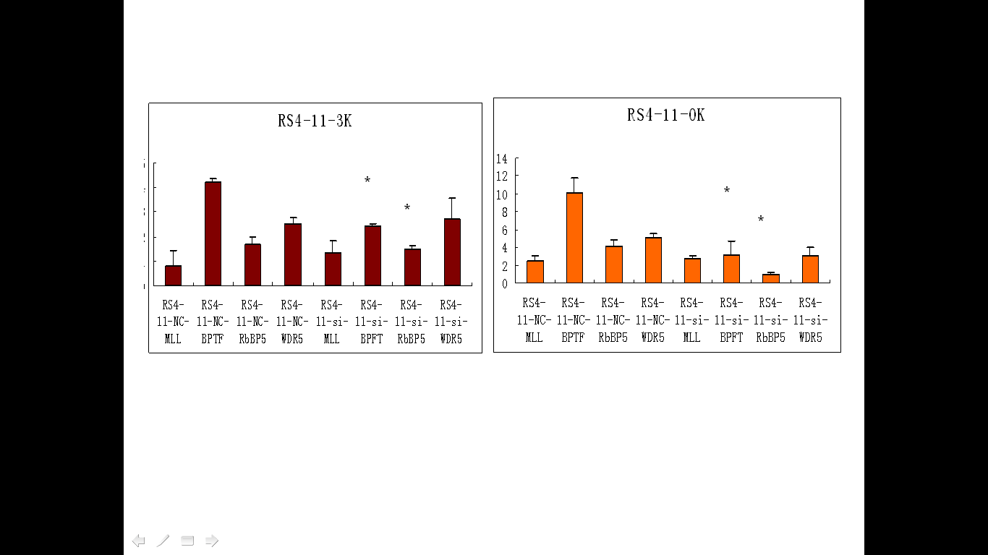

*
*

Supplemental Figure 5.The modification of H3K4-me3 in HOXC8 Promoter Region after siRNA-ASH2L

