Supplementary material
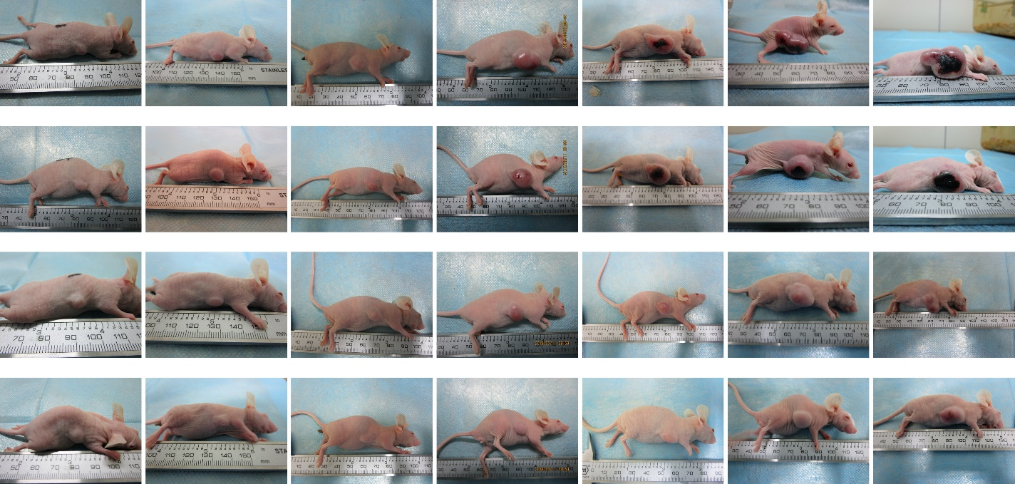
PEG-PE
PBS
Free BTM
BTM@PEG-PE
D3
D5
D7
D9
D11
D13
D15
Figure S1. Representative photos showing tumors in mice before and after treatment. Tumors are highlighted by red circles.

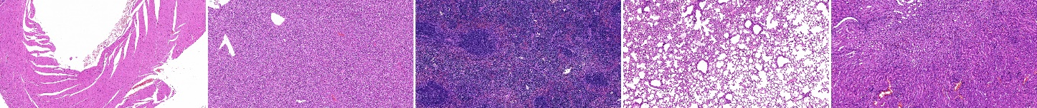
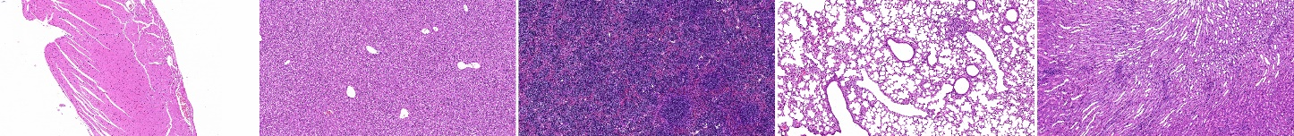
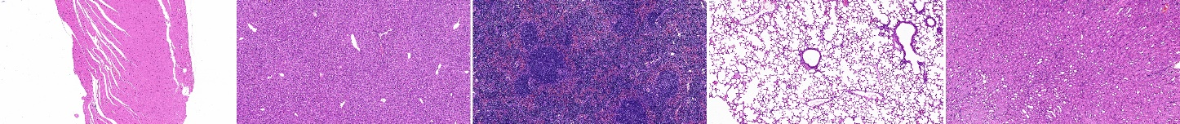
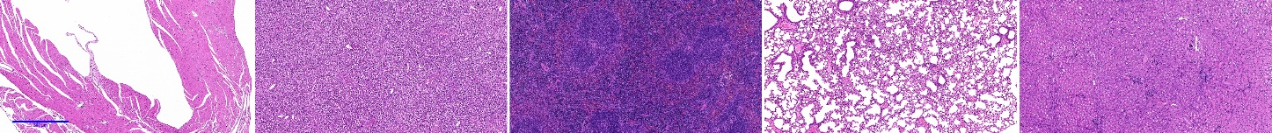
PEG-PE
PBS
Free BTM
BTM@PEG-PE
Heart
Liver
Spleen
Lung
Kidney

Figure S2. H&E-stained tissues after treatment, scale bar = 500 μm .

