Analysis time (hours) | Hydrodynamic diameter of NPs by DLS (nm) |  | Polydispersity index
Analysis time (hours) | Average size | Standard deviation | Average value | Standard deviation
0 | 114 | 2 | 0.127 | 0.013
1 | 127 | 2 | 0.202 | 0.015
2 | 136 | 2 | 0.239 | 0.014
3 | 151 | 3 | 0.314 | 0.022
4 | 180 | 5 | 0.440 | 0.055
5 | 221 | 23 | 0.487 | 0.094
6 | 334 | 35 | 0.548 | 0.091
7 | 426 | 37 | 0.602 | 0.059
8 | 685 | 169 | 0.702 | 0.113
9 | 857 | 251 | 0.716 | 0.090
10 | 1383 | 313 | 0.758 | 0.048
11 | 1573 | 750 | 0.724 | 0.150
12 | 662 | 75 | 0.556 | 0.053
13 | 703 | 171 | 0.596 | 0.113
14 | 1047 | 318 | 0.738 | 0.149
15 | 584 | 110 | 0.590 | 0.069
16 | 606 | 140 | 0.559 | 0.122
17 | 780 | 193 | 0.675 | 0.144
18 | 596 | 140 | 0.609 | 0.170
19 | 583 | 80 | 0.508 | 0.039
20 | 872 | 557 | 0.666 | 0.206
21 | 1043 | 280 | 0.764 | 0.098
22 | 903 | 406 | 0.670 | 0.166
23 | 826 | 243 | 0.646 | 0.156
24 | 900 | 387 | 0.629 | 0.178
Supplementary materials

Table S1. The results of the characterization of a suspension of ZnO NPs in deionised water.

Analysis time (hours) | Hydrodynamic diameter of NPs by DLS (nm) |  | Polydispersity index
Analysis time (hours) | Average size | Standard deviation | Average value | Standard deviation
0 | 118 | 1 | 0.177 | 0.011
1 | 121 | 2 | 0.220 | 0.012
2 | 127 | 4 | 0.257 | 0.030
3 | 138 | 7 | 0.296 | 0.028
4 | 151 | 8 | 0.341 | 0.040
5 | 169 | 11 | 0.436 | 0.059
6 | 209 | 26 | 0.518 | 0.090
7 | 201 | 11 | 0.500 | 0.048
8 | 231 | 19 | 0.492 | 0.071
9 | 633 | 203 | 0.780 | 0.132
10 | 589 | 166 | 0.776 | 0.070
11 | 834 | 262 | 0.732 | 0.128
12 | 1202 | 421 | 0.886 | 0.128
13 | 841 | 258 | 0.664 | 0.099
14 | 1020 | 240 | 0.752 | 0.158
15 | 867 | 330 | 0.701 | 0.222
16 | 633 | 103 | 0.563 | 0.105
17 | 726 | 76 | 0.617 | 0.157
18 | 678 | 138 | 0.590 | 0.118
19 | 596 | 159 | 0.508 | 0.161
20 | 784 | 371 | 0.642 | 0.209
21 | 530 | 68 | 0.590 | 0.103
22 | 584 | 122 | 0.589 | 0.156
23 | 605 | 245 | 0.519 | 0.127
24 | 526 | 80 | 0.458 | 0.084
Table S2. The results of the characterization of a suspension of ZnO+0.1%Ag NPs in deionised water.
Analysis time (hours) | Hydrodynamic diameter of NPs by DLS (nm) |  | Polydispersity index
Analysis time (hours) | Average size | Standard deviation | Average value | Standard deviation
0 | 145 | 1 | 0.197 | 0.015
1 | 146 | 2 | 0.205 | 0.023
2 | 155 | 8 | 0.258 | 0.050
3 | 153 | 3 | 0.257 | 0.019
4 | 164 | 9 | 0.292 | 0.035
5 | 189 | 18 | 0.382 | 0.077
6 | 192 | 12 | 0.438 | 0.080
7 | 225 | 35 | 0.513 | 0.127
8 | 242 | 36 | 0.501 | 0.095
9 | 260 | 37 | 0.534 | 0.081
10 | 256 | 35 | 0.491 | 0.083
11 | 289 | 35 | 0.525 | 0.100
12 | 375 | 71 | 0.557 | 0.066
13 | 363 | 54 | 0.509 | 0.052
14 | 1281 | 527 | 0.774 | 0.170
15 | 1375 | 580 | 0.855 | 0.125
16 | 689 | 153 | 0.683 | 0.092
17 | 557 | 142 | 0.584 | 0.112
18 | 643 | 211 | 0.583 | 0.128
19 | 679 | 155 | 0.590 | 0.070
20 | 1309 | 611 | 0.791 | 0.182
21 | 693 | 228 | 0.586 | 0.159
22 | 754 | 425 | 0.574 | 0.174
23 | 672 | 149 | 0.570 | 0.100
24 | 1198 | 517 | 0.858 | 0.152
Table S3. The results of the characterization of a suspension of ZnO+1%Ag NPs in deionised water.

Analysis time (hours) | Hydrodynamic diameter of NPs by DLS (nm) |  | Polydispersity index
Analysis time (hours) | Average size | Standard deviation | Average value | Standard deviation
0 | 642 | 44 | 0.584 | 0.048
1 | 3110 | 1245 | 0.602 | 0.215
2 | 1464 | 679 | 0.944 | 0.077
3 | 758 | 188 | 0.687 | 0.217
4 | 451 | 112 | 0.677 | 0.246
5 | 1188 | 542 | 0.916 | 0.091
6 | 423 | 249 | 0.793 | 0.127
7 | 503 | 148 | 0.817 | 0.107
8 | 670 | 226 | 0.764 | 0.199
9 | 688 | 317 | 0.636 | 0.172
10 | 539 | 90 | 0.554 | 0.063
11 | 484 | 102 | 0.728 | 0.151
12 | 514 | 169 | 0.592 | 0.124
13 | 375 | 61 | 0.481 | 0.187
14 | 348 | 45 | 0.474 | 0.067
15 | 364 | 36 | 0.462 | 0.087
16 | 362 | 43 | 0.431 | 0.075
17 | 404 | 61 | 0.511 | 0.060
18 | 314 | 26 | 0.434 | 0.087
19 | 343 | 21 | 0.456 | 0.042
20 | 372 | 32 | 0.453 | 0.071
21 | 308 | 17 | 0.459 | 0.049
22 | 301 | 26 | 0.466 | 0.063
23 | 293 | 15 | 0.458 | 0.081
24 | 342 | 31 | 0.481 | 0.044
Table S4. The results of the characterization of a suspension of ZnO+10%Ag NPs in deionised water.

Analysis time (hours) | Hydrodynamic diameter of NPs by DLS (nm) |  | Polydispersity index
Analysis time (hours) | Average size | Standard deviation | Average value | Standard deviation
0 | 239 | 8 | 0.609 | 0.119
1 | 272 | 13 | 0.611 | 0.148
2 | 304 | 38 | 0.620 | 0.159
3 | 330 | 34 | 0.660 | 0.148
4 | 358 | 19 | 0.702 | 0.152
5 | 347 | 36 | 0.737 | 0.088
6 | 352 | 11 | 0.706 | 0.110
7 | 372 | 27 | 0.601 | 0.126
8 | 373 | 28 | 0.657 | 0.107
9 | 379 | 30 | 0.619 | 0.126
10 | 398 | 28 | 0.685 | 0.165
11 | 408 | 21 | 0.694 | 0.082
12 | 423 | 21 | 0.662 | 0.127
13 | 394 | 19 | 0.704 | 0.115
14 | 422 | 65 | 0.640 | 0.126
15 | 431 | 24 | 0.567 | 0.119
16 | 430 | 23 | 0.706 | 0.147
17 | 451 | 31 | 0.633 | 0.136
18 | 434 | 15 | 0.740 | 0.116
19 | 450 | 21 | 0.703 | 0.109
20 | 455 | 23 | 0.627 | 0.127
21 | 463 | 26 | 0.754 | 0.079
22 | 448 | 16 | 0.727 | 0.078
23 | 480 | 56 | 0.694 | 0.095
24 | 466 | 15 | 0.606 | 0.125
Table S5. The results of the characterization of a suspension of Ag NPs in deionised water.

Analysis time (hours) | Hydrodynamic diameter of NPs by DLS (nm) |  | Polydispersity index
Analysis time (hours) | Average size | Standard deviation | Average value | Standard deviation
0 | 1644 | 57 | 0.542 | 0.063
1 | 1889 | 72 | 0.572 | 0.064
2 | 2231 | 134 | 0.548 | 0.059
3 | 2520 | 169 | 0.537 | 0.090
4 | 2584 | 68 | 0.539 | 0.048
5 | 2771 | 157 | 0.519 | 0.089
6 | 2965 | 113 | 0.551 | 0.111
7 | 3047 | 166 | 0.543 | 0.094
8 | 3118 | 93 | 0.537 | 0.077
9 | 3457 | 230 | 0.579 | 0.066
10 | 3478 | 222 | 0.506 | 0.079
11 | 3699 | 613 | 0.541 | 0.087
12 | 3490 | 167 | 0.525 | 0.054
13 | 3718 | 342 | 0.513 | 0.086
14 | 3682 | 909 | 0.481 | 0.090
15 | 3872 | 327 | 0.542 | 0.039
16 | 3758 | 304 | 0.551 | 0.073
17 | 3815 | 202 | 0.547 | 0.085
18 | 3797 | 247 | 0.548 | 0.065
19 | 3887 | 138 | 0.511 | 0.067
20 | 3947 | 139 | 0.553 | 0.077
21 | 4087 | 230 | 0.529 | 0.064
22 | 4043 | 147 | 0.511 | 0.077
23 | 4047 | 243 | 0.562 | 0.115
24 | 900 | 387 | 0.629 | 0.178
Table S6. The results of the characterization of a suspension of ZnO NPs in artificial saliva.

Analysis time (hours) | Hydrodynamic diameter of NPs by DLS (nm) |  | Polydispersity index
Analysis time (hours) | Average size | Standard deviation | Average value | Standard deviation
0 | 1701 | 93 | 0.590 | 0.108
1 | 1860 | 103 | 0.546 | 0.070
2 | 2123 | 79 | 0.572 | 0.071
3 | 2469 | 160 | 0.574 | 0.026
4 | 2525 | 127 | 0.572 | 0.068
5 | 2618 | 107 | 0.579 | 0.058
6 | 2971 | 387 | 0.522 | 0.045
7 | 2853 | 122 | 0.609 | 0.072
8 | 2944 | 88 | 0.539 | 0.078
9 | 3174 | 120 | 0.517 | 0.055
10 | 3383 | 228 | 0.577 | 0.053
11 | 3246 | 196 | 0.540 | 0.105
12 | 3365 | 86 | 0.565 | 0.067
13 | 3475 | 168 | 0.577 | 0.071
14 | 3556 | 269 | 0.524 | 0.077
15 | 3552 | 128 | 0.568 | 0.074
16 | 3666 | 219 | 0.603 | 0.091
17 | 3768 | 146 | 0.554 | 0.050
18 | 3802 | 390 | 0.587 | 0.074
19 | 3810 | 204 | 0.488 | 0.069
20 | 3778 | 138 | 0.541 | 0.037
21 | 3703 | 274 | 0.555 | 0.076
22 | 3976 | 343 | 0.498 | 0.116
23 | 3956 | 296 | 0.581 | 0.075
24 | 3946 | 268 | 0.547 | 0.058
Table S7. The results of the characterization of a suspension of ZnO+0.1%Ag NPs in artificial saliva.

Analysis time (hours) | Hydrodynamic diameter of NPs by DLS (nm) |  | Polydispersity index
Analysis time (hours) | Average size | Standard deviation | Average value | Standard deviation
0 | 2315 | 168 | 0.570 | 0.040
1 | 2599 | 60 | 0.598 | 0.035
2 | 2724 | 148 | 0.590 | 0.076
3 | 3084 | 203 | 0.544 | 0.070
4 | 3224 | 251 | 0.571 | 0.087
5 | 3311 | 164 | 0.554 | 0.057
6 | 3473 | 217 | 0.563 | 0.037
7 | 3567 | 231 | 0.568 | 0.079
8 | 3649 | 187 | 0.554 | 0.034
9 | 3861 | 211 | 0.596 | 0.040
10 | 4035 | 507 | 0.540 | 0.049
11 | 4094 | 291 | 0.519 | 0.093
12 | 4042 | 237 | 0.573 | 0.068
13 | 4377 | 209 | 0.549 | 0.063
14 | 4081 | 390 | 0.569 | 0.064
15 | 4619 | 314 | 0.549 | 0.038
16 | 4377 | 272 | 0.501 | 0.059
17 | 4323 | 236 | 0.557 | 0.063
18 | 4473 | 337 | 0.541 | 0.041
19 | 4356 | 238 | 0.522 | 0.104
20 | 4631 | 270 | 0.571 | 0.043
21 | 4959 | 528 | 0.603 | 0.059
22 | 4608 | 157 | 0.534 | 0.079
23 | 4820 | 244 | 0.537 | 0.074
24 | 4907 | 499 | 0.540 | 0.051
Table S8. The results of the characterization of a suspension of ZnO+1%Ag NPs in artificial saliva.

Analysis time (hours) | Hydrodynamic diameter of NPs by DLS (nm) |  | Polydispersity index
Analysis time (hours) | Average size | Standard deviation | Average value | Standard deviation
0 | 8388 | 1376 | 0.898 | 0.085
1 | 22887 | 4073 | 0.650 | 0.182
2 | 15178 | 7463 | 0.851 | 0.227
3 | 19651 | 7908 | 0.660 | 0.281
4 | 14170 | 5829 | 0.832 | 0.215
5 | 18396 | 6099 | 0.767 | 0.256
6 | 22747 | 6880 | 0.685 | 0.249
7 | 20688 | 6756 | 0.631 | 0.222
8 | 19826 | 8105 | 0.647 | 0.247
9 | 23395 | 5877 | 0.584 | 0.131
10 | 26278 | 5250 | 0.418 | 0.081
11 | 23567 | 1305 | 0.496 | 0.044
12 | 16238 | 4113 | 0.735 | 0.194
13 | 17548 | 8869 | 0.712 | 0.290
14 | 21300 | 4696 | 0.458 | 0.169
15 | 23745 | 3244 | 0.455 | 0.043
16 | 16795 | 5533 | 0.772 | 0.221
17 | 17470 | 6022 | 0.786 | 0.234
18 | 20482 | 3054 | 0.465 | 0.041
19 | 21843 | 2669 | 0.510 | 0.049
20 | 23947 | 3991 | 0.453 | 0.050
21 | 21490 | 4692 | 0.516 | 0.143
22 | 22715 | 2713 | 0.537 | 0.017
23 | 17698 | 6956 | 0.590 | 0.234
24 | 17792 | 2409 | 0.531 | 0.098
Table S9. The results of the characterization of a suspension of ZnO+10%Ag NPs in artificial saliva.

Analysis time (hours) | Hydrodynamic diameter of NPs by DLS (nm) |  | Polydispersity index
Analysis time (hours) | Average size | Standard deviation | Average value | Standard deviation
0 | 2162 | 219 | 0.883 | 0.179
1 | 2386 | 157 | 0.721 | 0.149
2 | 2816 | 245 | 0.802 | 0.164
3 | 3089 | 347 | 0.731 | 0.147
4 | 2988 | 250 | 0.862 | 0.179
5 | 3715 | 322 | 0.667 | 0.171
6 | 4145 | 338 | 0.696 | 0.035
7 | 4055 | 193 | 0.663 | 0.046
8 | 4513 | 325 | 0.622 | 0.055
9 | 4373 | 225 | 0.712 | 0.144
10 | 4177 | 329 | 0.753 | 0.194
11 | 4279 | 290 | 0.650 | 0.030
12 | 4301 | 435 | 0.607 | 0.052
13 | 4184 | 357 | 0.676 | 0.172
14 | 4372 | 470 | 0.725 | 0.095
15 | 4603 | 460 | 0.660 | 0.077
16 | 5041 | 115 | 0.665 | 0.047
17 | 4808 | 571 | 0.722 | 0.165
18 | 4530 | 299 | 0.641 | 0.067
19 | 4744 | 439 | 0.642 | 0.047
20 | 5105 | 368 | 0.719 | 0.049
21 | 5154 | 603 | 0.688 | 0.039
22 | 4820 | 518 | 0.691 | 0.060
23 | 4555 | 408 | 0.632 | 0.090
24 | 4757 | 503 | 0.675 | 0.167
Table S10. The results of the characterization of a suspension of Ag NPs in artificial saliva.

Analysis time (hours) | Hydrodynamic diameter of NPs by DLS (nm) |  | Polydispersity index
Analysis time (hours) | Average size | Standard deviation | Average value | Standard deviation
0 | 379 | 18 | 0.413 | 0.086
1 | 1003 | 124 | 0.799 | 0.092
2 | 949 | 65 | 0.762 | 0.068
3 | 879 | 70 | 0.743 | 0.042
4 | 921 | 121 | 0.762 | 0.116
5 | 802 | 73 | 0.776 | 0.181
6 | 820 | 83 | 0.770 | 0.121
7 | 846 | 69 | 0.674 | 0.051
8 | 885 | 52 | 0.696 | 0.037
9 | 788 | 62 | 0.692 | 0.036
10 | 811 | 58 | 0.733 | 0.100
11 | 781 | 88 | 0.783 | 0.118
12 | 814 | 51 | 0.673 | 0.036
13 | 765 | 72 | 0.753 | 0.125
14 | 1632 | 281 | 1.000 | 0.121
15 | 786 | 64 | 0.697 | 0.018
16 | 766 | 41 | 0.651 | 0.048
17 | 754 | 53 | 0.688 | 0.052
18 | 712 | 41 | 0.661 | 0.058
19 | 747 | 102 | 0.742 | 0.123
20 | 692 | 129 | 0.824 | 0.119
21 | 726 | 49 | 0.707 | 0.099
22 | 715 | 54 | 0.668 | 0.062
23 | 703 | 57 | 0.641 | 0.078
24 | 653 | 80 | 0.713 | 0.060
Table S11. The results of the characterization of a suspension of ZnO NPs in human saliva.

Analysis time (hours) | Hydrodynamic diameter of NPs by DLS (nm) |  | Polydispersity index
Analysis time (hours) | Average size | Standard deviation | Average value | Standard deviation
0 | 341 | 16 | 0.690 | 0.029
1 | 917 | 209 | 0.772 | 0.060
2 | 817 | 116 | 0.799 | 0.102
3 | 928 | 173 | 0.799 | 0.068
4 | 845 | 146 | 0.751 | 0.054
5 | 852 | 154 | 0.775 | 0.067
6 | 926 | 228 | 0.778 | 0.047
7 | 861 | 122 | 0.776 | 0.066
8 | 842 | 106 | 0.759 | 0.065
9 | 853 | 158 | 0.801 | 0.106
10 | 925 | 158 | 0.782 | 0.069
11 | 876 | 71 | 0.766 | 0.037
12 | 804 | 47 | 0.747 | 0.037
13 | 857 | 118 | 0.772 | 0.059
14 | 831 | 86 | 0.745 | 0.051
15 | 843 | 57 | 0.757 | 0.037
16 | 895 | 71 | 0.757 | 0.018
17 | 861 | 124 | 0.747 | 0.044
18 | 836 | 75 | 0.730 | 0.027
19 | 866 | 53 | 0.765 | 0.048
20 | 824 | 105 | 0.710 | 0.048
21 | 882 | 94 | 0.760 | 0.041
22 | 859 | 120 | 0.734 | 0.055
23 | 856 | 25 | 0.757 | 0.026
24 | 839 | 139 | 0.791 | 0.109
Table S12. The results of the characterization of a suspension of ZnO+0.1%Ag NPs in human saliva.

Analysis time (hours) | Hydrodynamic diameter of NPs by DLS (nm) |  | Polydispersity index
Analysis time (hours) | Average size | Standard deviation | Average value | Standard deviation
0 | 367 | 44 | 0.518 | 0.100
1 | 472 | 76 | 0.616 | 0.094
2 | 456 | 55 | 0.641 | 0.084
3 | 474 | 52 | 0.646 | 0.124
4 | 476 | 47 | 0.634 | 0.095
5 | 461 | 46 | 0.658 | 0.090
6 | 477 | 23 | 0.631 | 0.121
7 | 496 | 27 | 0.571 | 0.093
8 | 472 | 27 | 0.653 | 0.101
9 | 490 | 38 | 0.631 | 0.092
10 | 490 | 76 | 0.668 | 0.054
11 | 521 | 43 | 0.662 | 0.127
12 | 486 | 26 | 0.661 | 0.068
13 | 508 | 42 | 0.594 | 0.114
14 | 530 | 46 | 0.589 | 0.088
15 | 506 | 44 | 0.594 | 0.081
16 | 539 | 64 | 0.567 | 0.065
17 | 520 | 37 | 0.618 | 0.095
18 | 537 | 53 | 0.593 | 0.036
19 | 531 | 57 | 0.595 | 0.109
20 | 489 | 40 | 0.695 | 0.135
21 | 523 | 40 | 0.580 | 0.033
22 | 539 | 43 | 0.627 | 0.112
23 | 558 | 31 | 0.544 | 0.027
24 | 537 | 51 | 0.612 | 0.104
Table S13. The results of the characterization of a suspension of ZnO+1%Ag NPs in human saliva.

Analysis time (hours) | Hydrodynamic diameter of NPs by DLS (nm) |  | Polydispersity index
Analysis time (hours) | Average size | Standard deviation | Average value | Standard deviation
0 | 616 | 42 | 0.595 | 0.178
1 | 608 | 78 | 0.585 | 0.038
2 | 568 | 21 | 0.605 | 0.055
3 | 513 | 39 | 0.558 | 0.034
4 | 503 | 24 | 0.562 | 0.054
5 | 499 | 33 | 0.522 | 0.016
6 | 486 | 27 | 0.518 | 0.041
7 | 487 | 26 | 0.500 | 0.052
8 | 470 | 11 | 0.524 | 0.083
9 | 468 | 15 | 0.504 | 0.027
10 | 474 | 10 | 0.509 | 0.024
11 | 449 | 18 | 0.548 | 0.068
12 | 450 | 18 | 0.606 | 0.124
13 | 464 | 21 | 0.511 | 0.080
14 | 465 | 18 | 0.492 | 0.070
15 | 446 | 15 | 0.492 | 0.050
16 | 453 | 14 | 0.542 | 0.089
17 | 450 | 17 | 0.515 | 0.081
18 | 467 | 15 | 0.498 | 0.087
19 | 466 | 19 | 0.525 | 0.048
20 | 448 | 13 | 0.557 | 0.073
21 | 461 | 22 | 0.496 | 0.064
22 | 461 | 18 | 0.520 | 0.095
23 | 462 | 20 | 0.500 | 0.051
24 | 450 | 24 | 0.545 | 0.080
Table S14. The results of the characterization of a suspension of ZnO+10%Ag NPs in human saliva.

Analysis time (hours) | Hydrodynamic diameter of NPs by DLS (nm) |  | Polydispersity index
Analysis time (hours) | Average size | Standard deviation | Average value | Standard deviation
0 | 531 | 84 | 0.583 | 0.116
1 | 409 | 16 | 0.369 | 0.031
2 | 398 | 18 | 0.376 | 0.039
3 | 389 | 13 | 0.369 | 0.035
4 | 401 | 9 | 0.365 | 0.026
5 | 396 | 4 | 0.345 | 0.026
6 | 398 | 9 | 0.368 | 0.039
7 | 399 | 11 | 0.377 | 0.056
8 | 406 | 7 | 0.371 | 0.022
9 | 414 | 11 | 0.363 | 0.017
10 | 403 | 10 | 0.402 | 0.054
11 | 400 | 10 | 0.392 | 0.048
12 | 409 | 8 | 0.403 | 0.059
13 | 409 | 9 | 0.413 | 0.046
14 | 410 | 20 | 0.383 | 0.037
15 | 402 | 11 | 0.391 | 0.040
16 | 401 | 7 | 0.365 | 0.029
17 | 404 | 13 | 0.372 | 0.018
18 | 389 | 10 | 0.372 | 0.046
19 | 388 | 11 | 0.352 | 0.004
20 | 383 | 9 | 0.344 | 0.021
21 | 374 | 8 | 0.343 | 0.019
22 | 366 | 4 | 0.354 | 0.043
23 | 358 | 9 | 0.362 | 0.023
24 | 359 | 9 | 0.337 | 0.022
Table S15. The results of the characterization of a suspension of Ag NPs in human saliva.

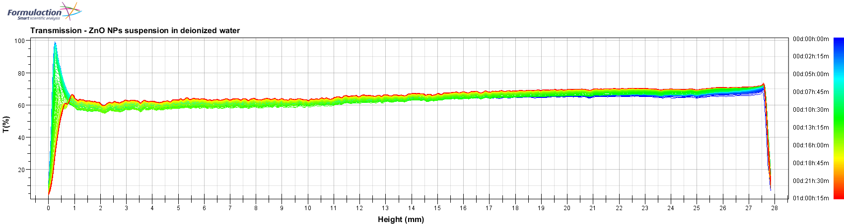
Figure S1. Transmission profile of ZnO NPs suspension in deionised water.
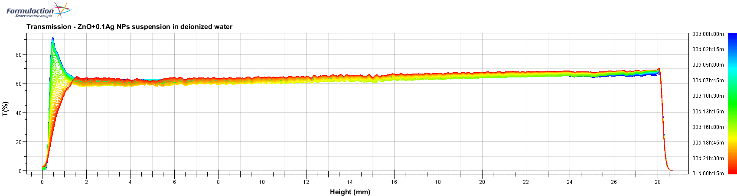
Figure S2. Transmission profile of ZnO+0.1%Ag NPs suspension in deionised water.
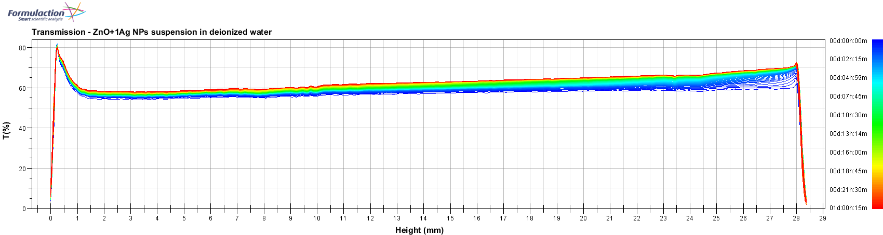
Figure S3. Transmission profile of ZnO+1%Ag NPs suspension in deionised water.

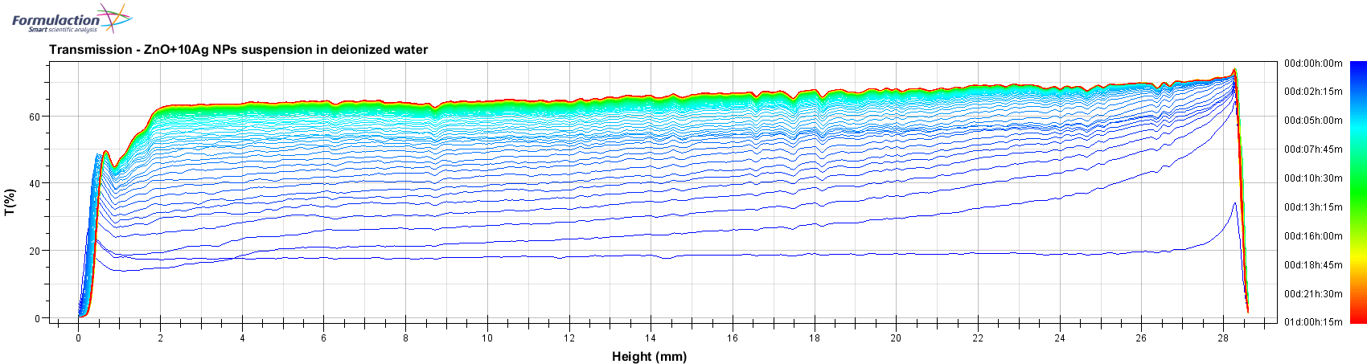
Figure S4. Transmission profile of ZnO+10%Ag NPs suspension in deionised water.

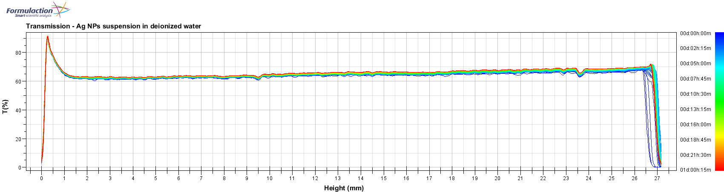
Figure S5. Transmission profile of Ag NPs suspension in deionised water.

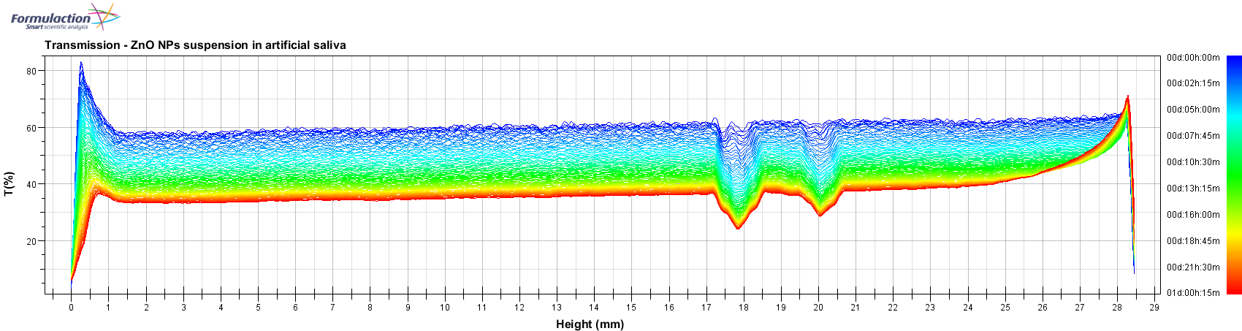
Figure S6. Transmission profile of ZnO NPs suspension in artificial saliva.

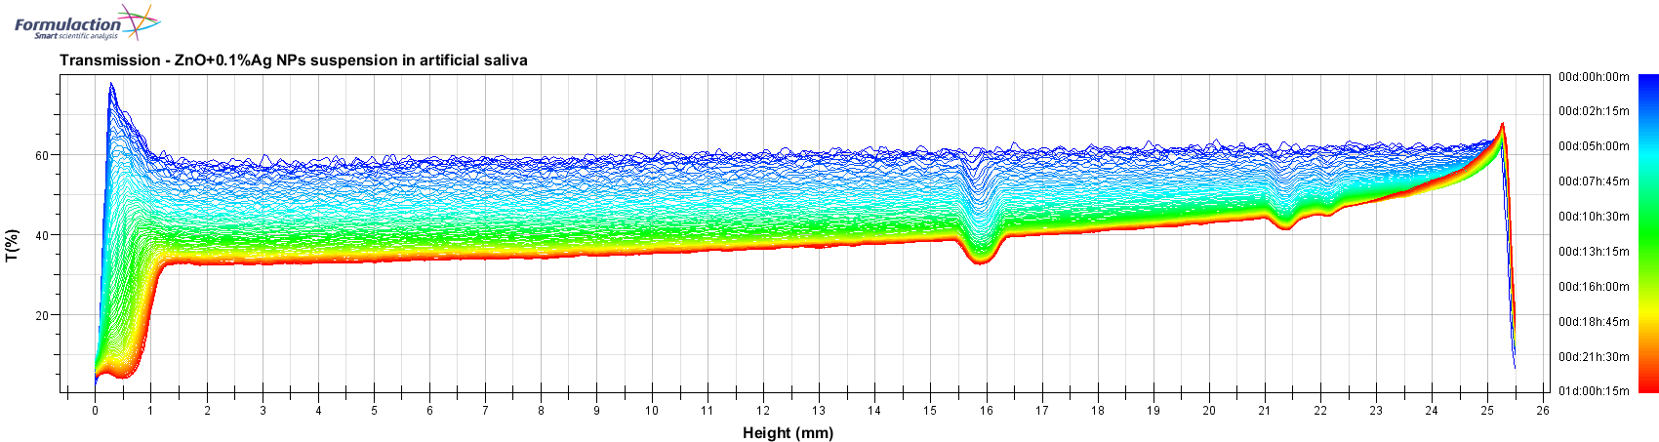
Figure S7. Transmission profiles of ZnO+0.1%Ag NPs suspension in artificial saliva.

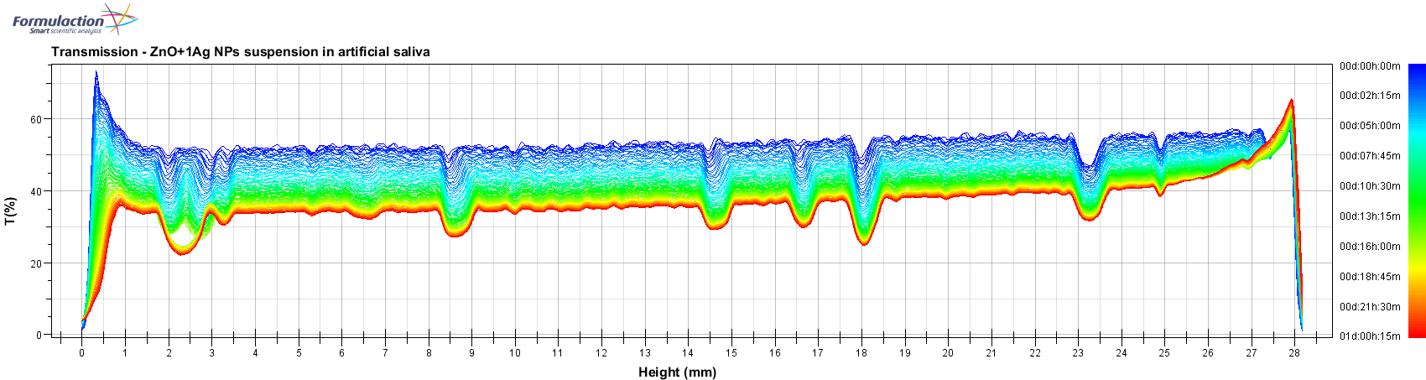
Figure S8. Transmission profile of ZnO+1%Ag NPs suspension in artificial saliva.
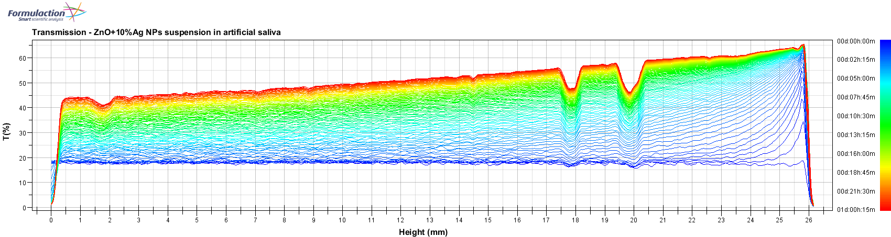
Figure S9. Transmission profile of ZnO+10%Ag NPs suspension in artificial saliva.

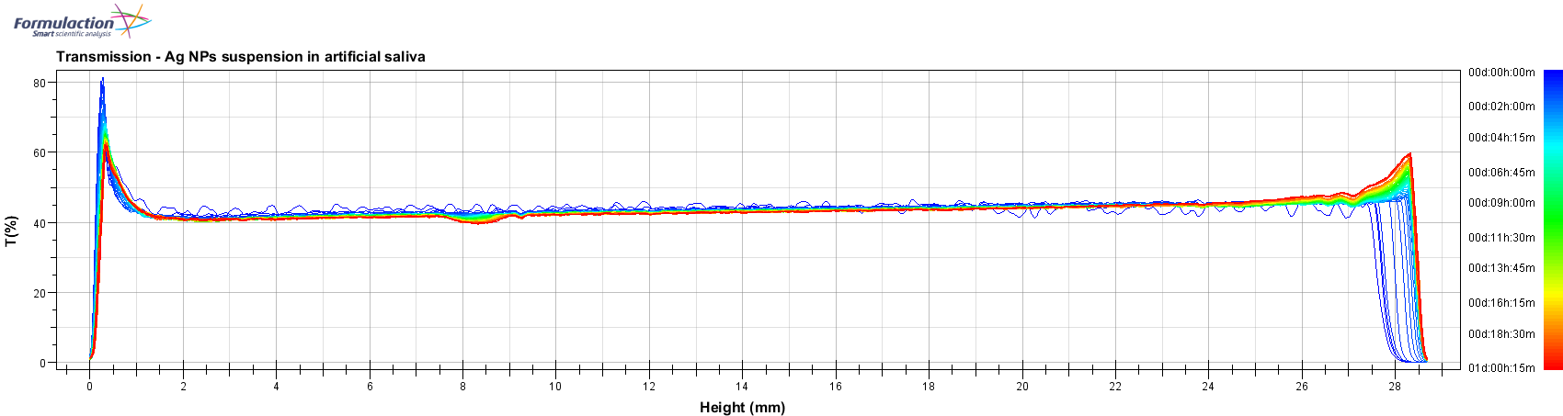
Figure S10. Transmission profile of Ag NPs suspension in artificial saliva.

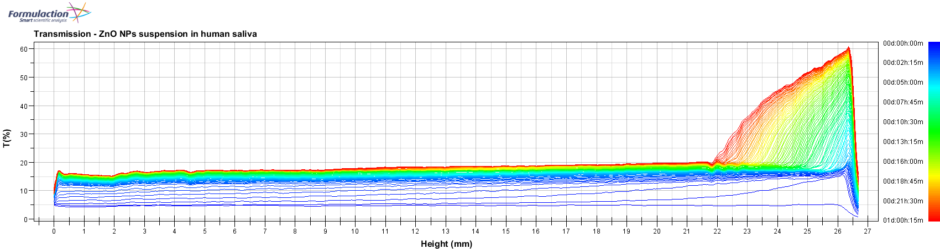
Figures S11. Transmission profile of ZnO NPs suspension in human saliva.

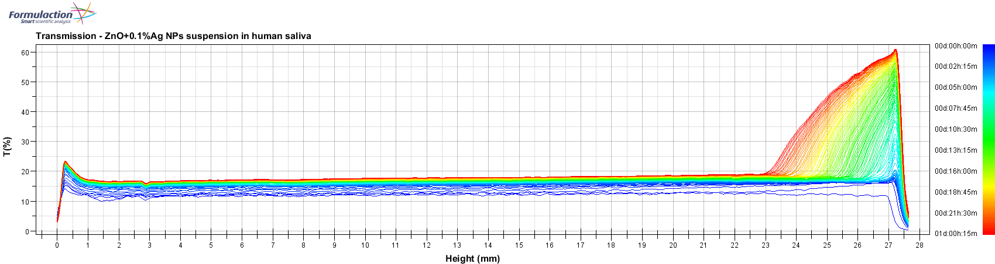
Figures S12. Transmission profile of ZnO+0.1%Ag NPs suspension in human saliva.

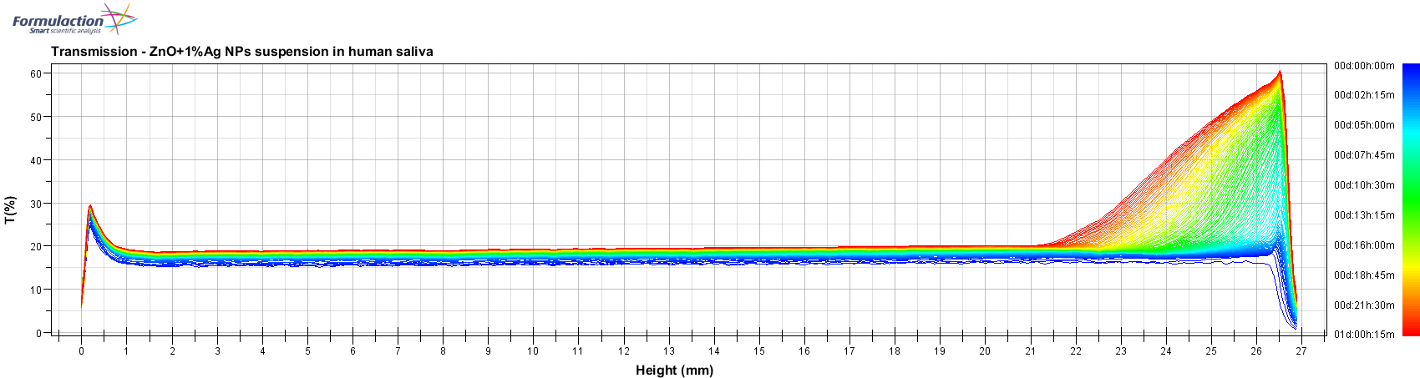
Figure S13. Transmission profile of ZnO+1%Ag NPs suspension in human saliva.

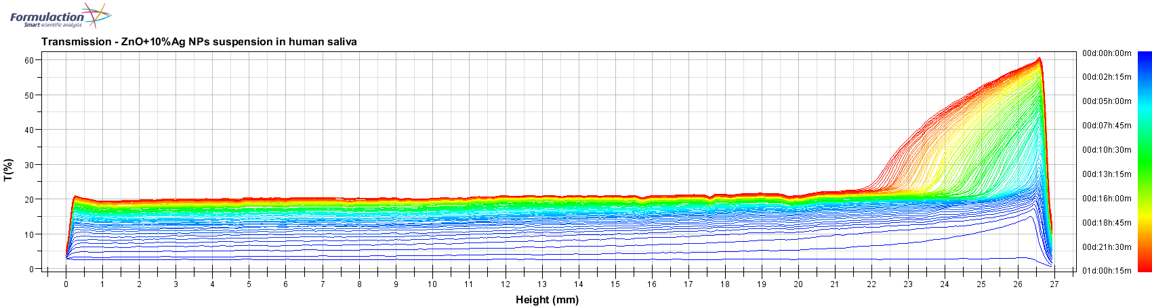
Figure S14. Transmission profile of ZnO+10%Ag NPs suspension in human saliva.

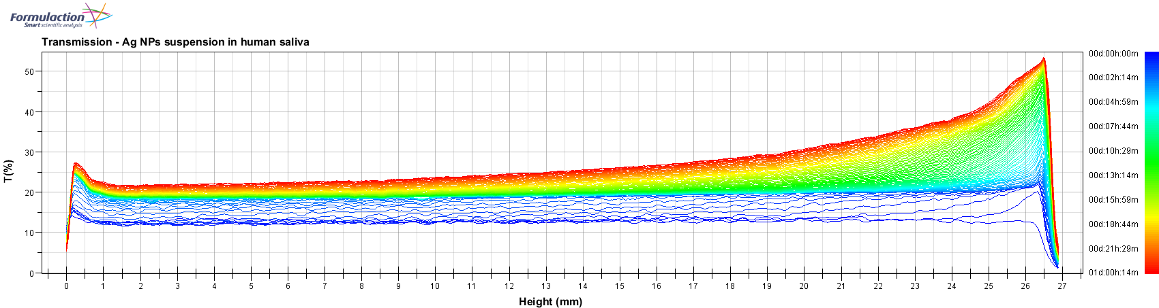
Figure S15. Transmission profile of Ag NPs suspension in human saliva.

