Supplementary material

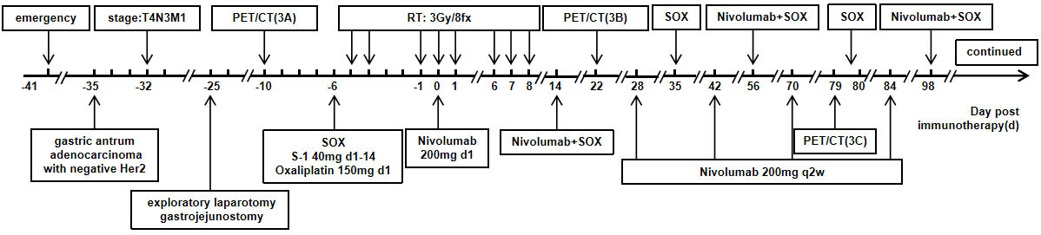

Supplemental Figure 1. The timeline of the patient’s treatments and the duration of each treatment.
Notes: SOX chemotherapy: S-1 40mg d1-14+Oxaliplatin 150mg d1 q3w; Nivolumab 200mg d1q2w; Radiotherapy (RT): 3Gy/8fx; All treatments were performed simultaneously. Six rounds of SOX chemotherapy were completed, followed by the maintenance of immune monotherapy.

