Supplementary data

Single-factor optimization of pRL preparation

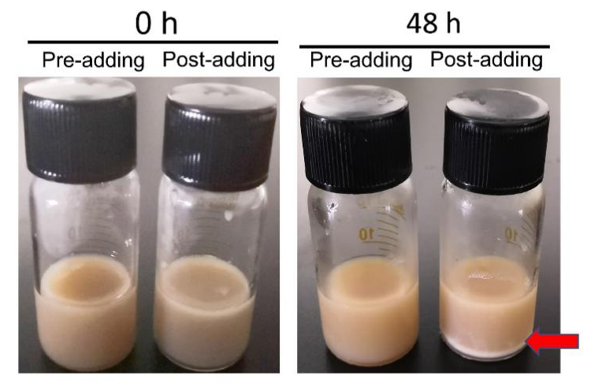
Figure S1. Comparison of the stability of pRL made with different adding method of DSPE-PEG₂₀₀₀ (In pre-adding method, DSPE-PEG₂₀₀₀ was mixed with lipid and cholesterol and then dissolved in organic solvent. While in post-adding method, DSPE-PEG₂₀₀₀ was added after the lipid nanoparticle was prepared. The encapsulation efficiency of pRL made with pre-adding method was 83.07±6.37%, while pRL made with post-adding method was 64.03±4.92%. After 48h the pre-adding one showed better stability compared with the post-adding one. )

Fig. S2 Effect of different molar ratio of lipid to cholesterol on Encapsulation Efficiency and Loading Efficiency of pRL (The highest encapsulation efficiency and loading efficiency were get when the molar ratio of lipid to cholesterol was 6:1.)

Fig. S3 Effect of different doses of DSPE-PEG₂₀₀₀ on Encapsulation Efficiency and Loading Efficiency of pRL (The highest encapsulation efficiency and loading efficiency were get when 5% of the DSPE-PEG₂₀₀₀ was added.)

Fig. S4 Effect of different weight ratio of lipid to drug on Encapsulation Efficiency and Loading Efficiency of PEG-RGPL (The highest encapsulation efficiency and loading efficiency were get when lipid to drug was 10:1.)

Fig. S5 Effect of sonication time on Encapsulation Efficiency and Loading Efficiency of PEG-RGPL (There were no significant changes among different sonication time. The sonication time was just fixed at 2 min.)

Fig. S6 Effect of rotary evaporation temperature on Encapsulation Efficiency and Loading Efficiency of PEG-RGPL (There were no significant changes among different temperature. The temperature was just fixed at 40℃)

