SUPPLEMENTARY MATERIALS
Supplemental Methods

Nanoparticle characterization
Size exclusion chromatography (SEC): SEC analyses were performed using a Shimadzu modular system comprising an SIL-20AD auto-injector, a PLgel 10 µm bead-size guard column (50 x 7.8 mm) followed by three 300 x 7.8 mm linear Shodex KF805L columns, an RID-10A differential refractive-index and SPD-20A UV-Vis detector. N,N-dimethylacetamide [DMAc; w/v LiBr, 0.05% 2, 7-di-butyl-4-methylphenol (BHT)] at 40°C was used as the eluent (flow rate = 1 mL/min). Samples were filtered through 0.45 μm PTFE filters before injection. Calibration was performed with narrow-polydispersity polystyrene standards ranging from 500 to 3 × 106 g/mol.
Nuclear Magnetic Resonance (NMR) Spectroscopy: 1H NMR spectroscopy using a Bruker UltraShield 400 MHz spectrometer (Bruker Daltronics Inc., NSW, Australia) running Topspin, version 1.3. All spectra were recorded in CDCl3.
Dynamic Light Scattering (DLS): DLS measurements were performed using a Malvern Zetasizer Nano Series running DLS software and operating a 4 mW He-Ne laser at 633 nm. Analysis was performed at an angle of 173° and a constant temperature of 25 °C. Stars were measured prior to labelling with Cyanine 5 due to the labelled particles having a strong absorbance at the laser wavelength. For mixed composition stars the total number of moles of arms was kept constant at 0.05 mmol, and the relative amounts of each arm based on desired composition and individual molecular weights was varied. All other details were kept constant.

Supplementary Figures

Figure S1. ¹H NMR spectrum of POEGA-BSPA arm polymer recorded in CDCl₃ (400 MHz). The inset in the Figure is the chemical structure of the synthesized polymer. The red letters identify the protons in the structure and the corresponding peaks in the 1H NMR spectrum.

Figure S2. ¹H NMR spectrum of POEGA-PDS arm polymer recorded in CDCl₃ (400 MHz). The inset in the Figure is the chemical structure of the synthesized polymer. The red letters identify the protons in the structure and the corresponding peaks in the 1H NMR spectrum.

Figure S3. ¹H NMR spectrum of core-crosslinked POEGA stars (‘Star-OEGA-Bz’) formed using POEGA-BSPA linear arm. The stars have unreactive benzyl moieties at the star periphery. Four-armed stars are shown for simplicity. The spectrum was recorded in (CD₃)₂CO (400 MHz). The inset in the Figure is the chemical structure of the synthesized polymer. The red letters identify the protons in the structure and the corresponding peaks in the 1H NMR spectrum.

Figure S4. ¹H NMR spectrum of core-crosslinked POEGA stars (‘Star-OEGA-PDS’) formed using POEGA-PDS linear arm. The stars have thiol-reactive pyridyl disulfide moieties at the star periphery. Four-armed stars are shown for simplicity. The spectrum was recorded in (CD₃)₂CO (400 MHz). The inset in the Figure is the chemical structure of the synthesized polymer. The red letters identify the protons in the structure and the corresponding peaks in the 1H NMR spectrum.

Figure S5. Size exclusion chromatographs of Star-OEGA-Bz with dual UV-vis/RI detection. Co-elution demonstrates effective labelling of the polymers with Cyanine5. The small shift arises from the detectors being installed in series.
Figure S6. ¹H NMR spectrum of PDEGA-PDS arm polymer recorded in CDCl₃ (400 MHz). The inset in the Figure is the chemical structure of the synthesized polymer. The red letters identify the protons in the structure and the corresponding peaks in the 1H NMR spectrum.

Figure S7. ¹H NMR spectrum of core-crosslinked POEGA-PDEGA stars (‘Star-OEGA/DEGA-PDS’) formed using a mixture of POEGA-BSPA and PDEGA-PDS linear arms. The stars have thiol-reactive pyridyl disulfide moieties on the end of the PDEGA arms and unreactive benzyl groups on the end of the POEGA arms. Four-armed stars are shown for simplicity. The spectrum was recorded in (CD₃)₂CO (400 MHz). The inset in the Figure is the chemical structure of the synthesized polymer. The red letters identify the protons in the structure and the corresponding peaks in the 1H NMR spectrum.

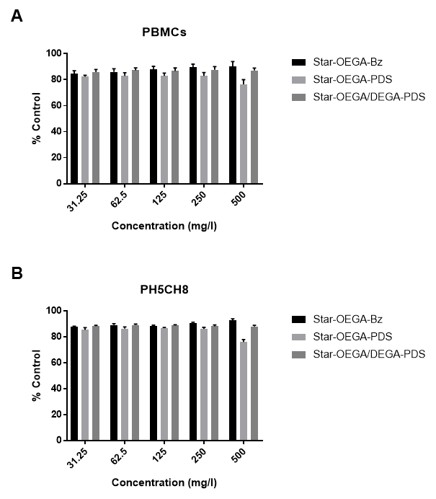
Figure S8. The effect of star polymers on non-malignant human cells. Normal human PBMCs (A) and clonal hepatocytes (PH5CH8) (B) were exposed to the star polymers for 24 hours across a range of concentrations. Cell viability was measured using Alamar Blue assay and the error bars represent mean ± SEM of 3 independent replicates.

Figure S9. Cellular association of star polymers. The thiol reactive star polymers A) Star-OEGA/DEGA-PDS and B) Star-OEGA-PDS displayed enhance association with B-ALL compared to T-ALL PDXs. C) Control star polymers Star-OEGA-Bz displayed similar association with B-ALL and T-ALL PDXs. The PDXs were incubated with the star polymers at 10 mg/l at 37 °C for 30 minutes. Free star polymers were washed and cell association with Cy5-labeled star polymers was determined by flow cytometry and represented by a median fluorescence index (MFI). * p < 0.05.

Figure S10. Confocal microscopy analysis of cellular uptake of star polymers. Nalm-6 and Jurkat cells were treated with endocytosis inhibitors before exposure to the star polymers (10 mg/l for 30 minutes). Endocytosis was blocked in Jurkat cell lines by treatment with Nystatin, Pitstop2 and Dyngo4a indicating dynamin dependent clathrin-mediate endocytosis. In Nalm-6 cell lines endocytosis was blocked by cellular treatment with Wortmannin, Nystatin, Pitstop2 and Dyngo4a indicating dynamin dependent clathrin-mediate endocytosis. Methyl-β-cyclodextrin (MβCD)

