Supplemental Tables and Figure Legend:

Supplemental Table 1: Repeatability of BDR testing 2-6 weeks after the initial

Metric | Repeatedly positive BDR N (%) | Repeatedly negative BDR N, (%) | Variable BDR N, (%) | Repeatability (%) | Kappa, k
FVC | 35 (35.7) | 40 (40.8) | 23 (23.5) | 76.5 | 0.53
FEV₁ | 25 (25.5) | 46 (46.9) | 27 (27.6) | 72.4 | 0.43
IC | 23 (23.5) | 40 (40.8) | 35 (35.8) | 64.3 | 0.27

Supplemental Table 2: Univariate and multivariate analysis of BDR_{FVC} as a risk factor associated with exacerbations
Univariate Negative Binomial model for COPD exacerbations
Label | RR | Lower_95CI | Upper_95CI | P-value
FVC-BD responders vs. FVC-BD non-responders | 1.456 | 1.018 | 2.083 | 0.039524
Multivariate Negative Binomial model for COPD exacerbations
Label | RR | Lower_95CI | Upper_95CI | P-value
FVC-BD responders vs. FVC-BD non-responders | 1.025 | 0.712 | 1.479 | 0.89111
Post-BD FEV₁ PCT (every 10% increase) | 0.714 | 0.644 | 0.791 | <0.00001
Age (every 10 years increase) | 1.684 | 1.304 | 2.175 | 0.00006
Use of inhaled bronchodilators | 1.752 | 1.021 | 3.007 | 0.04173

Supplemental Table 3: Univariate and multivariate analysis of isolated BDR_{FVC} as a risk factor associated with overall survival

Univariate Cox proportional hazards model
Label | HR | Lower_95CI | Upper_95CI | P value
Isolated FVC-BD responders vs. *Others | 1.707 | 1.092 | 2.670 | 0.019102
Multivariate Cox proportional hazards model
Label | HR | Lower_95CI | Upper_95CI | P value
Isolated FVC-BD responders vs. *Others | 0.888 | 0.556 | 1.418 | 0.62007
Post-BD FEV₁ PCT (every 10% increase) | 0.708 | 0.637 | 0.787 | <0.00001
Age (every 10 years increase) | 1.687 | 1.307 | 2.179 | 0.00006
Use of inhaled bronchodilators | 1.747 | 1.018 | 2.999 | 0.04277

*Others are composed of individuals with COPD who show no BDR, who show isolated BDR_{FEV1} or who show dual BDR_{FEV1}/BDR_{FVC}

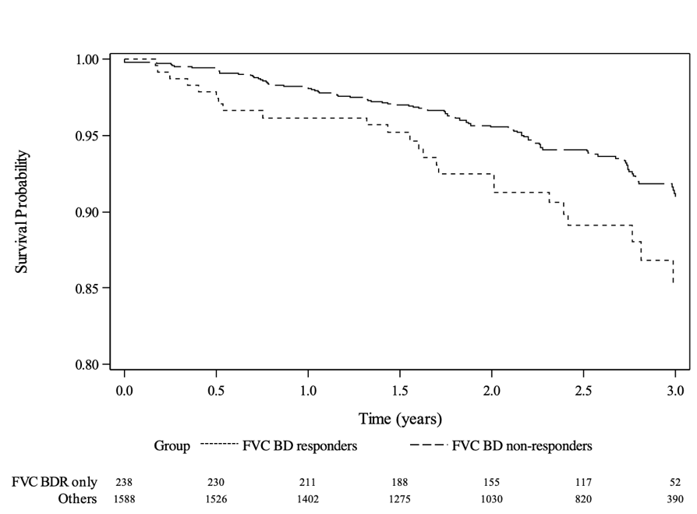

Supplemental Figure 1: Kaplan-Meier plot of overall survival up to 3 years: subjects who demonstrated BDR_{FVC} but not BDR_{FEV1} have lower survival relative to other COPD participants (85.4% vs. 91.0% respectively, P<0.05)

