Supplementary Material

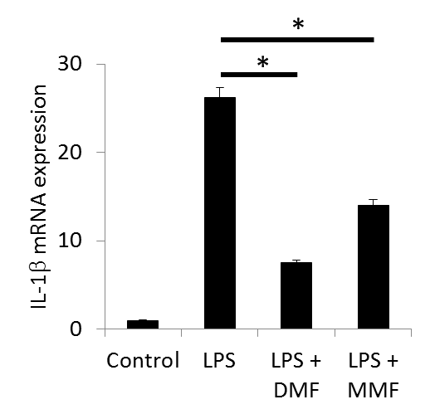
Supplementary Figure 1. DMF or MMF inhibits LPS-induced the expression of IL-1β mRNA in U937 cells. ∗P values <0.01 compare the mRNA expression in LPS-activated cells vs. those incubate with LPS in addition to DMF or MMF.

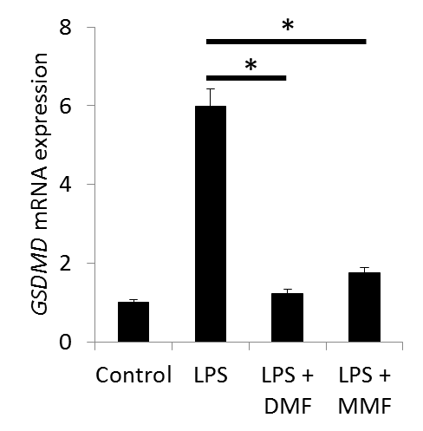
Supplementary Figure 2. RT-PCR data showing the mRNA expression of GSDMD gene expression in U937 cells. Cells were either left untreated (Control), treated with 10 μg/ml LPS or LPS plus 100 μM of either DMF or MMF in the presence of 200 IU/ml IL-2. ∗P<0.01 comparing the gene expression of GSDMD in the presence of LPS vs. in the presence of LPS plus DMF or MMF

