Supporting Information

Title: A Dual-Modality MR/PA Imaging Contrast Agent Based on Ultrasmall Biopolymer Nanoparticles for Orthotopic Hepatocellular Carcinoma Imaging
Jinghua Sun^{a,b}, Xiaoyan Li^{b}, Anqi Chen^{b}, Wenwen Cai^{b}, Xiaoyang Pengª, Liping Li^{c}, Bo Fan^{c}, Lingjie Wang^{b}, Huanhu Zhang^{d} and Ruiping Zhang*^{b}

ª Center for Translational Medicine Research, Shanxi Medical University, Taiyuan 030001, China
^{b} Imaging Department, The Affiliated Bethune Hospital of Shanxi Medical University; Imaging Department of Shanxi Medical University, Taiyuan 030032, China
^{c} Shanxi Medical University, Taiyuan 030001, China
^{d} The Affiliated Tumor Hospital of Shanxi Medical University, Taiyuan 030013, China
*E-mail: zrp_7142@sxmu.edu.cn.
Jinghua Sun, Xiaoyan Li and Anqi Chen were contributed equally to this work.

Figure S1. MALDI-TOF MS of melanin nanoparticles.

Figure S2. Fluorescence spectra of FITC and FITC-labeled MPGds, suggesting the successfully labeling of FITC.

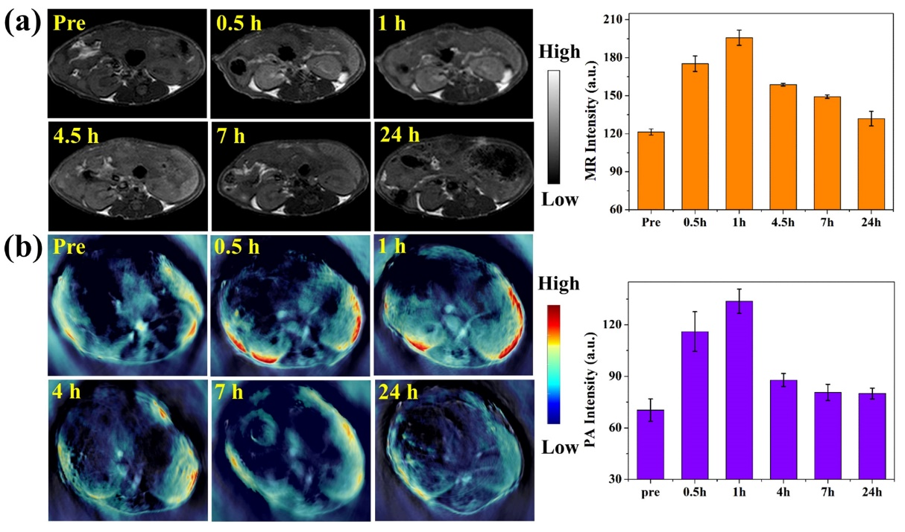
Figure S3. (a) T₁-weighted MR axial images and the corresponding data analysis of MR measurements of mice before (pre) and at various time points (0.5 h, 1 h, 4.5 h, 7 h and 24 h) after injection of MPGds. (b) PA images and the corresponding PA signal intensities in kidney collected by MOST imaging system before (pre) and at various time points (0.5 h, 1 h, 4 h, 7 h and 24 h) after injection of MPGds. Error bars mean standard deviations (n = 4).

