Supplementary information
cRGDfK-grafted small-size quercetin micelles for enhancing therapy efficacy of active ingredient from the Chinese medicinal herb
Pengcheng Xu¹, Haisheng Wan³, Hongxiang Hu², Yong Ye⁴, Yu Dong¹, Suxin Li², Dong Mei², Zhaoming Guo², Dan Wang², Yanxue Sun¹, Tengfei Yu¹, Junchan Qiao¹ and Qiang Zhang^{2*}
1.Department of pharmaceutical Engineering, College of Pharmacy, Inner Mongolia Medical University, Hohhot 010110, china.
2.Beijing Key Laboratory of Molecular Pharmaceutics and New Drug Delivery Systems, Department of pharmaceutics, School of Pharmaceutical Sciences, Peking University, Beijing 100191, China.
3.Department of Biochemistry, College of Basic Medical Sciences, Inner Mongolia Medical University, Hohhot 010110, china.
4. Department of pharmaceutics, College of Pharmacy, Guangxi Medical University, Nanning, 530021, China.

Fig S1.Synthesis scheme for cRGDfK-PEG-DSPE

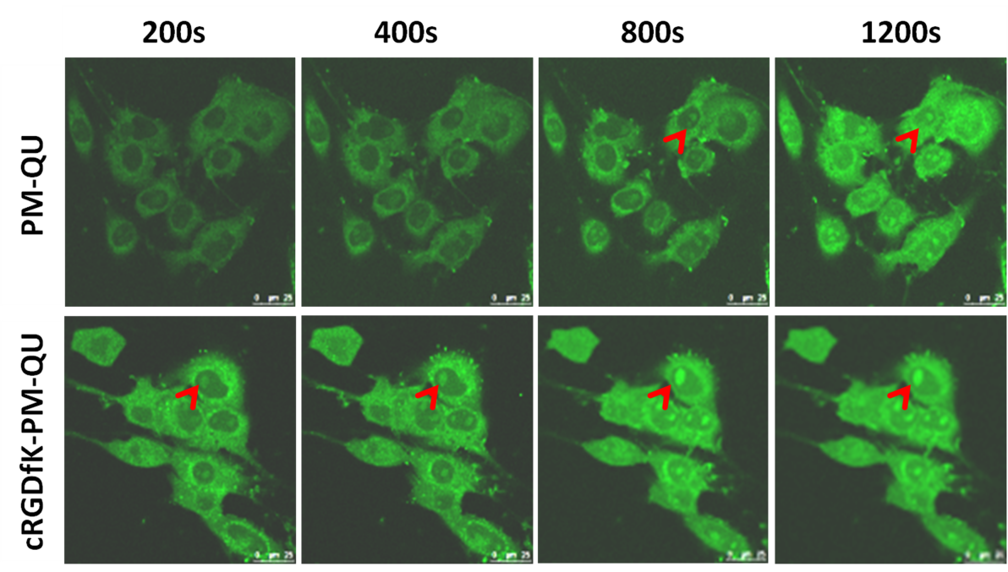
Fig S2. Quercetin distributed not only in the cytoplasm, but also in the nucleus (red arrow indicate that quercetin enter nucleolus)

