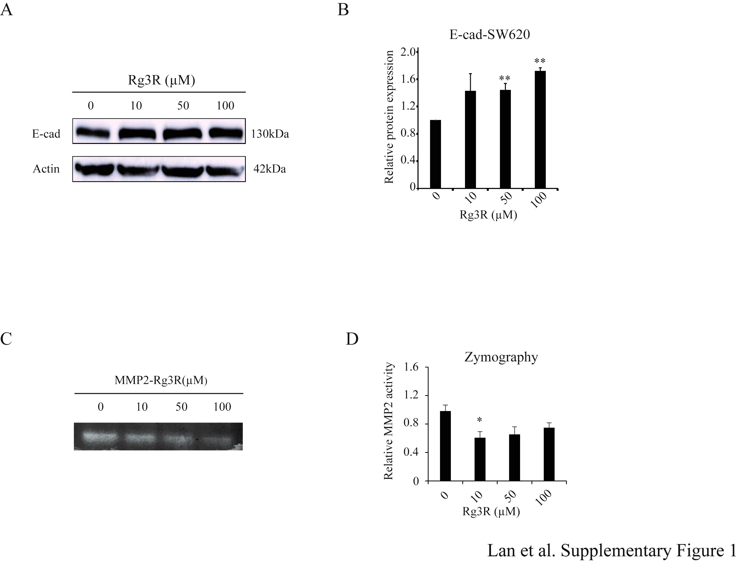
Supplementary Figure 1. Effect of ginsenoside Rg3R on MMP2 activity in CRC cells.
(A and B) SW620 cells were treated with ginsenoside Rg3R, and the protein levels of E-cad was determined by western blotting. ACTIN was used as a loading control. Representative images was shown (A). Values represent the relative densities of the blotting bands normalized to ACTIN (B). Data were presented as the mean ± SEM of three independent experiments (*, P< 0.05; **, P< 0.01). (C and D) MMP2 activity in SW620 cells after ginsenoside Rg3R treatment in serum-free media was detected by gelatin zymography analysis. ACTIN was used as a loading control. Values represent the relative density of the blotting bands normalized to ACTIN. The statistical analysis is shown (*, P< 0.05; **, P< 0.01). Data were presented as the mean ± SEM of three independent experiments

Supplementary Table 1. Primers used for realtime qPCR

B2M-F | TGAAGCTGACAGCATTCGG
B2M-R | CTGCTGGATGACGTGAGTAAA
EGFR-F | GCCAAGGCACGAGTAACAAGC
EGFR-R | AGGGCAATGAGGACATAACC
SNAIL-F | CTGGGTGCCCTCAAGATGCA
SNAIL-R | CCGGACATGGCCTTGTAGCA
SOX2-F | CCTTCTTCATGAGCGTCTTG
SOX2-R | GATGCACAACTCGGAGATC
NANOG-F | AGAAGGCCTCAGCACCTA
NANOG-R | GGCCTGATTGTTCCAGGA
OCT4-F | ACATCAAAGCTCTGCAGAAAGAAC
OCT4-R | CTGAATACCTTCCCAAATAGAACCC
MMP2-F | CGCTCAGATCCGTGGTGA
MMP2-R | CGCCAAATGAACCGGTCCTT

