Supplemetary materials

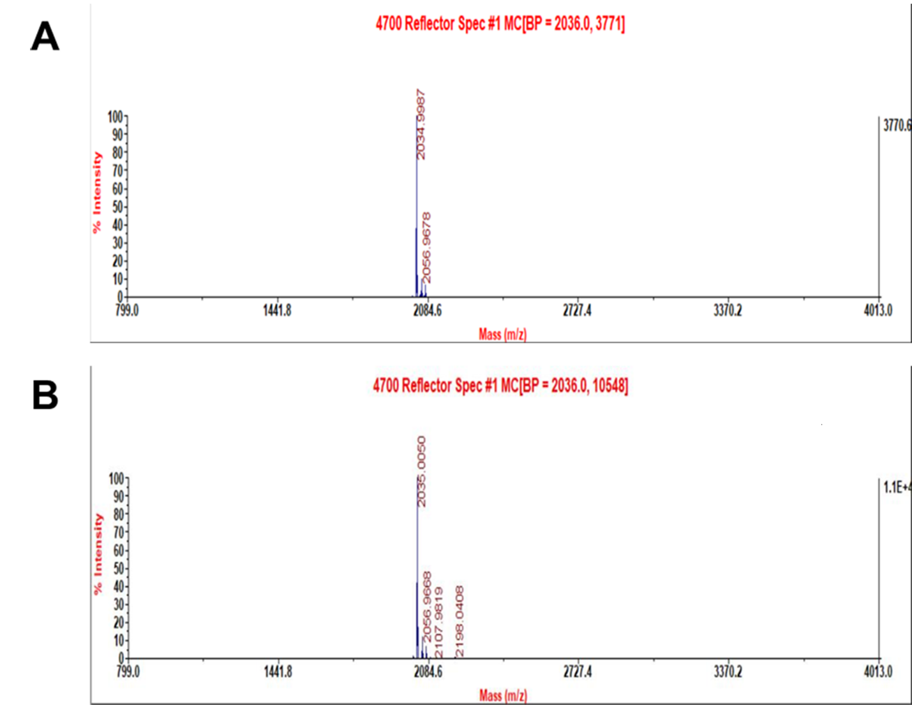
Figure S1. Mass spectra of purified peptides. Molecular weight of HPRP-A1 (A) and HPRP-A2 (B) is 2035 Dolton.

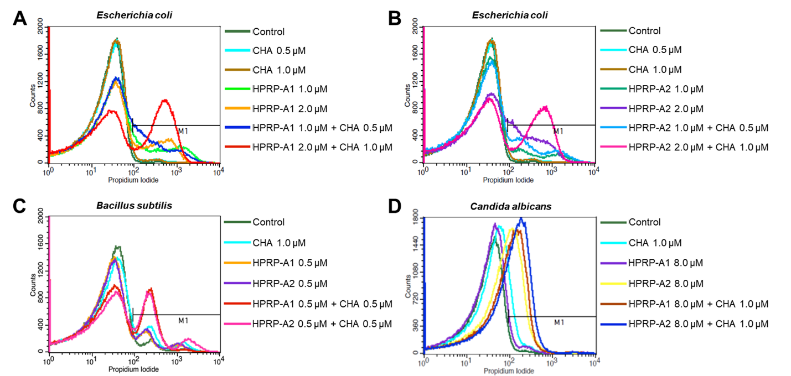
Figure S2. FACS Analysis. LB medium (A, B, C)/SD (D) broth medium (Control). (A) HPRP-A1 (1.0 μM) and/or CHA (0.5μM), HPRP-A1 (2.0 μM) and/or CHA (1.0μM) against E. coli; (B) HPRP-A2 (1.0 μM) and/or CHA (0.5 μM), HPRP-A1 (2.0 μM) and/or CHA (1.0μM) against E. coli; (C) HPRP-A1/HPRP-A2 (0.5μM) and/or CHA (0.5 μM) against B. subtilis; (D) HPRP-A1 (8.0 μM), HPRP-A2 (8.0 μM) and/or CHA (1.0 μM) against C. albicans. Bacterial or fungal cells were incubated for 1 h at 37 °C, followed by 15 min incubation with PI, and analysis by FACS.
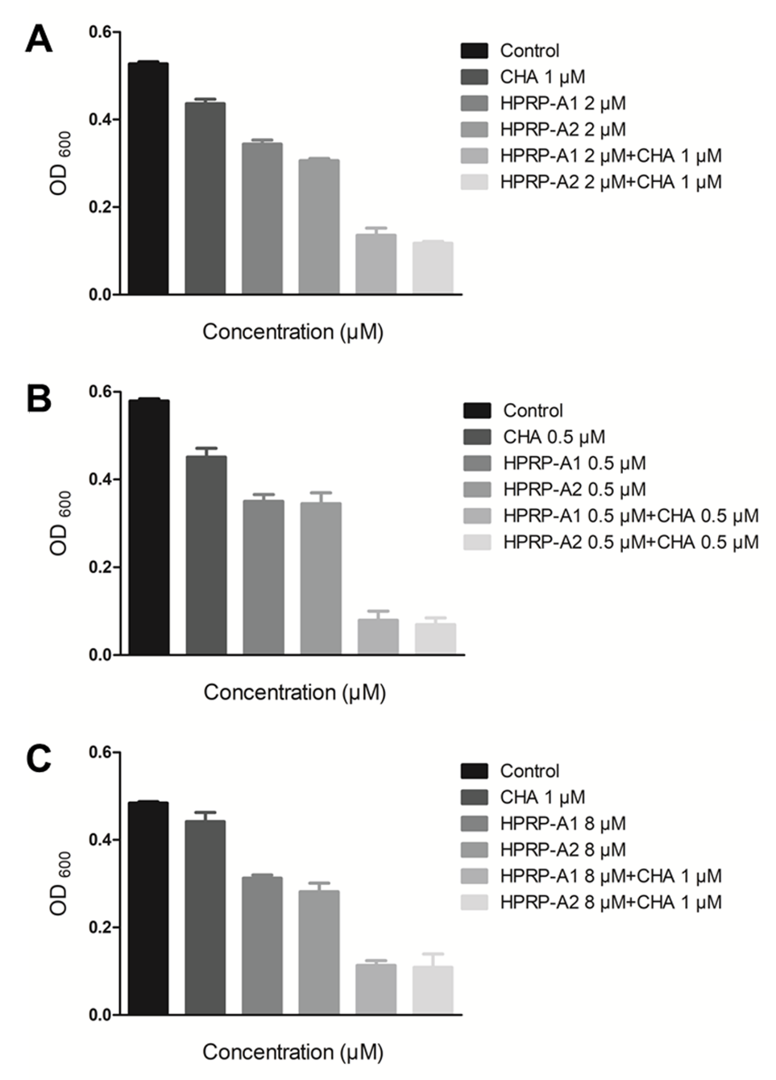
Figure S3. Evaluated by turbidity method analysis. Antibacterial effect of HPRP-A1, HPRP-A2 and/or CHA on the growth of (A) E. coli ATCC25922, (B) B. subtilis ATCC6633, (C) C.albicans JLC30364. Bacteria and fungi of incubated with synergistic concentrations of HPRP-A1, HPRP-A2 and CHA were grown overnight at 37 °C or 35 °C in 96-well microtiter plates. Absorbance is optical density (OD) 600.

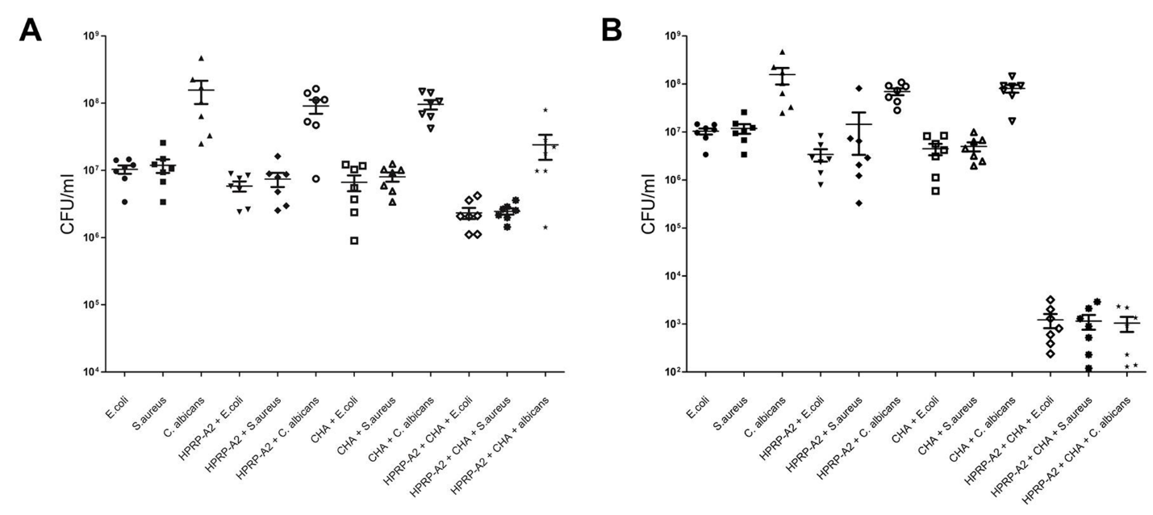

Figure S4. Inhibition of mice and rats’ bacteria. (A) Low dosage group, HPRP-A2 (0.5 mg/ml) + CHA (0.02 mg/ml) (B) high dosage group, HPRP-A2 (1.0 mg/ml) + CHA (0.3 mg/ml). Statistics of 7 groups, each of the groups treated for 8 days, then the bacterial count was measured by spread plate method. According to the formula: CFU_{i} = CFU_{c}–CFU_{d}, CFU_{i} is the number of bacteria inhibited, CFU_{d} is the number of bacterial colonies in the drug treatment group, CFU_{c} is the number of bacterial colonies in the control group.

