Supplementary data

In Vitro Synergism Calculation.
The combination index (CI) for the viability of cells equal to 50% were calculated from the CI equation:
$$\text{CI }\text{= }\frac{{\left(\text{D}\right)}_{\text{1}}}{{\text{(Dx)}}_{\text{1}}}\text{+}\frac{{\left(\text{D}\right)}_{\text{2}}}{{\left(\text{Dx}\right)}_{\text{2}}}$$
The effect of drug combinations could be additive (CI = 1), synergistic (CI < 1), or antagonistic (CI > 1). where (Dx)₁ and (Dx)₂ are doses of drug 1 and 2 alone inhibiting cell growth to 50%, and (D)₁ and (D)₂ are doses of drug 1 and 2 in combination having the same inhibition effect.
When the inhibition of cell growth is 50%, the dosage of PTX is about 8.1 μg mL⁻¹ (PTX group) and the dosage of MPDA-PEG nanoparticles is about 56 μg mL⁻¹ (MPDA-PEG+Laser group), and for MPDA-PEG-PTX+Laser group, the dosage of MPDA-PEG-PTX is about 21 μg mL⁻¹ (containing 3.15 μg mL⁻¹ PTX and 17.85 μg mL⁻¹ MPDA-PEG nanoparticles, DLC=15%). So the CI value of MPDA-PEG-PTX is calculated as 0.71.
$$\text{CI }\text{= }\frac{\text{3.15}}{\text{8.1}}\text{+}\frac{\text{17.85}}{\text{56}}\text{ =0.708 ≈0.71 }$$
The percentage of injected nanoparticle dose per gram of tissue (% ID/g).
%ID/g values were calculated via the following formula:
$$\text{\% ID/g= }\frac{\text{dose in tissues }}{\text{injected dose ×weight of tissue (g)}}\text{ ×100 }$$
Where the dose in tissue samples was determined according to the linearity relationship between the fluorescence intensity of nanoparticles (y value) and nanoparticle concentration (x value). The circulating blood volume in mice was estimated to be 6% of the mice body weight.
Tumor volume was calculated as formula:
$$\text{V=}\frac{\text{1}}{\text{2}}\text{ D}{\text{ d}}^{\text{2}}$$
Where d, D represent the shortest diameter and the longest diameter of tumor, respectively.
And tumor growth inhibition (TGI) values were calculated via the following formula：
$$\text{Relative Tumor Volume (RTV) = 1 -}\frac{{\text{V}}_{\text{t}}}{{\text{ V}}_{\text{0}}}$$
$$\text{TGI=1}\text{-} \frac{{\text{RTV}}_{ex}}{{\text{RTV}}_{con}}\text{×100\%}$$
Where RTV_{ex} and RTV_{con} represent the relative tumor volume of experiment group and control group, respectively.

Table S1. The colloidal data of NPDA nanoparticles before and after PEG-modified.
Sample | D_{TEM} (nm) | D_{h} (nm) | PDI | Zeta potential (mV)
NPDA-90 | 85$±$7 | 97 | 0.106 | -28.3
NPDA-140 | 136 $±$6 | 165 | 0.072 | -31.8
NPDA-200 | 203$±$9 | 233 | 0.057 | -31.1
NPDA-PEG-90 | - | 118 | 0.081 | -7.3
NPDA-PEG-140 | - | 173 | 0.065 | -8.2
NPDA-PEG-200 | - | 241 | 0.052 | -8.9
Abbreviations: TEM, transmission electron microscope; PDI, polydispersity index; NPDA, noneporous polydopamine; NPDA-PEG, polyethylene glycol modified noneporous polydopamine.

Table S2. Summary of various nanomaterials developed for photothermal therapy.
Photothermal  agents | Wavelength (nm) | Powder density  (W cm⁻²) | Photothermal conversion efficiency (η) | References
Fe₃O₄ clusters | 808 | 5 | 16.9% | [S1]
Au nanorods | 800 | 20 | 21% | [15]
Pd nanosheet | 808 | 1.4 | 27.8% | [S2]
MOF derived carbon NPs | 808 | 1 | 33% | [S3]
Carbon dots | 808 | 0.8 | 38.3% | [S4]
Natural melanin NPs | 808 | 2 | 40% | [21]
ZIF-8 derived carbon NPs | 808 | 3 | 42.7% | [37]
Nano-graphene | 808 | 2 | 51.6% | [S5]
Noneporous polydopamine NPs | 808 | 2 | 33.1% | This work
Mesoporous polydopamine NPs | 808 | 2 | 41.2% | This work
Abbreviations: MOF, metal organic framework; NP, nanoparticles.

Table S3. Whole blood panel analysis of nanoparticle-treated mice at 48 h post injection. Data are means ± sd. N = 3.
 | Unit | Control | MPDA-PEG | MPDA-PEG-PTX
WBC | ×10⁹ cell/L | 7.33 ± 0.81 | 6.97 ± 0.31 | 7.07 ± 0.35
RBC | ×10¹² cell/L | 5.67 ± 0.16 | 5.50 ± 0.25 | 5.49 ± 0.52
HGB | g/L | 117.67 ± 4.04 | 116 ± 5.57 | 116.35 ± 3.79
HCT | % | 43.23 ± 1.90 | 45.67 ± 2.83 | 46.30 ± 1.73
MCV | fL | 76.67 ± 2.82 | 77.67 ± 2.91 | 77 ± 0.87
MCH | pg | 21.8 ± 1.65 | 25.67 ± 2.73 | 22.97 ± 3.11
MCHC | g/L | 272 ± 10.15 | 289 ± 9.54 | 278 ± 10.00
RDW | % | 16.27 ± 1.27 | 16.83 ± 0.76 | 16.1 ± 1.21
PLT | ×10⁹ cell/L | 225.67 ± 22.9 | 217.67 ± 23.5 | 210 ± 25.0
Abbreviations: WBC, white blood cell; RBC, red blood cell; HGB, hemoglobin; HCT, hematocrit; MCV, mean corpuscular volume; MCH, mean corpuscular hemoglobin; MCHC, mean corpuscular hemoglobin concentration; RDW, red blood distribution width; PLT, platelets.

Figure S1. Transmission electron microscope image of mesoporous polydopamine nanoparticles (~190 nm). The scale bar is 50 nm.
Figure S2. a) Transmission electron microscope images of NPDA nanoparticles, (i) ~90 nm, (ii) ~140 nm, and (iii) ~200 nm. The scale bars are 100 nm. b) FT-IR spectra and c) Raman spectra of NPDA-PEG-90, NPDA-PEG-140, NPDA-PEG-200 nanoparticles.
Abbreviations: NPDA, noneporous polydopamine; NPDA-PEG, polyethylene glycol modified noneporous polydopamine.

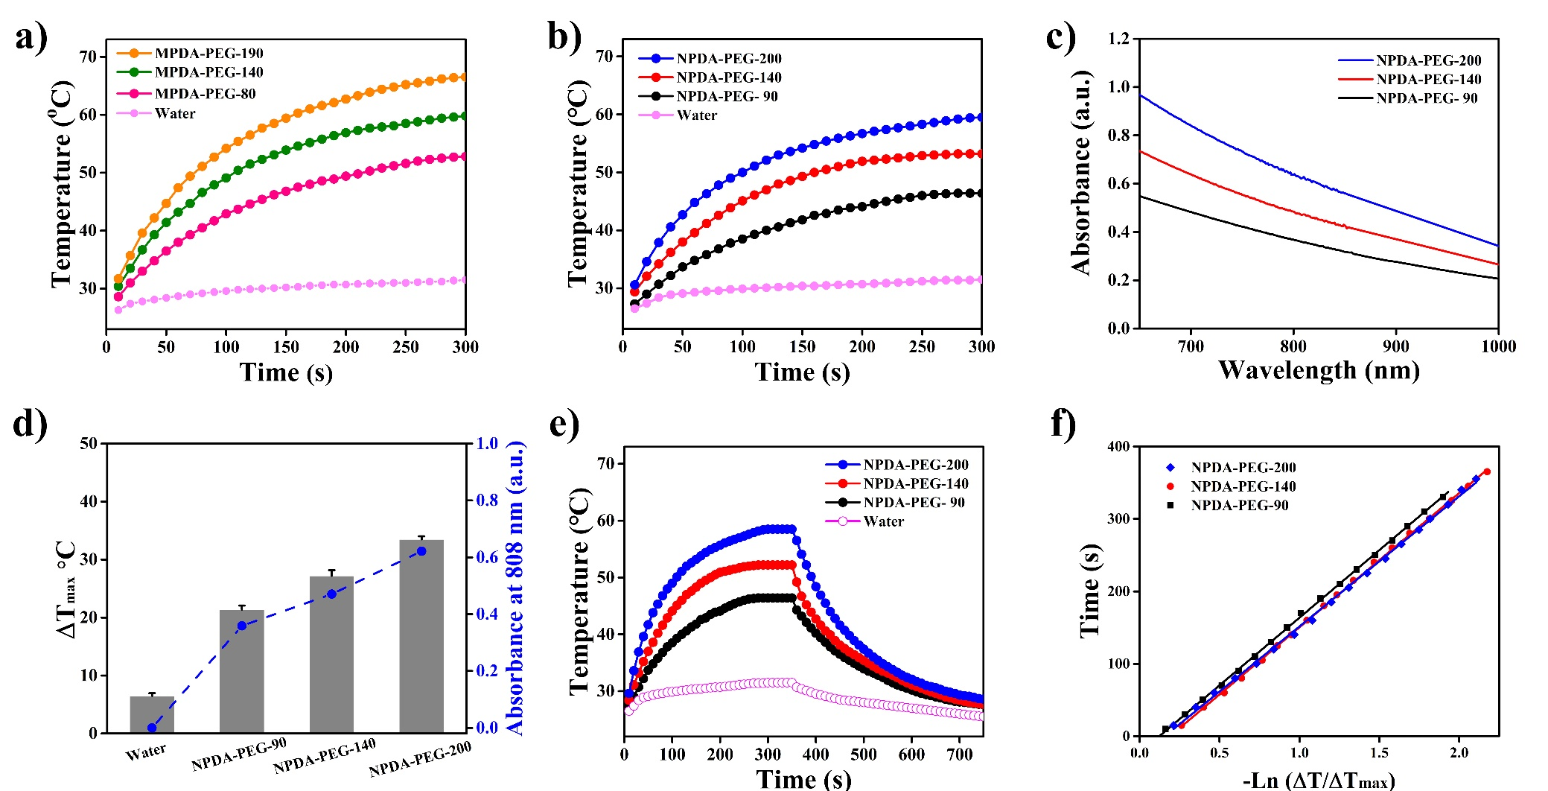
Figure S3. Photothermal effects of a) MPDA-PEG and b) NPDA-PEG under NIR laser irradiation (100 μg mL⁻¹, 808 nm, 2 W cm⁻²). c) UV-vis spectra of NPDA-PEG dispersions and d) summary of the maximum temperature change of the nanoparticle suspensions together with their absorbance at 808 nm. e) Photothermal effects of NPDA-PEG under laser irradiation and f) linear time data versus –Ln (ΔT/ΔT_{max}) obtained from the cooling periods of Figure S3e.
Abbreviations: MPDA-PEG, polyethylene glycol modified mesoporous polydopamine, NPDA-PEG, NPDA-PEG, polyethylene glycol modified noneporous polydopamine.
Figure S4. a) Temperature changes of MPDA-PEG suspension (100 μg mL⁻¹) upon five circles of laser irradiation (808 nm, 2 W cm⁻²). b) Absorbance of MPDA-PEG nanoparticles (100 μg mL⁻¹) at 808 nm before and after laser irradiation five times. Data are means ± sd. N = 3.
Abbreviation: MPDA-PEG, polyethylene glycol modified mesoporous polydopamine.

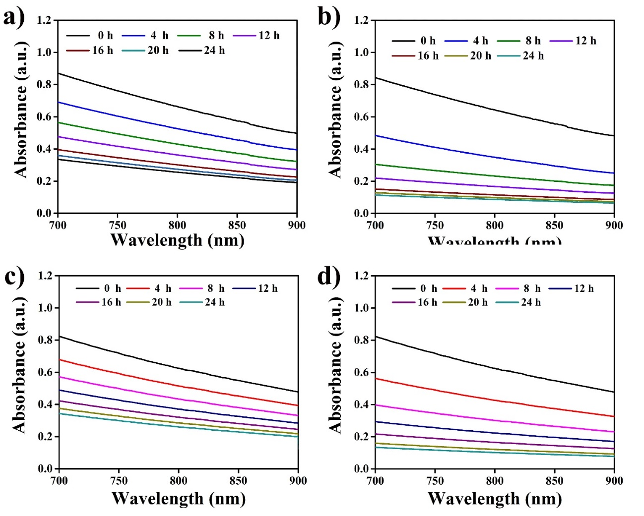
Figure S5. UV-vis spectra of MPDA-PEG-190 nanoparticles (100 μg mL⁻¹) reacted with a) 5 mM H₂O₂ and b) 10 mM H₂O₂ for different time. UV-vis spectra of NPDA-PEG-200 reacted with c) 5 mM H₂O₂ and d) 10 mM H₂O₂ for different time.
Abbreviations: MPDA-PEG, polyethylene glycol modified mesoporous polydopamine, NPDA-PEG, polyethylene glycol modified noneporous polydopamine

Figure S6. Cellular uptake of Cy5 modified MPDA-PEG-PTX nanoparticles in A549 cells after 4 h incubation. Blue represented fluorescence of DAPI, the red represented fluorescence of Cy5. The scale bar is 50 μm.
Abbreviation: MPDA-PEG-PTX, paclitaxel loaded polyethylene glycol modified mesoporous polydopamine.
Figure S7. In vitro PA signal versus various concentrations of MPDA-PEG nanoparticles. Inset is the PA images of MPDA-PEG nanoparticles with various concentrations of 25, 50, 100, 200 and 500 μg mL⁻¹.
Abbreviations: PA, photoacoustic; MPDA-PEG, polyethylene glycol modified mesoporous polydopamine.

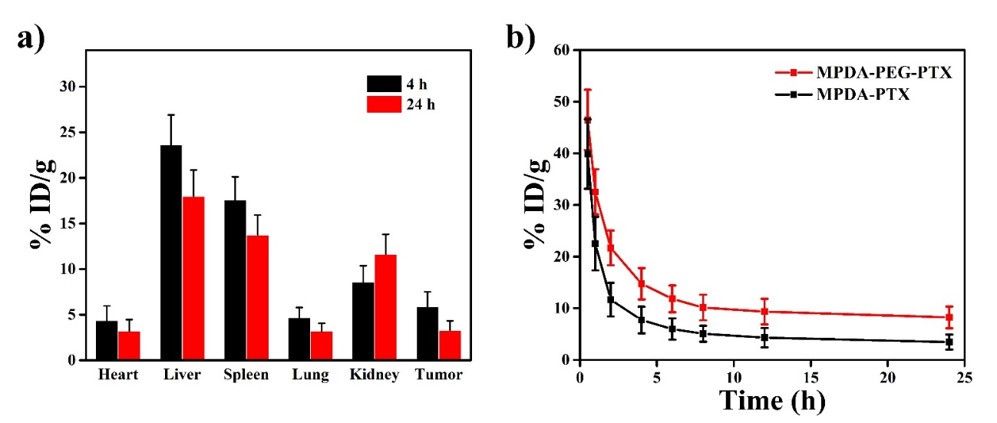
Figure S8. a) Biodistribution (4 h and 24 h) and b) pharmacokinetic experiments of Cy5 modified MPDA-PEG-PTX in A549 tumor-bearing mice at. Data are means ± sd. N = 4.
Abbreviations: MPDA-PEG-PTX, paclitaxel loaded polyethylene glycol modified mesoporous polydopamine.

Figure S9. Comprehensive blood biochemistry panel analysis conducted on ICR mice treated with 0.4 mg MPDA-PEG or MPDA-PEG-PTX nanoparticles. Blood is collected at 48 h post injection. Normal mice without any treatment are used as a negative control and the marker levels of control mice are defined as 1.0. Data are means ± sd. N = 3.
Abbreviations: MPDA-PEG-PTX, paclitaxel loaded polyethylene glycol modified mesoporous polydopamine.
References
S1. Chu M, Shao Y, Peng J, et al. Near-infrared laser light mediated cancer therapy by photothermal effect of Fe3O4 magnetic nanoparticles. Biomaterials. 2013;34(16):4078-4088.
S2. Huang X, Tang S, Mu X, et al. Freestanding palladium nanosheets with plasmonic and catalytic properties. Nat Nanotechnol. 2011;6(1):28-32.
S3. Geng BJ, Yang DW, Pan DY, et al. NIR-responsive carbon dots for efficient photothermal cancer therapy at low power densities. Carbon. 2018;134:153-162.
S4. Wang S, Shang L, Li L, et al. Metal-Organic-Framework-Derived Mesoporous Carbon Nanospheres Containing Porphyrin-Like Metal Centers for Conformal Phototherapy. Adv Mater. 2016;28(38):8379-8387.
S5. Yang K, Zhang S, Zhang G, Sun X, Lee ST, Liu Z. Graphene in mice: ultrahigh in vivo tumor uptake and efficient photothermal therapy. Nano Lett. 2010;10(9):3318-3323.

