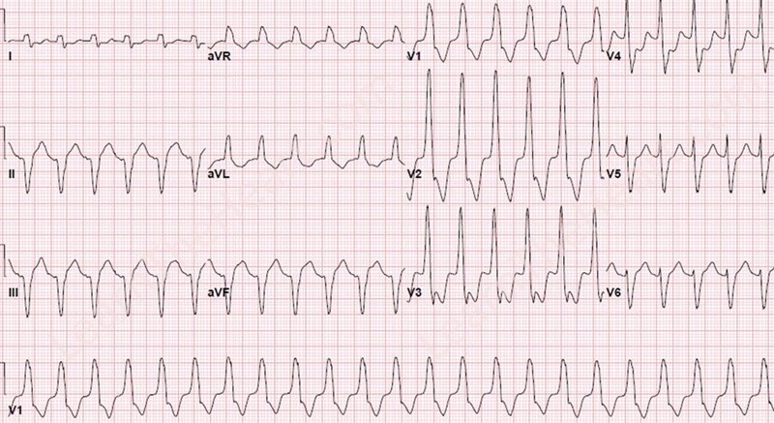
Terraces 1 (Easy)
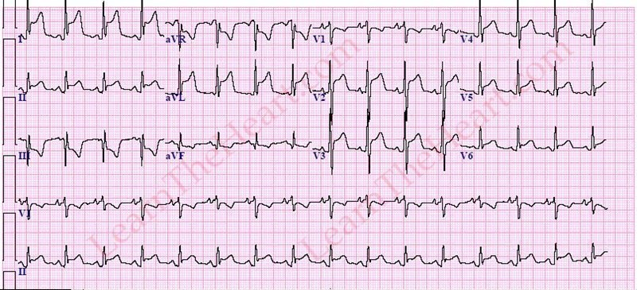
Terraces 2 (Difficult)

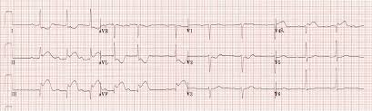

Terraces 3 (Middle)

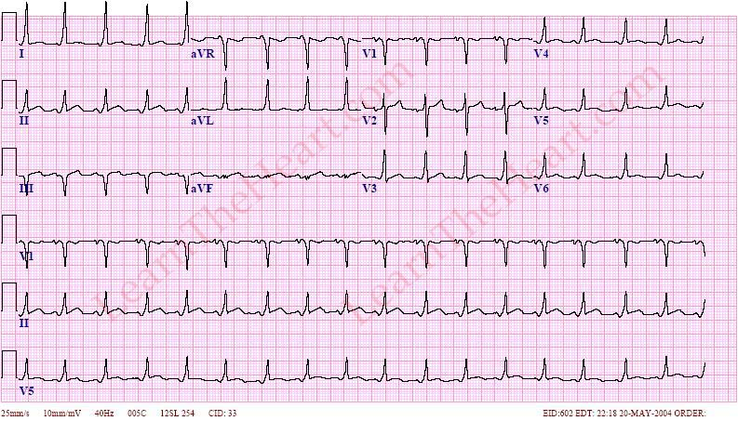

Terraces 4 (Difficult)

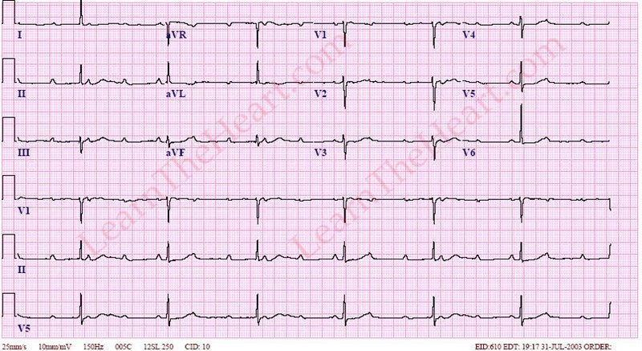
Terraces 5 (Middle)

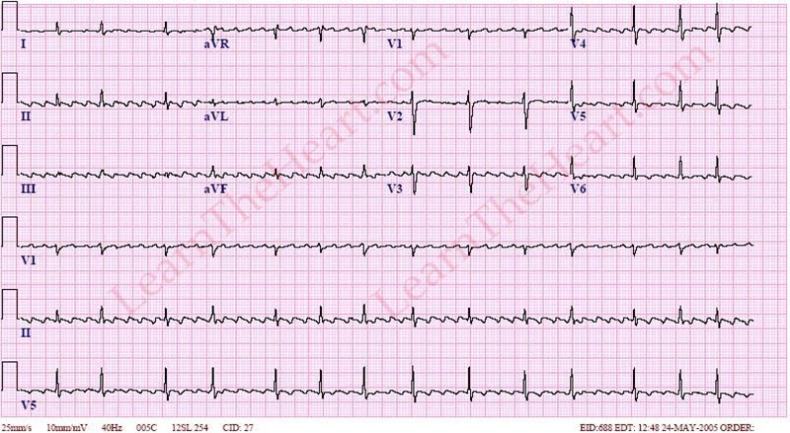
Terraces 6 (Middle)
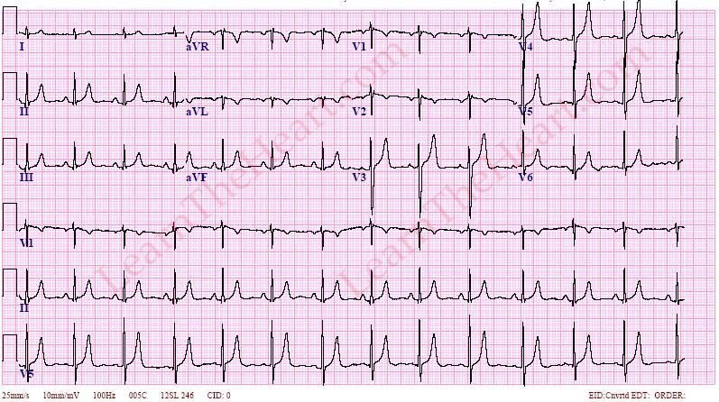
Terraces 7 (Easy)
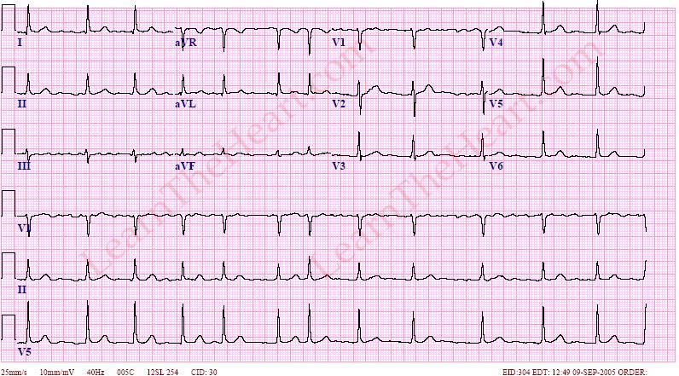
Terraces 8 (Easy)

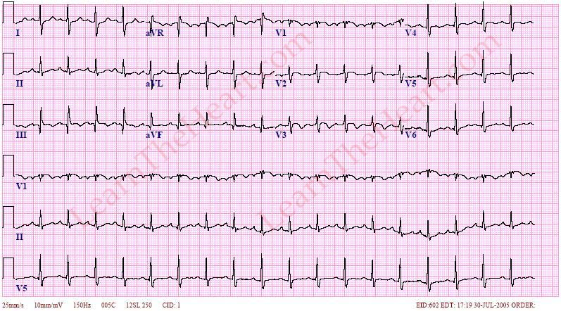

Terraces 9 (Difficult)

Supplementary Figure 1. Nine different ECG terraces verified by Department of Cardiology professors at Mashhad University of Medical Sciences

