Table S1. Dataset for CCK-8, ROS and GSH measurement
CCK-8 | XFM19  (Mean) | XFM19  (SD) | XFM20  (Mean) | XFM20  (SD) | XFM21  (Mean) | XFM21  (SD)
0μg/mL | 100.3804784 | 0.405145359 | 100.3804784 | 0.405145359 | 100.3804784 | 0.405145359
4μg/mL | 92.63047261 | 6.768016116 | 90.16253793 | 8.975749547 | 85.61668376 | 3.311372333
8μg/mL | 93.77971953 | 4.415552908 | 90.14261973 | 6.868986746 | 87.57975127 | 5.262114151
16μg/mL | 87.45450053 | 4.699346154 | 81.75023074 | 8.684091183 | 80.48242963 | 10.73679502
32μg/mL | 76.25413742 | 3.988522747 | 74.86543507 | 12.89308935 | 74.97416517 | 4.622581811
64μg/mL | 69.61805189 | 2.271551437 | 60.9990485 | 17.29955835 | 70.84446009 | 11.03158871
ROS
0μg/mL | 100.0232499 | 0.119047235 | 100.0232499 | 0.119047235 | 100.0232499 | 0.119047235
4μg/mL | 113.8096212 | 17.36610656 | 114.019953 | 16.41283355 | 111.6718137 | 13.90652744
8μg/mL | 123.9292037 | 17.79734662 | 129.6677592 | 18.85940223 | 127.9089234 | 7.103587117
16μg/mL | 143.2167872 | 15.57779354 | 153.0424837 | 15.18752245 | 146.9464199 | 9.045203758
32μg/mL | 163.7422663 | 15.72813361 | 182.1138509 | 17.41009092 | 164.0154565 | 8.819814128
64μg/mL | 184.927271 | 23.13682899 | 193.058469 | 27.97778261 | 170.0725653 | 19.41478877
GSH
0μg/mL | 100.0258243 | 0.079121589 | 100.0258243 | 0.079121589 | 100.0258243 | 0.079121589
4μg/mL | 91.6764695 | 0.638890078 | 86.30690571 | 10.32110919 | 83.78856493 | 3.036424319
8μg/mL | 82.22567113 | 2.231332005 | 76.4230534 | 7.86264072 | 78.48560012 | 8.012974359
16μg/mL | 73.16817337 | 12.7475545 | 71.68283588 | 9.795712258 | 71.6946039 | 12.69598744
32μg/mL | 66.58738037 | 11.57278016 | 63.16692651 | 9.863025299 | 64.45654564 | 11.78155399
64μg/mL | 56.34181134 | 16.13875262 | 52.0559851 | 14.31768832 | 55.60869894 | 17.23368582

Table S2. Dataset for qRT-PCR and Western blot
 | Control  (mean) | Control  (SD) | XFM19  (mean) | XFM19  (SD) | XFM20  (mean) | XFM20  (SD) | XFM21  (mean) | XFM21  (SD)
caspase-3 | 99.99993421 | 3.014850447 | 127.631495 | 3.014850447 | 80.92099939 | 3.947365824 | 96.05256839 | 3.014850447
cleaved caspase-3 | 100 | 10 | 180 | 10 | 406.6666667 | 15.27525232 | 316.6666667 | 15.27525232
caspase-8 | 100 | 14.28571429 | 176.1904762 | 8.247860988 | 128.5714286 | 14.28571429 | 109.5238095 | 16.49572198
cleaved caspase-8 | 100 | 6.25 | 106.25 | 6.25 | 239.5833333 | 7.216878365 | 131.25 | 6.25
IRE1α | 100 | 8.333333333 | 172.2222222 | 9.622504486 | 255.5555556 | 20.97176232 | 108.3333333 | 8.333333333
BCL-2 | 99.99983871 | 2.793625829 | 75.80632934 | 2.793625829 | 40.32251561 | 2.793625829 | 45.16121748 | 2.793625829
p-chop | 99.99977273 | 3.936470162 | 115.9088275 | 6.818166322 | 95.45432851 | 6.818166322 | 136.3633264 | 6.818166322
chop | 99.99983871 | 7.3912392 | 109.6772425 | 7.3912392 | 229.0318887 | 2.793625829 | 266.128603 | 4.838701873
DDIT3 | 1.0000E+00 | 5.7735E-03 | 1.1521E+00 | 1.4729E-01 | 2.517387594 | 0.158255366 | 1.6974E+00 | 6.8007E-03
XBP-1s | 1.0000E+00 | 1.5275E-01 | 7.1454E-01 | 9.2529E-02 | 0.548118494 | 0.076854802 | 7.8215E-01 | 1.0860E-01

Table S3. The qPCR amplification procedure
Temperature Time
95℃ 10min
95℃ 15s
40cycles
60℃ 60s
Melting curve analysis: 60℃-95℃

Figure S1. The Western blot images.
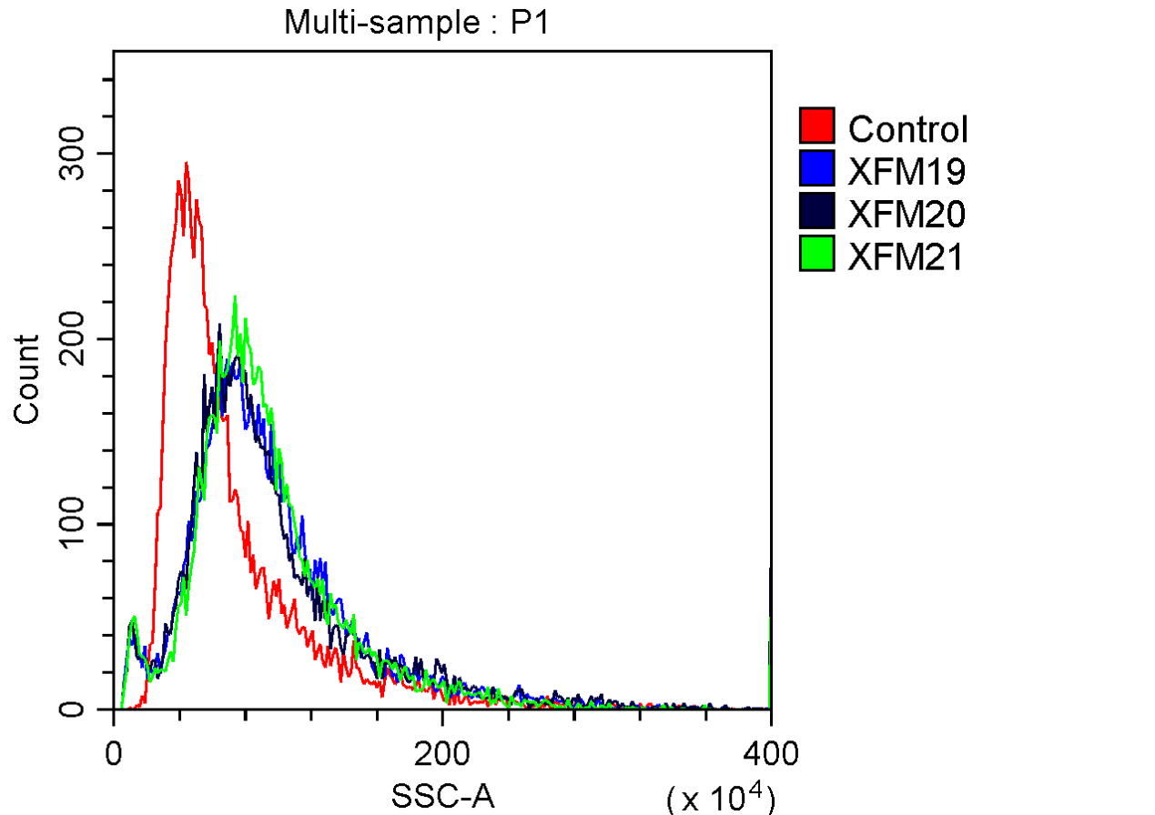
Figure S2. The internalization of MWCNTs into HUVECs. HUVECs were exposed to 64 μg/mL of pristine MWCNTs (XFM19), hydroxylated MWCNTs (XFM20) or carboxyxlated MWCNTs (XFM21). After 24 h exposure, the changes in SSC were determined by using flow cytometry to indicate the internalization of MWCNTs.

