Supplementary information

Figure SI-1. Acoustic intensity mapping at the target region, f = 1.1 MHz. a) Horizontally (total diameter of target region is 35 mm). b) Vertically, from the concave plate of transducer. c) Distribution of acoustic intensity as a function of input voltage. Experimental data was fitted to a second-order polynomial model (included)

Figure SI-2. Characterization of PEG-coated nanoparticles. a) TEM image; D_{p} = 16 nm, b) DLS measurements; D_{h} = 50 nm, c) SQUID magnetization curves; d) Increasing temperature profiles; SAR = 402 W/g_{Fe}, e) Zeta Potential as a function of pH, f) TGA curves; iron oxide core = 18%,

Figure SI-3. Optimization of ultrasound experimental conditions and effect on viability of HeyA8 cells. a) effect of pulse type at various acoustic intensities and exposure times (t_{US}), b) effect on cell numbers at various spatial peak temporal average intensity (I_{SPTA}) values. Error bars represent the standard deviation of three independent experiments.

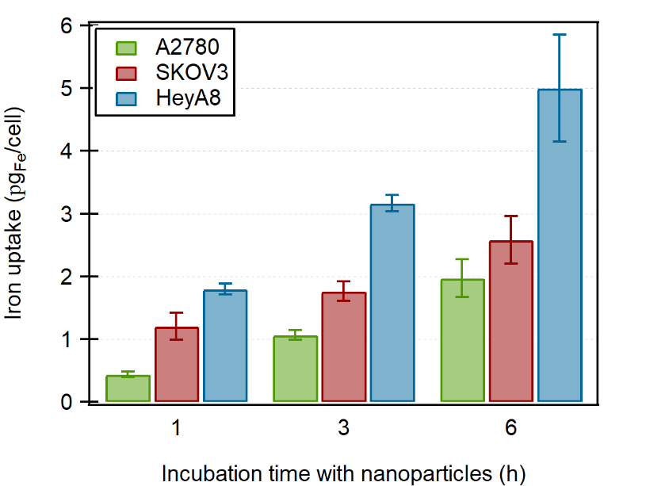

Figure SI-4. Cellular uptake of PEG-coated nanoparticles (0.6 mg_{IO}/mL) by ovarian cancer cells as quantified by UV/Vis spectroscopy. Error bars represent standard deviations of three independent experiments

Figure SI-5. Viability ratio of ovarian cancer cells after exposure to MFH and PES. a) AMF (H_{o} = 15 – 20 kA/m, f = 245 kHz) exposure for 30 min. Control groups represent cells incubated at 37°C, “MNP w/o AMF” group represents cells incubated with MNP in the absence of AMF, and “AMF w/o MNP” represents cells exposed to AMF in the absence of MNP. Error bars represent the standard deviation of three independent experiments. b) Incubation of HeyA8 cells with various PES concentrations for up to 72 hours. Error bars represent the standard deviation of n = 6.

