SUPPLEMENTAL MATERIAL

Figure S1 Density Plots of the Diary-to-Questionnaire Sleep Duration Ratios by Time Period in the Retirement and Sleep Trajectories Study (n = 5,313)ª
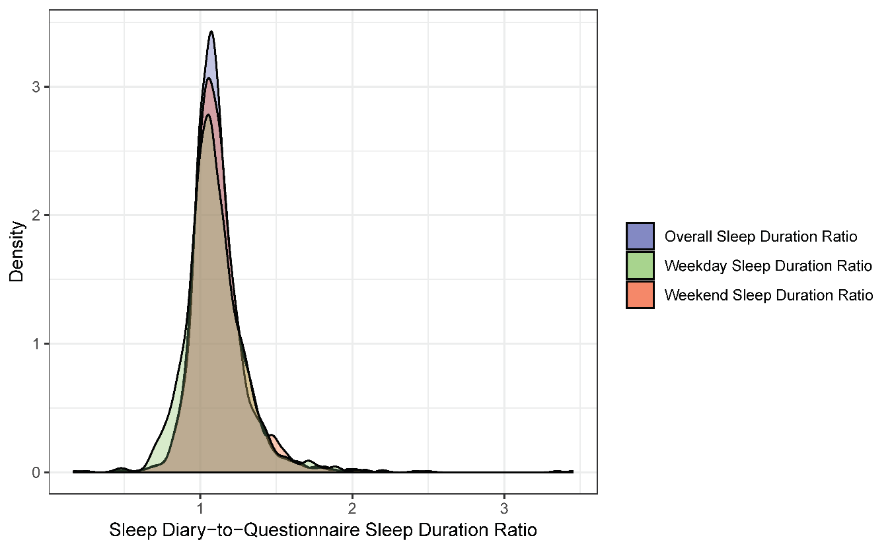
Key: Blue indicates overall sleep duration ratio; green indicates weekday-specific sleep duration ratio; red indicates weekend-specific sleep duration ratio.
ªThere were 5,313 questionnaire-diary pairs for 1,516 study participants, and each participant returned at least one of potentially four questionnaire-diary pairs throughout the study duration.

