Supplementary material
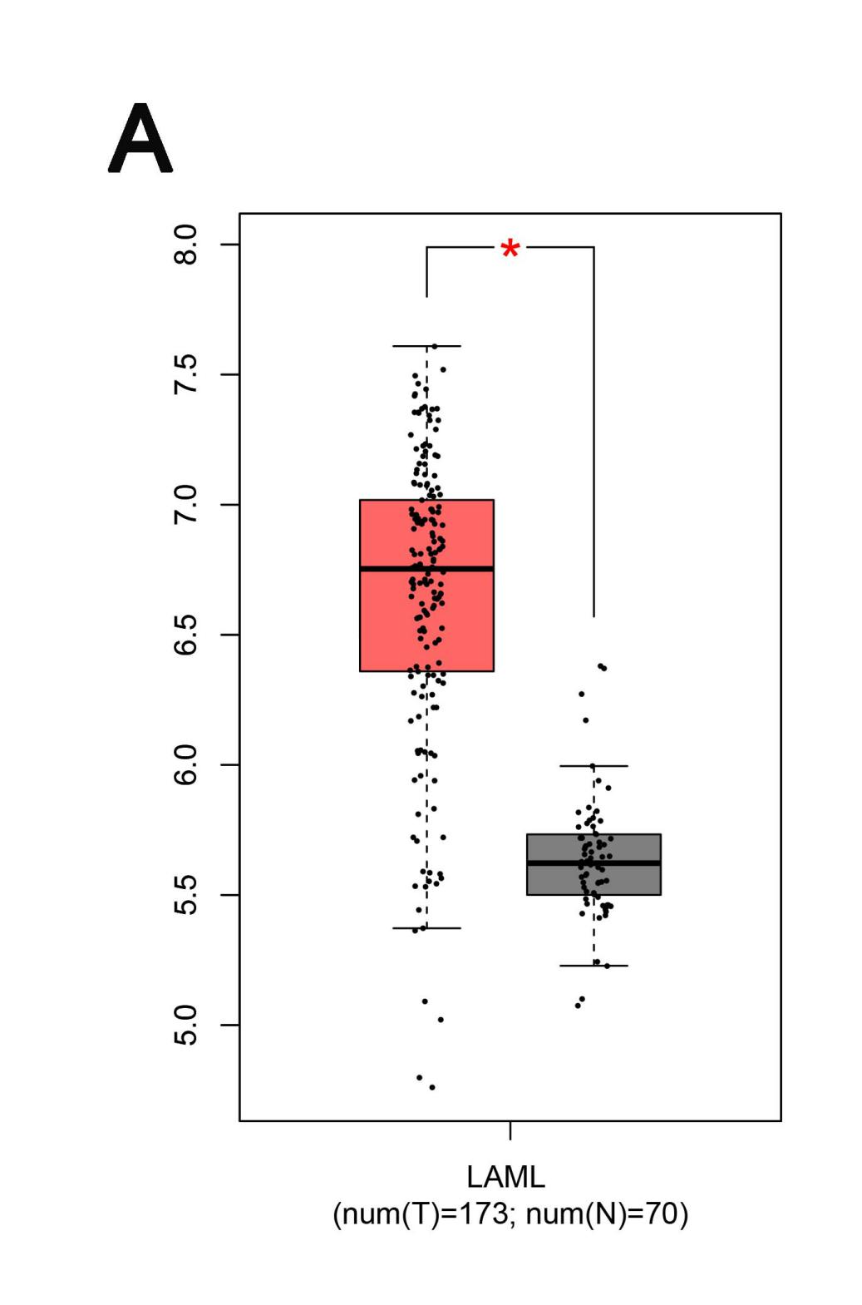
Supplementary Figure 1. The expression of TUG1 in AML and normal bone marrow tissues of TCGA data was analyzed by Gepia database.
Compared with normal bone marrow cells, the expression levels of TUG1 in AML cells were significantly up-regulated,
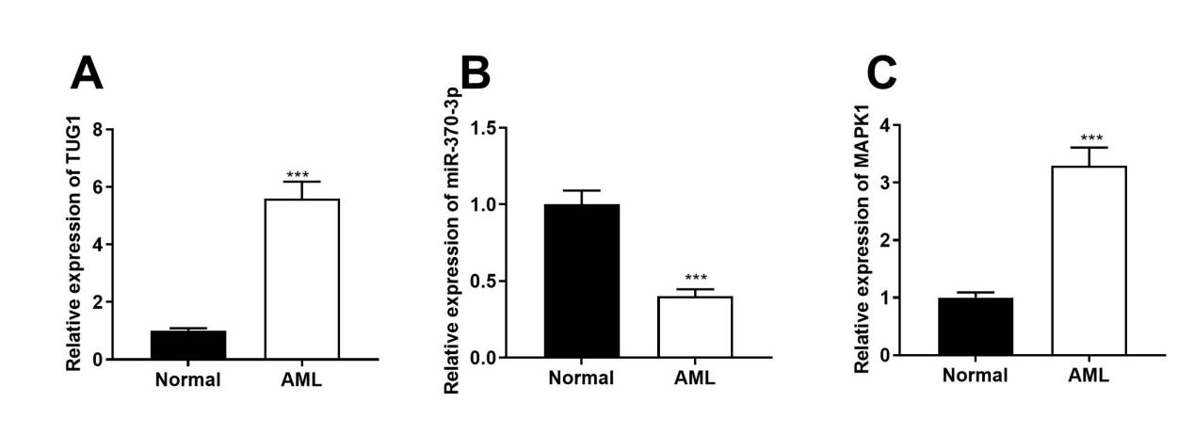
Supplementary Figure 2. The expression of TUG1, MiR-370-3p and MAPK1 in AML cells.
The expression of TUG1, MiR-370-3p and MAPK1 in AML cells was detected by qRT-PCR. Compared with normal bone marrow cells, the expression levels of TUG1 and MAPK1 in AML cells were significantly up-regulated, while the expression levels of miR-370-3p were significantly down-regulated.

