Supplementary Figure 1. Search strategy flow diagram
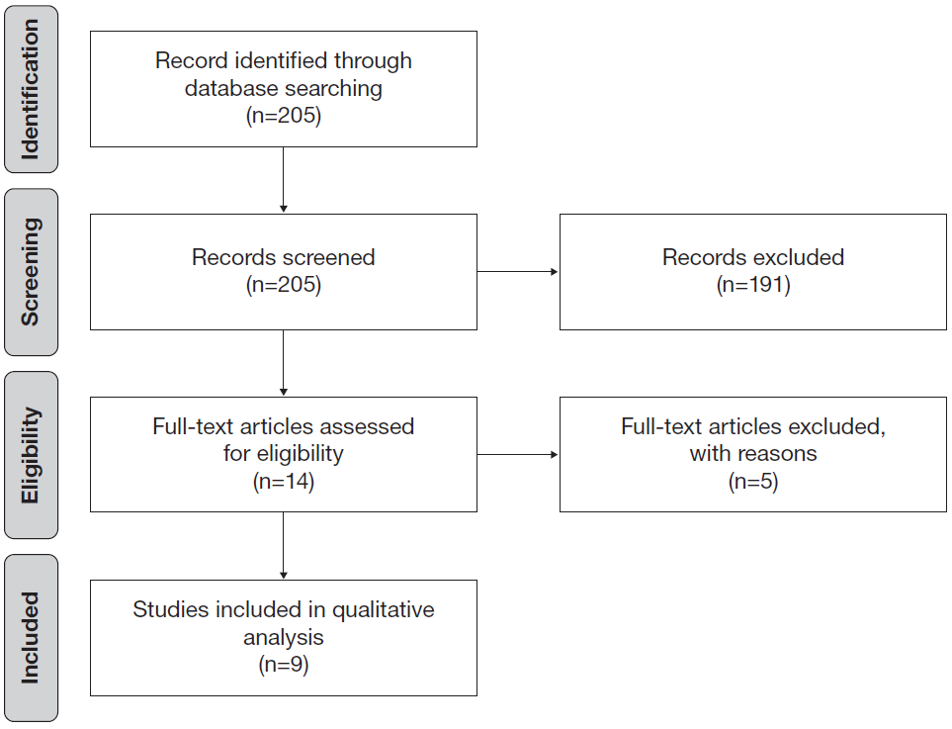
Searches were conducted in PubMed in October 2018.
Search terms were as follows:
COPD[Title/Abstract] AND (treatment-naïve[Title/Abstract] OR treatment naïve[Title/Abstract] OR naïve to maintenance therapy[Title/Abstract] OR naïve to maintenance treatment[Title/Abstract] OR maintenance-naïve[Title/Abstract] OR maintenance naïve[Title/Abstract] OR LABA-naïve[Title/Abstract] OR LABA naïve[Title/Abstract] OR LAMA-naïve[Title/Abstract] OR LAMA naïve[Title/Abstract] OR prior treatment[Title/Abstract] OR prior therapy[Title/Abstract] OR inexperienced[Title/Abstract] OR first maintenance)

