Supplementary materials
Exacerbation frequency and eosinophil counts among patients with COPD currently prescribed triple therapy (Benson et al.)

Contents
Supplementary methods
Calculating weighted percentages
- A weight per patient was developed using the following steps:
  - Weight (W) = 1/(number of visits in the last 12 months), where the number of visits is capped, eg, capped to a maximum of 12 visits.
  - W was multiplied by a factor such that W sums to the number of patients managed by the physician (this number will be capped, eg, the min and max differ by no more than a factor of 10). This factor was unique to each physician.
  - W was multiplied by a factor such that W sums to the total number of physicians of the same type within the same country, multiplied by the average number of patients managed by the physicians (within the same group).
  - W was multiplied by a factor such that W sums to the number of patients within that country. This factor was unique to each country. If the number of patients within each country was not known (obtained from epidemiology figures) then the general population numbers were used as sourced for example from office of national statistics in the UK. This assumes that the disease prevalence in each country is similar.
- The ‘number of visits’ and the ‘total number of patients managed by the physician’ variables were capped prior to their use in the weighting. This was to limit the variability of the weight and to ensure that the scenario where a small number of patients have an unreasonably large influence did not occur. The caps were selected based on the variable distributions.

Supplementary figure legends and footnotes

Supplementary Figure 1 DSP methodology.
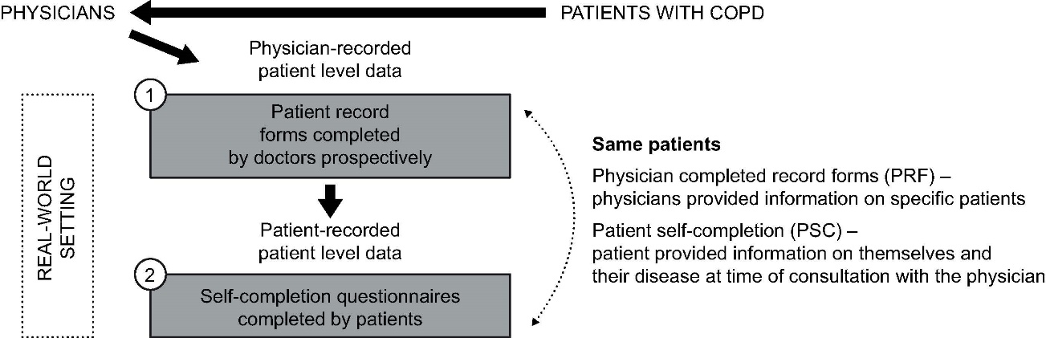
Abbreviations: COPD, chronic obstructive pulmonary disease; DSP, Adelphi Real-World Respiratory Disease Specific Programme.

Supplementary Figure 2 Overview of main analysis and sensitivity analyses.
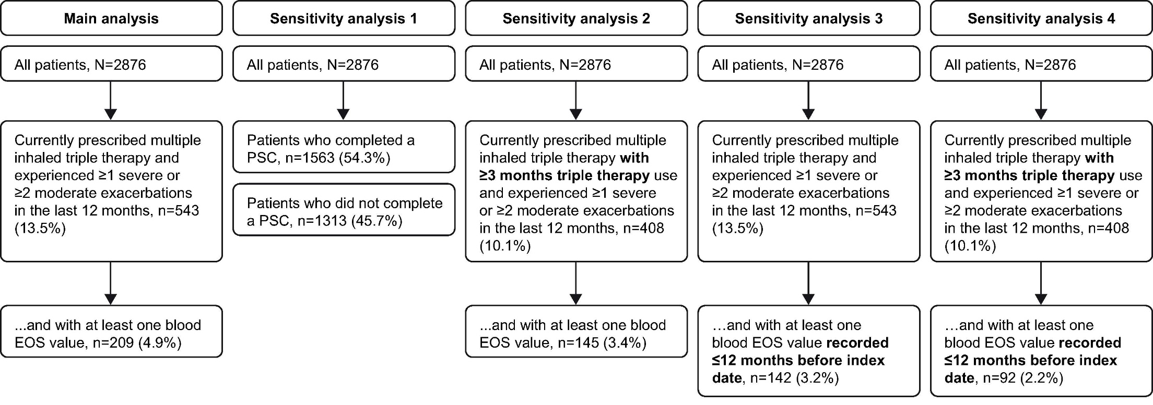
Abbreviations: EOS, blood eosinophil count; PSC, patient self-completion questionnaire

Supplementary Table
Supplementary Table 1 Weighted percentagesª of all patients with COPD who fulfilled the conditions of being treated with triple therapy, experienced ≥2 moderate or ≥1 severe AECOPD in the 12 months prior to index date and had a blood eosinophil count of ≥150 (T-AECOPD-EOS150 cohort) or ≥300 cells/µL (T-AECOPD-EOS300 cohort) by country
 | n (weighted percentages)
 | France  (n=565) | Germany  (n=587) | Italy  (n=580) | Spain  (n=583) | UK  (n=561)
Proportion of patients currently prescribed maintenance treatment (%) | 96.9 | 92.2 | 98.2 | 96.7 | 88.5
% based on denominator | 96.9 | 92.2 | 98.2 | 96.7 | 88.5
… and currently prescribed triple therapy (%) | 25.2 | 17.9 | 13.7 | 31.1 | 34.8
% based on denominator | 24.4 | 16.5 | 13.5 | 30.0 | 30.8
… … and experienced ≥1 severe or ≥2 moderate AECOPD in the last 12 months (%) | 64.6 | 43.1 | 65.0 | 67.8 | 65.5
% based on denominator | 15.8 | 7.1 | 8.4 | 20.3 | 20.0
… … … and with EOS ≥150 cells/µl^{b} (%) | 90.9 | 97.1 | 100.0 | 70.9 | 72.1
% based on denominator | 14.3 | 6.9 | 8.4 | 14.4 | 14.4
… … … and with EOS ≥300 cells/µl^{b} (%) | 51.0 | 25.3^{c} | 37.5^{c} | 57.5 | 37.1
% based on denominator | 8.0 | 1.8^{c} | 3.1^{c} | 11.7 | 7.4

Notes: ªWeighted percentages are based on the total number of patients. Weighted using an adjustment factor taking into account physician consultation rates, and consultation workload, physician specialty and country size; ^{b}Based on the total with eosinophil count collected as part of routine clinical care; ^{c}For some conditions, the proportion of patients was extremely small (n<5) and should be interpreted with caution.
Abbreviations: AECOPD, acute exacerbation of COPD; COPD, chronic obstructive pulmonary disease; EOS, blood eosinophil count.

