Supplementary materials

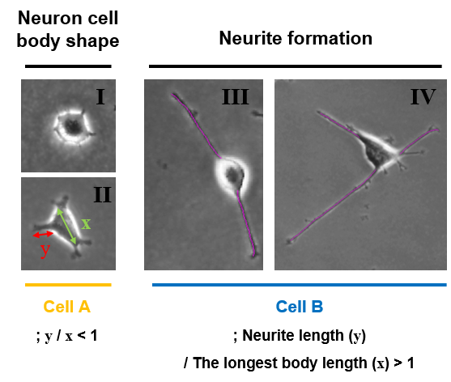
Figure S1. Definition of the neuron cell shape and neurite formation. Neuron cell body shape (I and II: round and elongated shape) and neurite formation (III and IV: two neurites and more than two neurites). Cell A and Cell B are non-extended cells and neurite-extended cells, respectively.
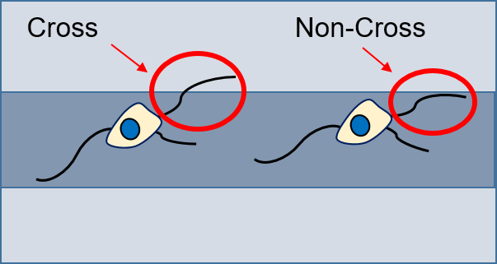
Figure S2. Neurite formation on the patterned substrate. The outgrowing neurites can be formed crossing or not crossing the patterned step.
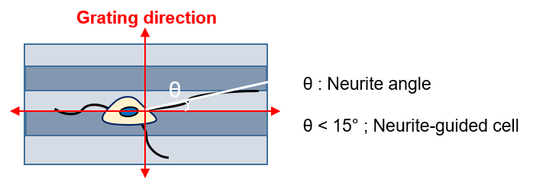
Figure S3. Measurement of neurite guidance. The direction of neurites is determined on the micropatterned substrate by the linear pattern of the photomask. Neurite angle with θ < 15° is categorized as an aligned neurite (neurite-guided cell) by a linear pattern.
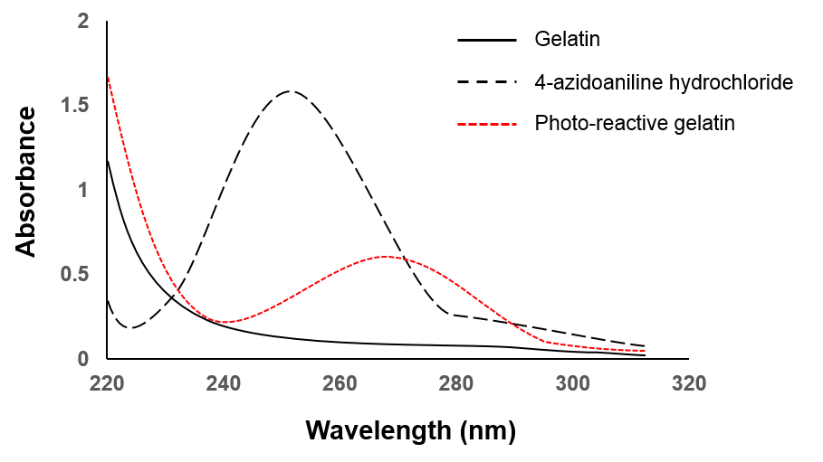
Figure S4. UV spectra before and after modification. A 0.1 w/v% aqueous solution of gelatin (black solid line), 4-azidoaniline hydrochloride (black-dash line), and photoreactive gelatin (red-dashed line) in a 1-cm light path quartz cell at room temperature.
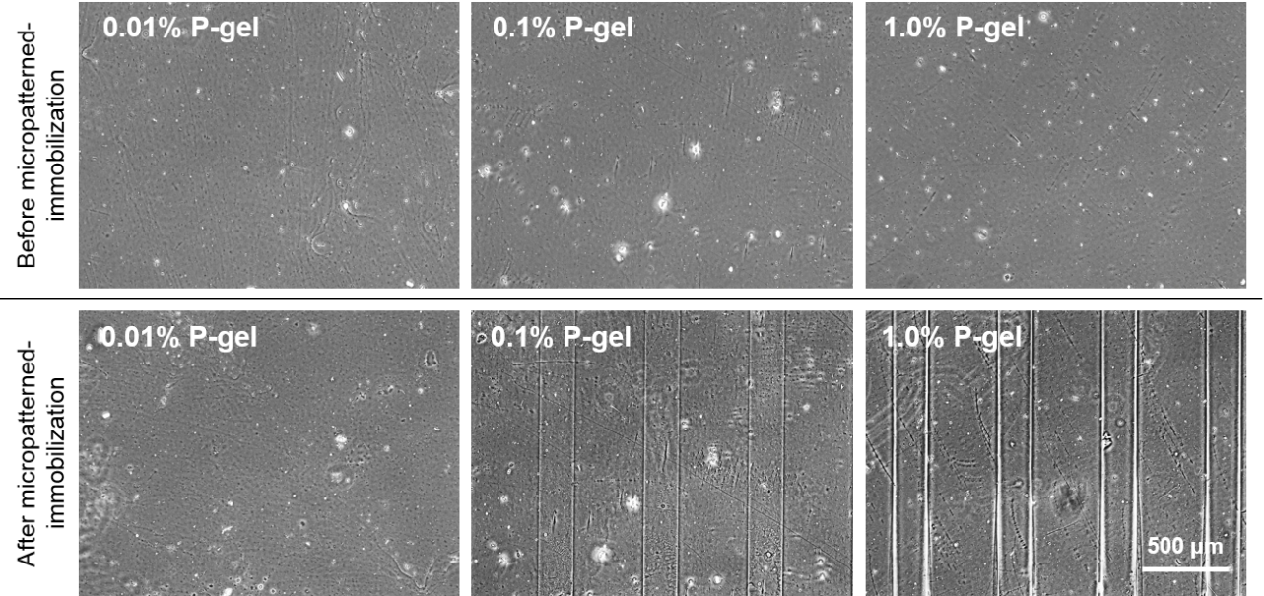

Figure S5. Comparison before and after immobilizing the surface at various concentrations of P-gel. The micropatterned regions were detected by UV treatment with a linear pattern photomask. Shaded area and open area of the photomask were 200 μm and 400 μm, respectively.

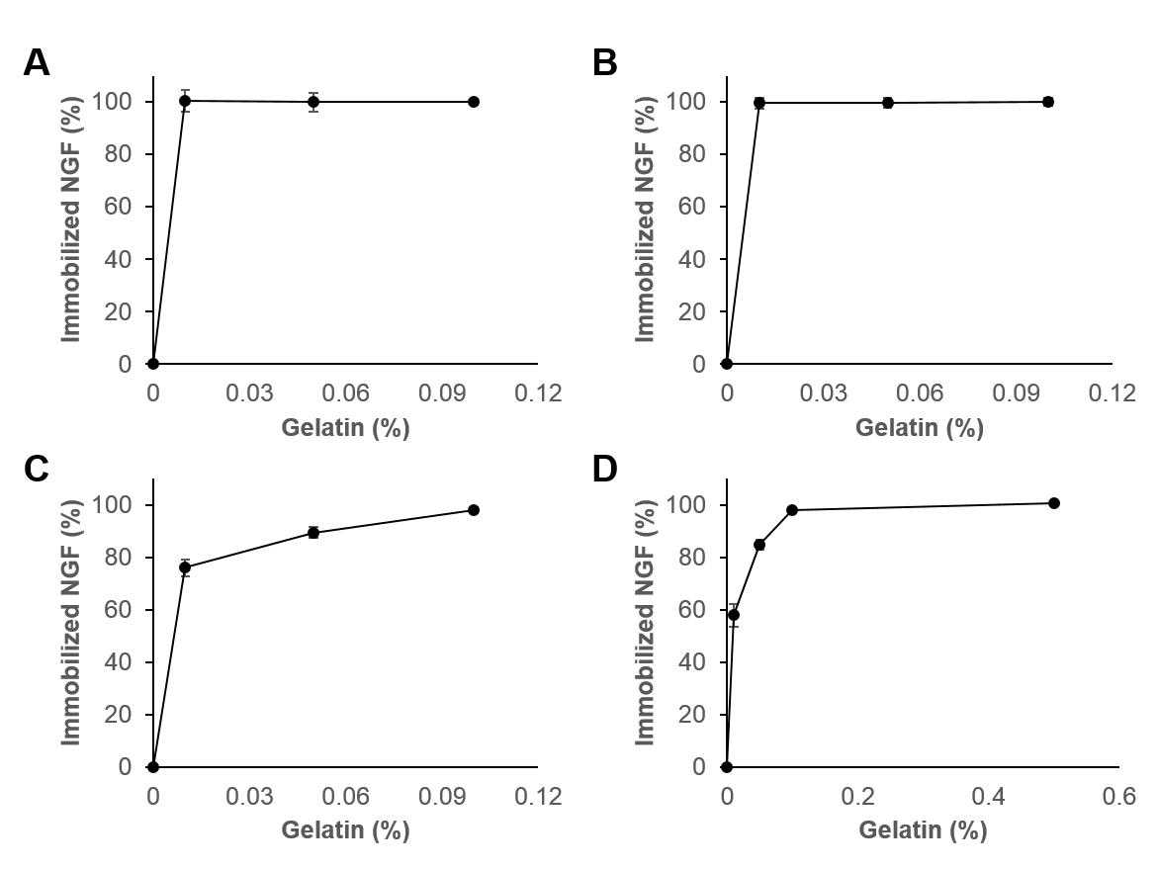
Figure S6. Measurement of immobilized NGF on the substrate by ELISA. Immobilization of (A) 1 ng, (B) 5 ng, (C) 20 ng, and (D) 50 ng NGF using various amounts of P-gel. Data are presented as the mean ± SD, n = 3.

