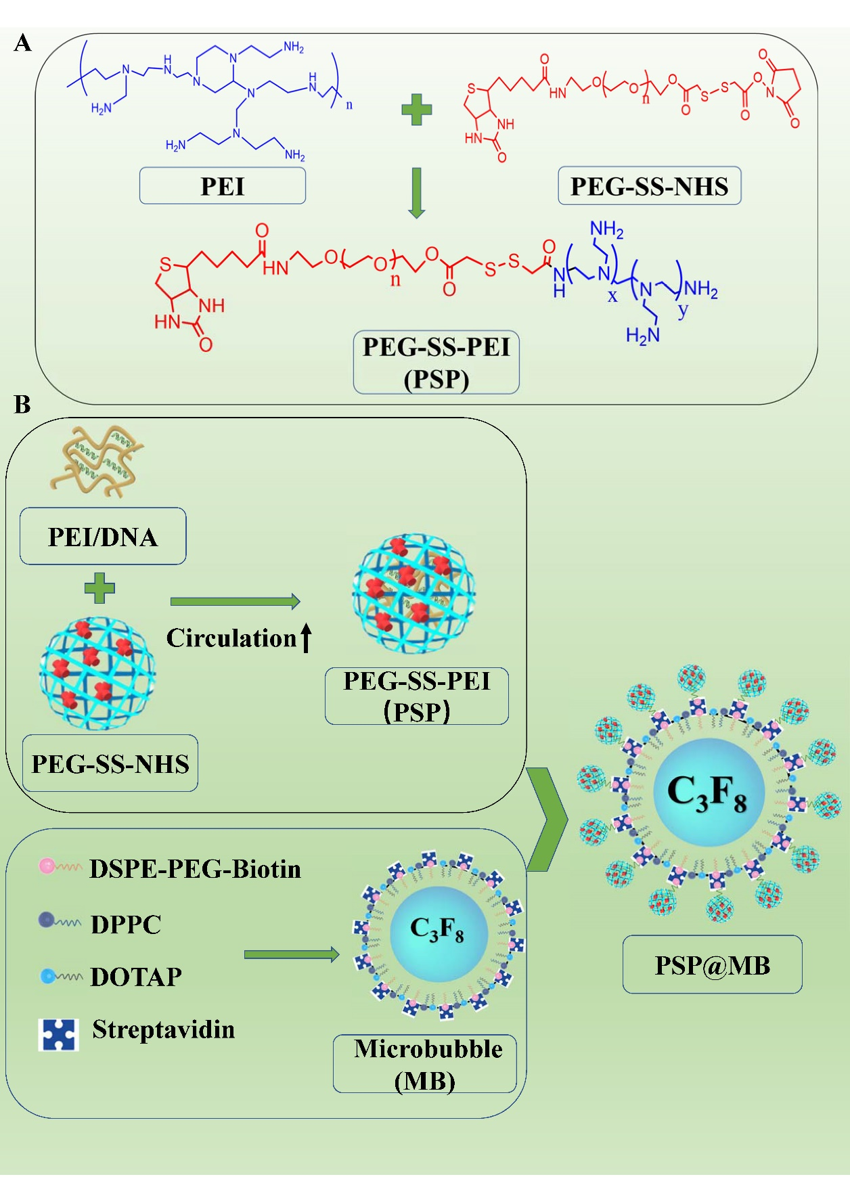
Figure S1
Schematic diagram representation of preparation of PSP@MB.
Notes: (A) The chemical structure diagram of biotinylated PSP. Biotinylated PSP was constructed by the biotin-PEG-SS-NHS and PEI via amide linkages. (B) The biotinylated lipid MB was fabricated with the thin-film hydration method. Schematic illustration to form PSP@MB through a biotin–streptavidin bridging chemistry method.

Abbreviations: PSP@MB, polyethyleneglycol-SS-polyethylenimine@ microbubble; PSP, polyethyleneglycol-SS-polyethylenimine; MB, microbubble. DPPC, 1,2-dipalmitoyl-snglycero-3-phosphocholine; DPTAP, 1,2-dipalmitoyl-3-t rimethylammonium-propane; DSPE-PEG2000-Biotin, 1,2-distearoyl-sn-glycero-3-p hosphoethanolamine-N-[methoxy(poly(ethyleneglycol))-2000]; PEI, branched polyethylenimine.
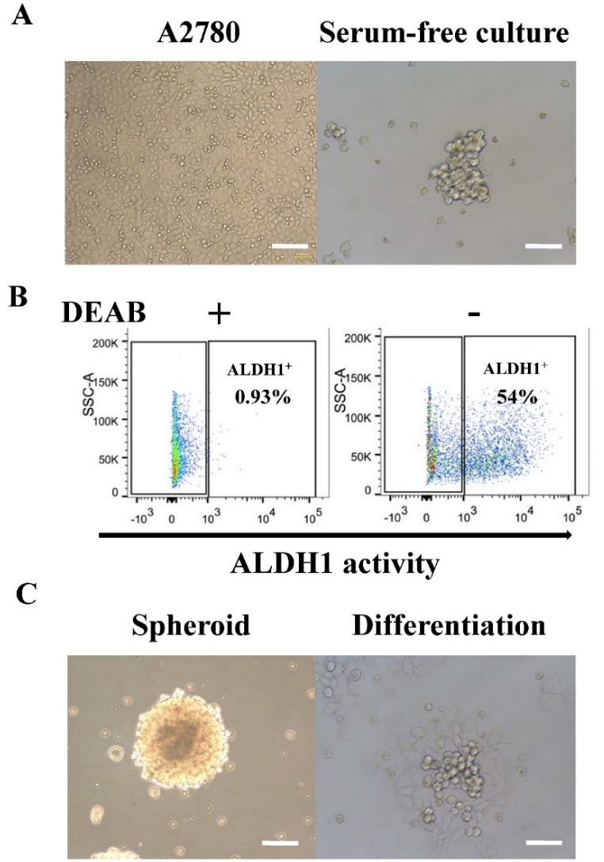
Figure S2
Spheroids derived from A2780 cells with ALDEFLUOR assay and Fluorescence-Activated Cell Sorting.
Notes: (A) The microscope image of the A2780 cells with serum culture medium in the first week. The A2780 cells have change into irregular spheroids with serum free culture in the third week. (B) In the third week, the spheroids were collected and sorted with ALDEFLUORTM assay and flow cytometry analysis. The test ALDH1⁺ population was gated using control cells incubated under identical condition in the presence of 5 μL of the ALDH1 inhibitor, diethylamino benzaldehyde (DEAB) reagent. The ALDH1⁺ and ALDH1⁻ cells were sorted by flow cytometry analysis. The percentage of ALDH1⁺ cells were 54% (right) compared with control groups (DEAB+). After sorting, the ALDH1⁺ cells and ALDH1⁻ cells were cultured in a serum-free culture. (C) The formation of ALDH1⁺ OCSC spheroids were shown at one month (left). Spheroid-to-monolayer when the ALDH1⁺ OCSC spheroids were cultured with serum in a culture medium for three days (right). (scale bar=100 μm).
Abbreviations: OCSC, ovarian cancer stem cell. FACS, fluorescence-activated cell sorting; DEAB, diethylamino benzaldehyde.

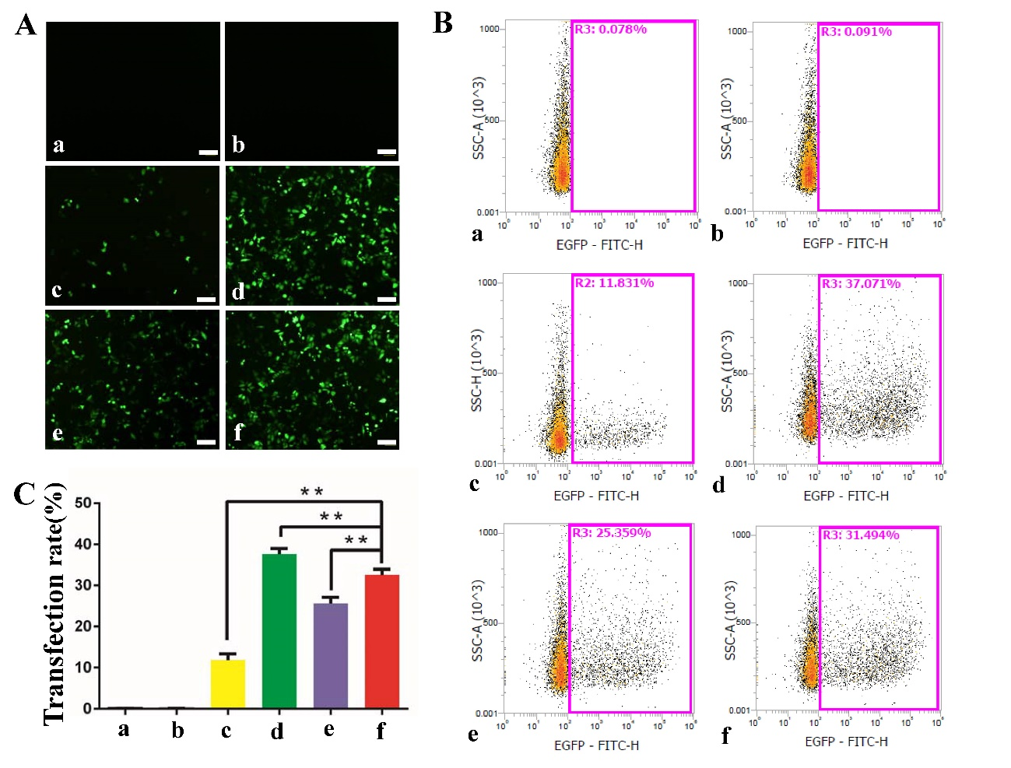
Figure S3
Effect of ultrasound on the transfection efficiency of PSP@MB/pDNA into A2780.
Notes: (A) Fluorescent images of A2780 exposed to plasmid-containing different reagents: PSP, MB, Lipofectamine 2000, Lipofectamine 3000, PSP@MB, with or without ultrasound irradiation, respectively, after 24 h. There were six groups: (a) Control (plasmid), (b) PSP, (c) MB+US, (d) Lipofectamine 2000, (e) Lipofectamine 3000, (f) PSP@MB+US. The optimized ultrasound parameters (0.8 W/cm², 1 MHz, 20% duty cycle, 30 s), (scale bar=100 μm). (B) Transfection efficiency rate was evaluated by flow cytometry. (C) Transfection efficiency rate was represented as histograms. The transfection efficiency rate was 31.4% in the PSP@MB+US group, lower than Lipofectamine 2000 group (37%), but higher than Lipofectamine 3000 group (25%) or MB+US group (11%). Data are represented as mean ± standard deviation; n = 3; **P<0.01.
Abbreviations: PSP, PEG-SS-PEI; PSP@MB, PEG-SS-PEI@microbubble; US, ultrasound.

