Appendix 1: Search terms

((intravitreal fluocinolone acetonide implant*).ti,ab OR (ocular fluocinolone acetonide implant*).ti,ab OR (fluocinolone acetonide intravitreal delivery device).ti,ab OR (fluocinolone acetonide intravitreal sustained-release device).ti,ab OR (Iluvien).ti,ab) AND ((non infectious posterior uveitis).ti,ab OR "UVEITIS, POSTERIOR"/ OR (noninfectious posterior uveitis).ti,ab OR (non infectious intraocular inflammation).ti,ab OR (noninfectious intraocular inflammation).ti,ab OR (noninfectious ocular inflammation).ti,ab OR (uveitic macular edema).ti,ab OR exp "MACULAR EDEMA"/ OR (uveitic macular oedema).ti,ab OR (cystoid macular edema).ti,ab OR (cystoid macular oedema).ti,ab OR (uveitic edema of the macula).ti,ab OR (uveitic oedema of the macula).ti,ab OR (cystoid edema of the macula).ti,ab OR (cystoid oedema of the macula).ti,ab)
Appendix 2: Consort Diagram
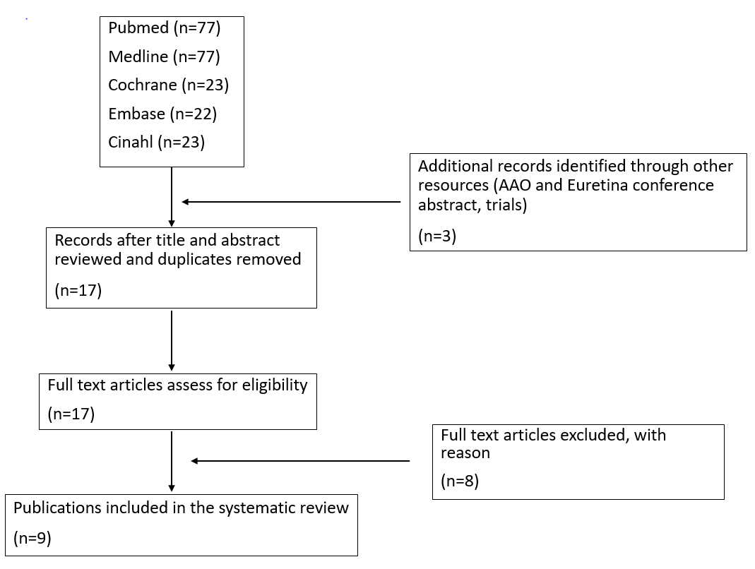
Abbreviation: AAO, American Academy of Ophthalmology.

