Supporting Information

Tumor-targeting photodynamic therapy based on folate-modified polydopamine nanoparticles

Table of Contents
- Figure S1. Chemical structure of Pc
- Figure S2. Dynamic light scattering (DLS) analysis of PDA, PDA-FA and PDA-FA-Pc.
- Figure S3. Hydrodynamic diameters of PDA and PDA-FA-Pc nanomedicine in PBS determined by dynamic light scattering (DLS) analysis. PDA and PDA-FA-Pc nanomedicine were standing at room temperature for 0, 4, and 8 days before determination.
- Figure S4. Apparent images of PDA-FA-Pc nanomedicine dispersed in aqueous solutions: water, PBS, and PBS with 20% fetal bovine serum (FBS) before and after standing at room temperature for 24 h.
- Figure S5. UV-vis absorption spectra of pure FA and Pc in PBS.
- Figure S6. The release of the monomeric Pc molecules from PDA-Pc in acidic (pH 5) and neutralized (pH 7) conditions.
- Figure S7. ROS production of PDA-FA-Pc nanomedicine in PBS.
- Figure S8. The phototoxicities and dark toxicities of PDA (a) and PDA-FA (b) in the Hela cell line. The survival rates were determined after incubation with PDA or PDA-FA at various concentrations with and without illumination at 680 nm with the same light dose in Figure 5.
- Figure S9. Body weights of mice during the in vivo experiments.
- References

Figure S1. Chemical structure of the photosensitizer (Pc) used in this study.^{[1, 2]}

Figure S2. Dynamic light scattering (DLS) analysis of PDA, PDA-FA and PDA-FA-Pc.
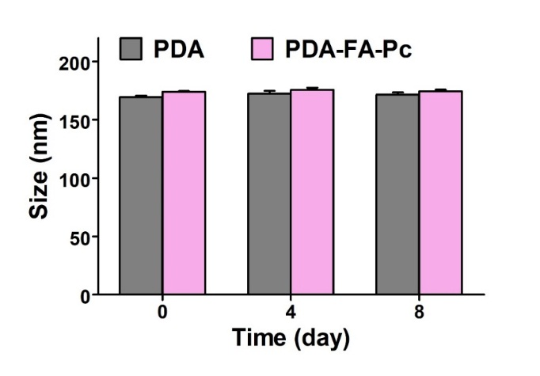
Figure S3. Hydrodynamic diameters of PDA and PDA-FA-Pc nanomedicine in PBS determined by dynamic light scattering (DLS) analysis. PDA and PDA-FA-Pc nanomedicine were standing at room temperature for 0, 4, and 8 days before determination.

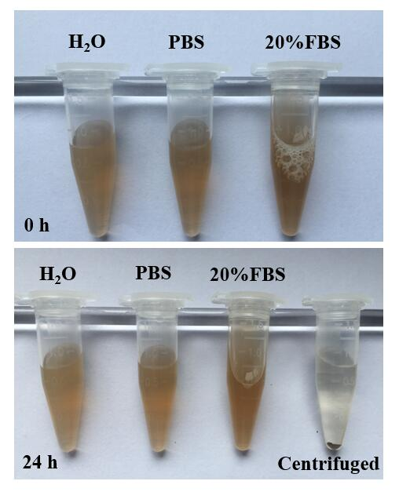
Figure S4. Apparent images of PDA-FA-Pc nanomedicine dispersed in aqueous solutions: water, PBS, and PBS with 20% fetal bovine serum (FBS) before and after standing at room temperature for 24 h.

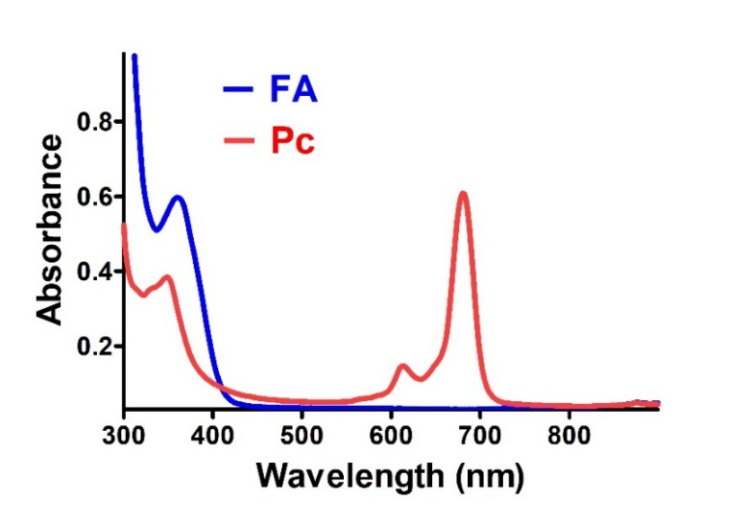
Figure S5. UV-vis absorption spectra of pure FA and Pc in PBS.

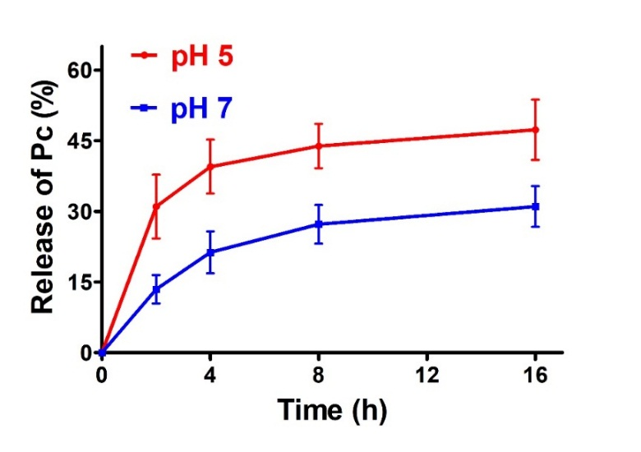
Figure S6. The release of the monomeric Pc molecules from PDA-Pc in acidic (pH 5) and neutralized (pH 7) conditions.

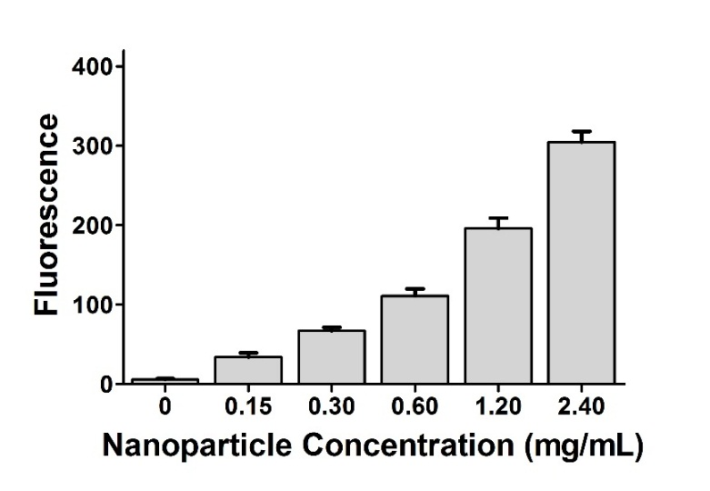
Figure S7. ROS production of PDA-FA-Pc nanomedicine in PBS.

Figure S8. The phototoxicities and dark toxicities of PDA (a) and PDA-FA (b) in the Hela cell line. The survival rates were determined after incubation with PDA or PDA-FA at various concentrations with and without illumination at 680 nm with the same light dose in Figure 5.

Figure S9. Body weights of mice during the in vivo experiments.

References
[1] X. S. Li, J. Guo, J. J. Zhuang, B. Y. Zheng, M. R. Ke and J. D. Huang, Bioorganic & Medicinal Chemistry Letters, 2015, 25, 2386.
[2] Y. X. Zhang, K. Zheng, Z. Chen, J. C. Chen, P. Hu, L. R. Cai, Z. Iqbal and M. D. Huang, Appl. Microbiol. Biot., 2017, 101, 4691.

