Supplements: Figure and Table legends

Fig. S1. 3-D cube plot of Box-Behnken experimental design for 3 factors.

Table S1. Scoring of human skin irritation study
Table S2. Criteria of single dose skin irritation study score system
Table S3. Effect of poloxamer on the average particle size of solid lipid nanoparticles.

Supplementary Information:

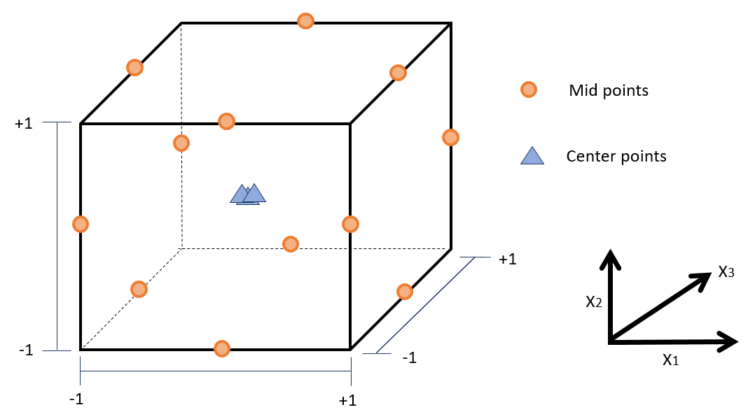

Fig. S1. 3-D cube plot of Box-Behnken experimental design for 3 factors.

Table S1. Scoring of human skin irritation study
Criteria | Score
No signs of inflammation, normal skin | 0 (-)
Doubtful or slight reaction | 0.5 (±)
Slight erythema | 1 (+)
Moderate erythema with or without partial edema or papules | 2 (++)
Moderate erythema with diffuse edema | 3 (+++)
Intense erythema with diffuse edema with vesicles | 4 (+++)

Table S2. Criteria of single dose skin irritation study score system
Criteria | Irritation score
No irritancy | 0-0.02
Low irritancy | 0.021-0.25
Slight irritancy | 0.26-1
Moderate irritancy | 1-2.5
Severe irritancy | 2.5-

Table S3. Effect of poloxamer on the average particle size of solid lipid nanoparticles.
 | Formulation
 | Rx 1 | Rx 2 | Rx 3
PPD (%, w/v) | 0.05 | 0.05 | 0.05
Cetyl palmitate (%, w/v) | 1 | 1 | 1
Tween 20 (%, v/v) | 1 | 1 | 1
Poloxamer (%, w/v) | 0 | 0.25 | 0.5
Particle size (nm) | 261 ± 2.44 | 223 ± 7.53 | 207 ± 6.23

Abbreviations: PPD, 20(S)-protopanaxadiol; Rx, NLC formulation

