Supplementary materials
Figure S1 Intensity particle size distribution of nanoparticles without crosslinking (A) and with crosslinking (B) dispersed in 1% acetic acid solution (N/P ratio=2.5).
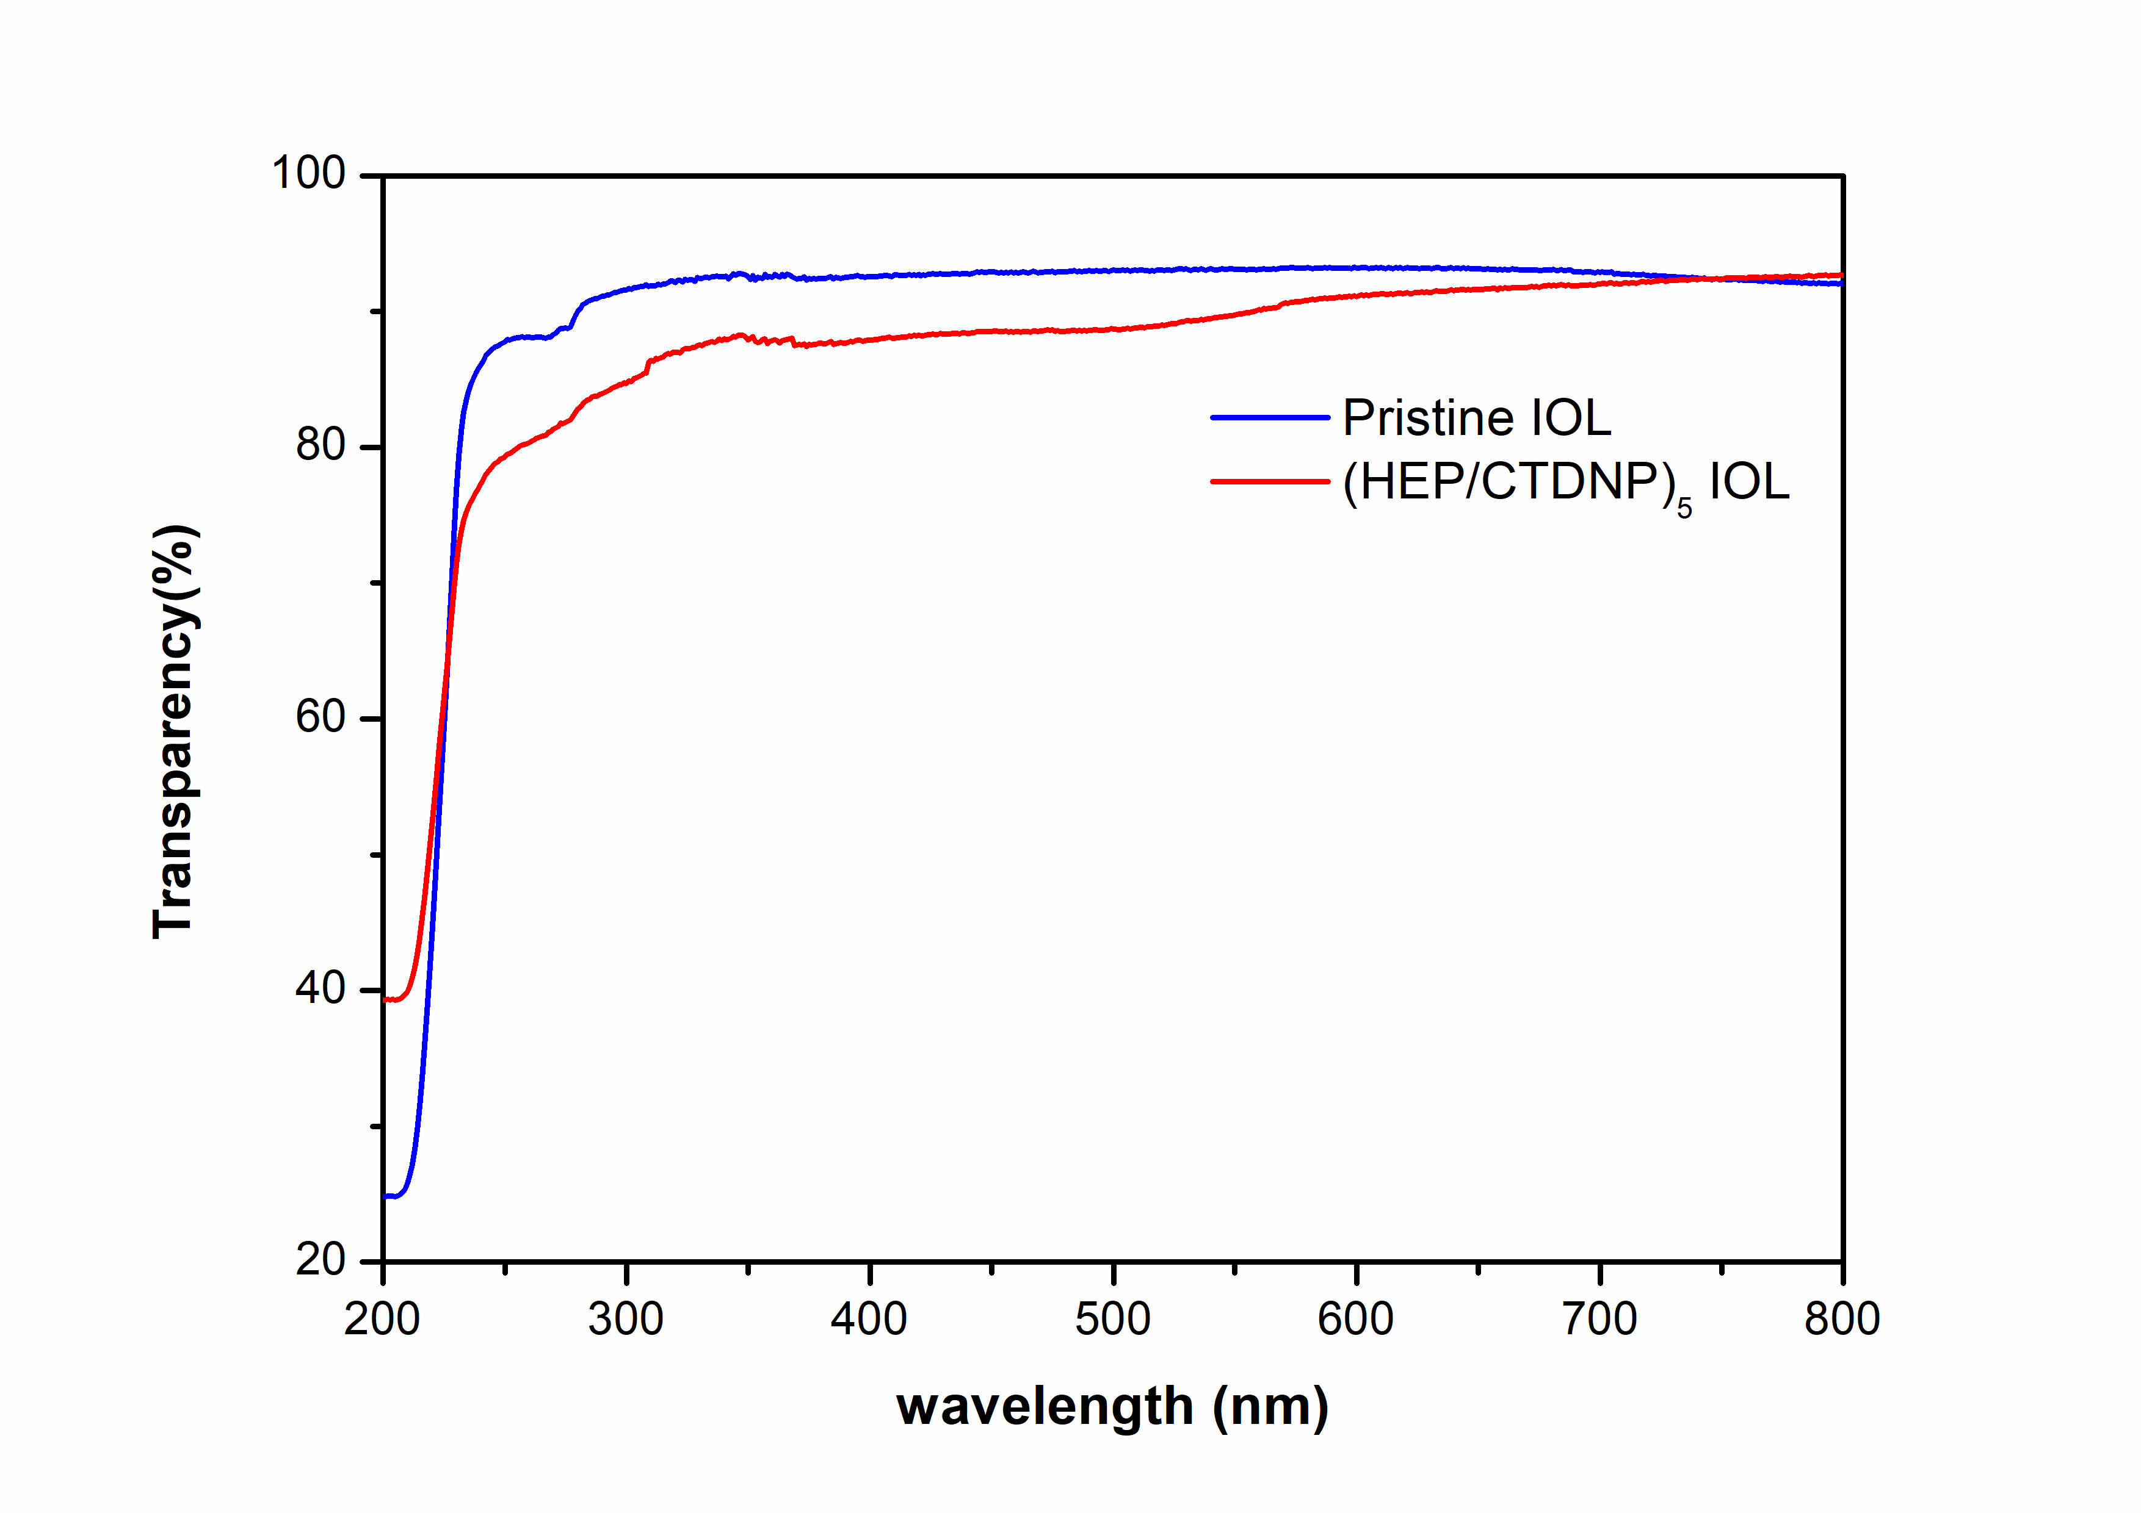
Figure S2 Light transmission curve of Pristine IOL and (HEP/CTDNP)₅-IOL

