Supplementary material
Figures
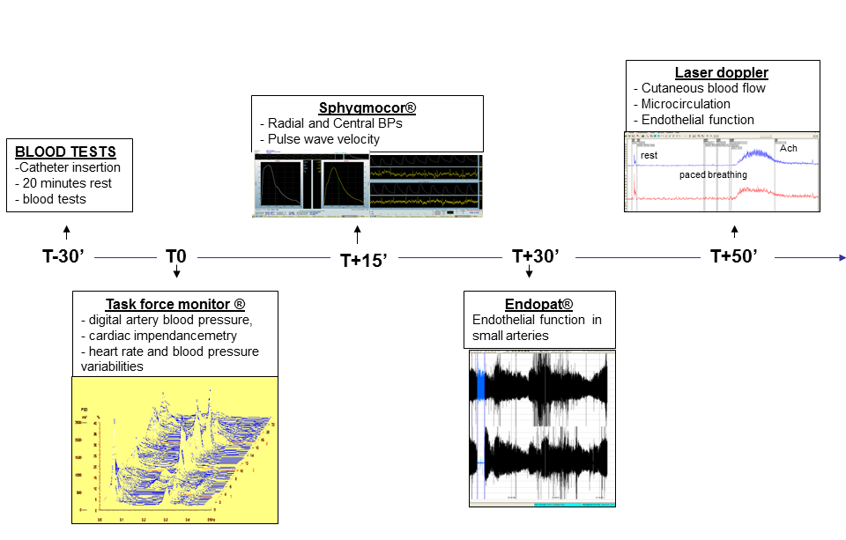
Figure 1 Schematic representation of cardiovascular investigations
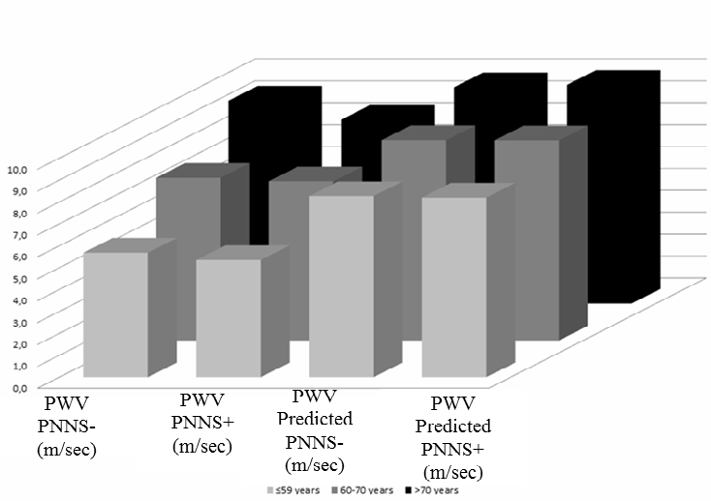

Supplementary Figure 2: Pulse wave velocity measured and predicted using age values for the PNNS+ and PNNS− groups.
Age-predicted values for PWV in all participants were also analyzed. Given the higher age of our subjects (60–65 years) and the increase in PWV with age, the fit with a full quadratic equation (0.000 × age + 0.83 × 10³ × age² + 5.55) ¹ would provide better values of R² than a linear fit.

References
- Boutouyrie P and Vermeersch SJ. Determinants of pulse wave velocity in healthy people and in the presence of cardiovascular risk factors: Establishing normal and reference values. Eur Heart J. 2010;31:2338-2350.
Tables

Supplementary Table 1: Energy and nutrient intake in 2007 and 2012 (n = 49 subjects)

 | 2007 | 2012 | p
Energy (kcal) | 2316.0 ± 779.6 | 2138.4 ± 562.1 | 0.027
Proteins (g) | 107.7 ± 39.0 | 97.0 ± 30.9 | 0.004
Animal proteins (g) | 79.5 ± 35.3 | 70.3 ± 28.3 | 0.006
Vegetable proteins (g) | 28.2 ± 12.0 | 26.7 ± 8.4 | 0.301
Carbohydrates (g) | 222.2 ± 85.6 | 204.8 ± 54.8 | 0.075
Total simple sugars (g) | 118.4 ± 53.3 | 107.5 ± 34.2 | 0.071
Added sugars (g) | 38.5 ± 29.3 | 35.7 ± 23.6 | 0.352
Cholesterol (mg) | 381.0 ± 140.4 | 355.0 ± 125.8 | 0.082
Fat (g) | 101.8 ± 39.9 | 96.5 ± 33.1 | 0.169
Saturated fat (g) | 39.2 ± 15.8 | 35.6 ± 13.0 | 0.025
Monounsaturated fat (g) | 39.4 ± 16.3 | 37.9 ± 14.3 | 0.338
Polyunsaturated fat (g) | 16.1 ± 8.1 | 16.2 ± 7.2 | 0.868
Linoleic acid (g) | 12.9 ± 6.8 | 12.8 ± 6.4 | 0.932
Arachidonic acid (g) | 0.2 ± 0.1 | 0.2 ± 0.1 | 0.221
Alpha linoleicacid (g) | 1.5 ± 0.9 | 1.5 ± 0.7 | 0.939
Eicosapentaenoic acid (g) | 0.2 ± 0.1 | 0.2 ± 0.2 | 0.036
Docosapentoic acid (g) | 0.1 ± 0.0 | 0.1 ± 0.1 | 0.259
Docosahexanoic acid (g) | 0.3 ± 0.2 | 0.4 ± 0.3 | 0.028
Alcohol (g) | 11.5 ± 16.6 | 8.9 ± 9.8 | 0.243

Supplementary Table 2: Energy and nutrient intake in 2007 and 2012 according to adherence to PNNS guidelines
PNNS+ and PNNS−: individuals who did (PNNS+) and did not (PNNS−) continuously adhered to the French Nutrition and Health Program guidelines (PNNS)

 | PNNS−-, n=23 |  | PNNS+, n=26
 | 2007 | 2012 | 2007 | 2012 | TIME | GROUP | INTERACTION
Energy intake(kcal) | 2902.8 ± 754.2 | 2550.8 ± 464.4 | 1819.6 ± 324.8 | 1789.4 ± 369.6 | 0.014 | < 0.001 | 0.370
Nutrient intake
(% of total energy intake)
Total Proteins (%) | 17.9 ± 3.15 | 18.1 ± 3.1 | 19.5 ± 2.5 | 18.2 ± 2.5 | 0.062 | 0.261 | 0.016
Animal proteins (%) | 13.4 ± 3.70 | 13.8 ± 3.3 | 14.0 ± 3.2 | 12.4 ± 3.0 | 0.086 | 0.639 | 0.012
Vegetable proteins (%) | 4.4 ± 1.45 | 4.3 ± 1.2 | 5.50 ± 1.5 | 5.8 ± 1.1 | 0.652 | 0.001 | 0.198
Carbohydrates (%) | 37.6 ± 8.03 | 36.5 ± 6.1 | 39.7 ± 6.7 | 40.9 ± 6.3 | 0.977 | 0.074 | 0.168
Total simple sugars (%) | 20.8 ± 5.57 | 20.7 ± 5.8 | 20.0 ± 3.9 | 20.1 ± 4.3 | 0.001 | 0.554 | 0.014
Added sugars (%) | 8.0 ± 4.31 | 8.2 ± 6.4 | 5.0 ± 2.5 | 5.5 ± 2.3 | 0.501 | 0.015 | 0.002
Fat (%) | 40.9 ± 6.48 | 43.0 ± 4.9 | 37.5 ± 6.2 | 37.5 ± 6.4 | 0.242 | 0.006 | 0.222
Saturated fat (%) | 15.8 ± 3.19 | 16.6 ± 2.7 | 14.5 ± 3.9 | 13.3 ± 2.3 | 0.581 | 0.006 | 0.021
Monounsaturated fat (%) | 15.8± 3.15 | 16.9 ± 2.8 | 14.4 ± 2.3 | 14.6 ± 2.9 | 0.172 | 0.008 | 0.265
Polyunsaturated fat (%) | 6.4 ± 2.01 | 6.5 ± 1.8 | 5.7 ± 1.0 | 6.8 ± 2.1 | 0.031 | 0.586 | 0.069
Nutrient intake (per day)
Linoleic acid (g) | 17.3 ± 7.6 | 14.9 ± 5.4 | 9.1 ± 2.5 | 11.0 ± 6.7 | 0.769 | < 0.001 | 0.018
Arachidonic acid (g) | 0.2 ± 0.1 | 0.2 ± 0.7 | 0.1 ± 0.0 | 0.1 ± 0.0 | 0.196 | < 0.001 | 0.351
Alpha linoleicacid (g) | 1.8 ± 1.1 | 1.7 ± 0.8 | 1.1 ± 0.4 | 1.2 ± 0.5 | 0.033 | 0.004 | 0.215
Eicosapentaenoic acid (g) | 0.2 ± 0.1 | 0.2 ± 0.2 | 0.2 ± 0.1 | 0.2 ± 0.1 | 0.031 | 0.324 | 0.156
Docosapentoic acid (g) | 0.1 ± 0.0 | 0.1 ± 0.1 | 0.1 ± 0.0 | 0.1 ± 0.0 | 0.246 | 0.016 | 0.593
Docosahexanoic acid (g) | 0.3 ± 0.2 | 0.4 ± 0.3 | 0.3 ± 0.2 | 0.4 ± 0.2 | 0.021 | 0.147 | 0.319
Alcohol (g) | 15.36 ± 22.60 | 9.00 ± 11.72 | 8.16 ± 8.00 | 8.76 ± 8.12 | 0.190 | 0.263 | 0.115

Supplementary table 3
*PWV adjusted for direct length derived from the equation: direct = 0.45 x subtracted + 0.21 × height + 0.08 (m))(1)
** Theoretical PWV derived from the equation: PWV=0.000 × age + 0.83 × 10-3 × age² + 5.55 (1)

 | Measured PWV  (m/sec) | PWV adjusted for direct length (m/sec)* | Theoretical PWV  (m/sec)**
PNNS + | 7.4±1.8 | 6.1 ± 0.9 | 9.3 ± 0.6
PNNS - | 7.1±2.4 | 5.9 ± 1.1 | 8.9 ± 0.6

We have recalculated an adjusted PWV with the direct path length according to the equation from the paper that established the reference values (1) (this is the reference 34 in our manuscript) and the results remained the same.

Additional statistical analyses:

Measured PWV vs PWV Adjusted for direct length: within subjects comparison, p<0.001, between subjects (PNNS+ vs PNNS-), p= 0.544, (interaction PWV*PNNS), p= 0.589.

Measured PWV vs Theoretical PWV: for direct length: within subjects comparison p<0.001, between subjects (PNNS+ vs PNNS-) p=0.306, (interaction PWV*PNNS), p=0.991.

PWV Adjusted for direct length Vs Theoretical PWV: within subjects comparison p<0.001, between subjects (PNNS+ vs PNNS-) p=0.170, (interaction PWV*PNNS, p=0.528).

The adjusted PWV with the direct path length was even lower than the measured one. Additional analysis had no impact in our results.

The use of the direct path length presents certain defaults.
The same authors of the paper that established the reference values(1) pointed out, “ as the use of direct distance (i.e. measured over the body surface) leads to overestimation of real PWV [using magnetic resonance imaging (MRI) or invasive measurements], we (i.e. the authors ) used a scaling factor of 0.8 derived from Sugawara et al. and Weber et al. to convert PWV obtained using direct distances to ‘real’ PWV” (1; 2).
This approach was used for treating data from different sources and strongly suggests the inaccuracy of the use of direct distance which needs to be transformed so as to approximate the real PWV.
The value of the subtracted path length was shown in another work in which the authors stated that “the subtracted, rather than direct, path length represent an extremely important step toward standardizing the methodology for assessment of aortic stiffness.”(3; 4)
Another strong point in our work was the absence of abdominal obesity which can make subtracted distance measurements inaccurate since the mean BMI in our population was 23.5±3.4 kg/m²

References

1. Determinants of pulse wave velocity in healthy people and in the presence of cardiovascular risk factors: 'establishing normal and reference values'. Eur Heart J 2010;31:2338-2350
2. Weber T, Ammer M, Rammer M, Adji A, O'Rourke MF, Wassertheurer S, Rosenkranz S, Eber B: Noninvasive determination of carotid-femoral pulse wave velocity depends critically on assessment of travel distance: a comparison with invasive measurement. J Hypertension 2009;27:1624-1630
3. Nemeth ZK, Studinger P, Kiss I, Othmane Tel H, Nemcsik J, Fekete BC, Deak G, Egresits J, Szathmari M, Tisler A: The method of distance measurement and torso length influences the relationship of pulse wave velocity to cardiovascular mortality. American journal of hypertension 2011;24:155-161
4. Sharman JE: What is the best path length for aortic pulse wave velocity? Preliminary answer to a stiff question. Am J Hypertension 2011;24:122

