Supplementary Figures
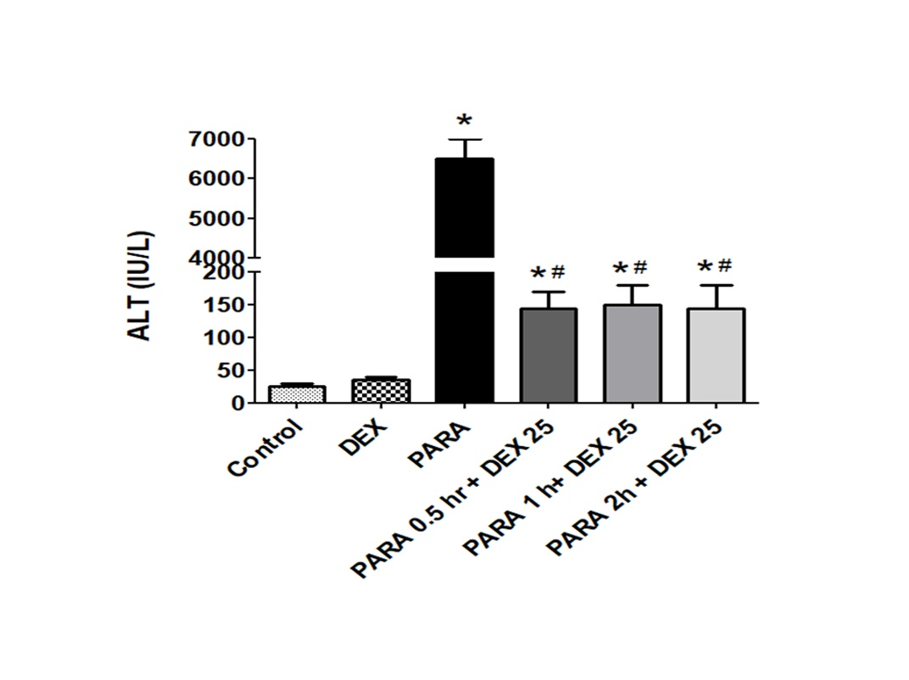
Supplemental Figure 1 Effect of DEX administration 1-2 hrs after PARA exposure.
Mice were intraperitoneally administered PARA (300 mg/kg) and DEX (25 μg/kg) was given 0.5, 1, and 2 hrs after injection of PARA. Then mice were sacrificed 16 hrs later for assessment of serum ALT levels. Results are presented as the mean ± SEM; n = 6 mice per group. *p < 0.05 vs. control; #p < 0.05 vs. PARA alone.

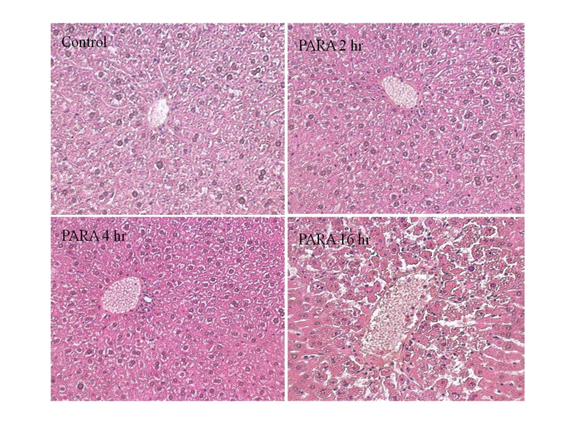

Supplemental Figure 2 Effect of PARA-induced liver toxicity-related histology for early time points compared to late time point. Mice were intraperitoneally administered saline (control), PARA (300 mg/kg) and were sacrificed 2, 4, and 16 hrs later for H&E staining (200x). Typical images were chosen from each group.
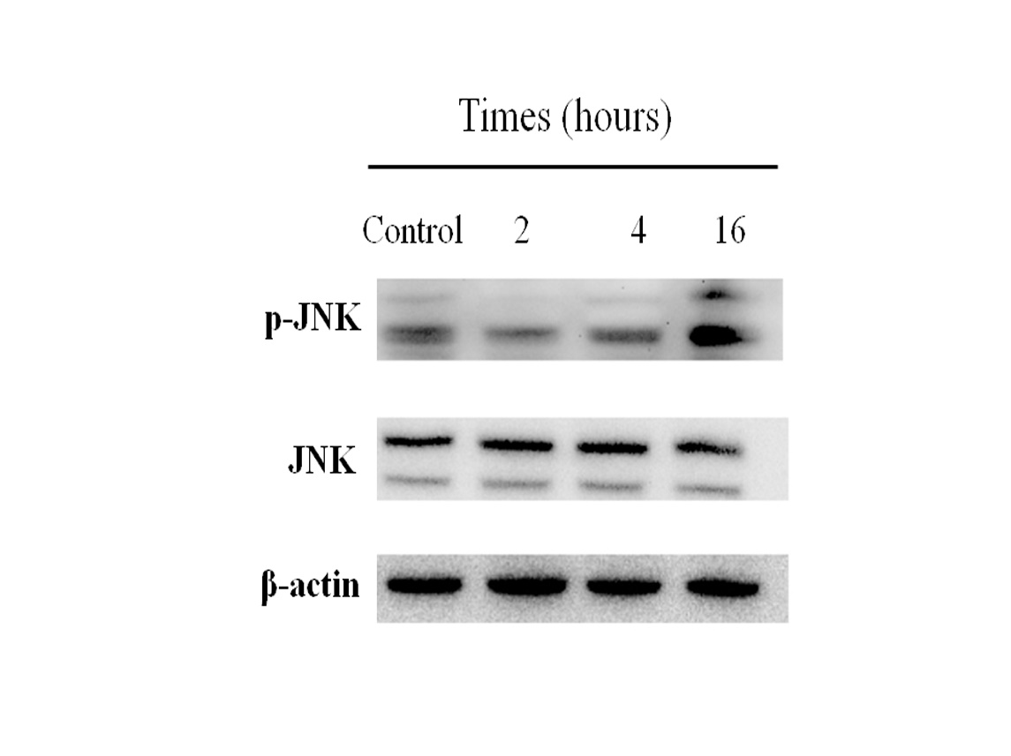

Supplemental Figure 3 Western blot analysis of phosphorylated JNK protein expression in early time points PARA-induced liver toxicity compared to late time point. Mice were intraperitoneally administered saline (control), PARA (300 mg/kg) and were sacrificed 2, 4, and 16 hrs later for JNK and p-JNK protein expression. Blots were reprobed for β-actin to ensure equal protein loading in all lanes.

