Development of nanosome-encapsulated honokiol for intravenous therapy against experimental autoimmune encephalomyelitis
Yai-Ping Hsiao¹, Hui-Ting Chen¹, Yu-Chih Liang², Tse-En Wang¹, Kai-Hung Huang³, Cheng-Chih Hsu³, Hong-Jen Liang⁴, Chung-Hsiung Huang^{5,}*, Tong-Rong Jan, PhD^{1,}*

¹Department of Veterinary Medicine, School of Veterinary Medicine, National Taiwan University, No.1, Sec. 4, Roosevelt Road, Taipei 10617, Taiwan
²School of Medical Laboratory Science and Biotechnology, College of Medical Science and Technology, Taipei Medical University, Taipei 10617, Taiwan.
³Department of Chemistry, National Taiwan University, No.1, Sec. 4, Roosevelt Road, Taipei 10617, Taiwan.
⁴Department of Food Science, Yuanpei University, No.306, Yuanpei Street, Hsinchu 30015, Taiwan.
⁵Department of Food Science, National Taiwan Ocean University, No.2, Beining Road, Keelung 20224, Taiwan. E-mail: huangch@mail.ntou.edu.tw
Correspondence:
Tong-Rong Jan, Department and Graduate Institute of Veterinary Medicine, School of Veterinary Medicine, National Taiwan University, No.1, Sec. 4, Roosevelt Road, Taipei 10617, Taiwan, ROC. Phone: +886-2-33661287; Fax: +886-2-23661475; E-mail: tonyjan@ntu.edu.tw
Chung-Hsiung Huang, Department of Food Science, National Taiwan Ocean University, No.2, Beining Road, Keelung 20224, Taiwan. Phone: +886-2-24622192#5115 ; E-mail: huangch@mail.ntou.edu.tw
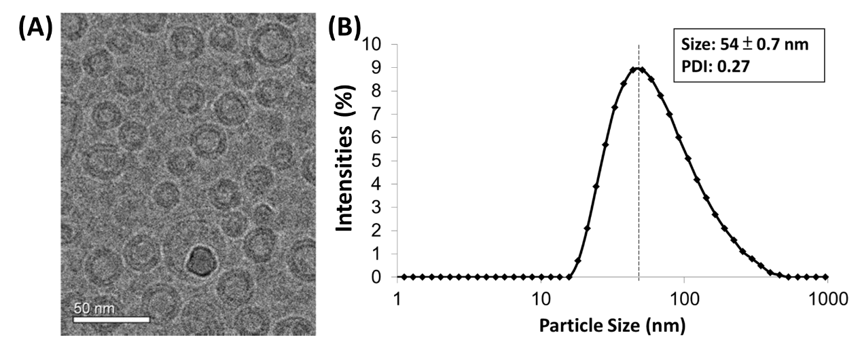
Supplementary Figure 1. (A) The prepared nanosomes observed by field emission gun electron microscopy revealed a sphere bilayer structure and homogeneously distributed around 50 nm, (B) which was consistent with the data of size distribution obtained from dynamic light scattering analysis.

