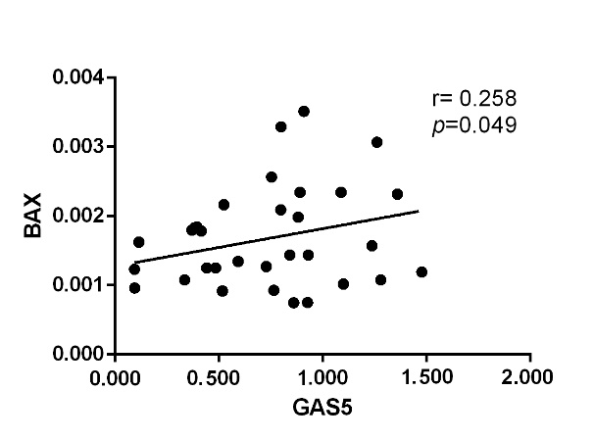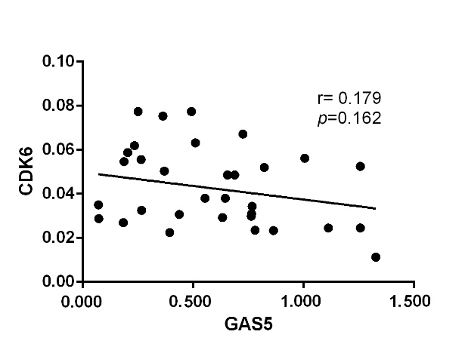
B
A
Figure S1. Correlation between GAS5 and BAX/CDK6. Relative expression of GAS5, BAX and CDK6 were detected in LSCC tissues (n=32). Correlation analysis between GAS5 and BAX（A）and correlation between GAS5 and CDK6 (B) were performed respectively.

