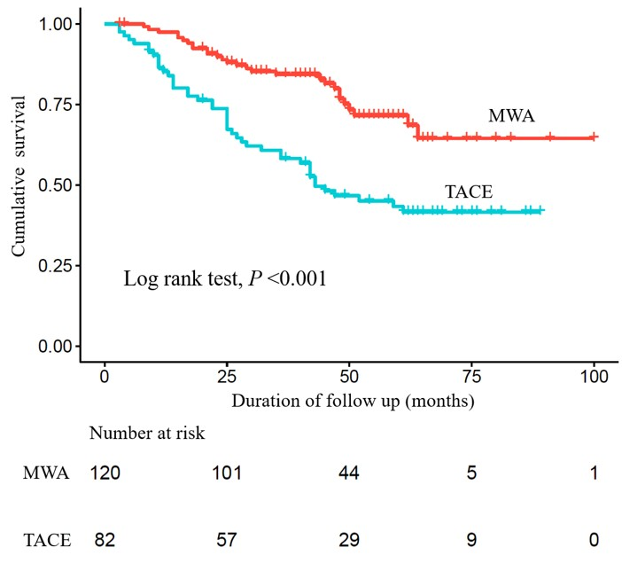
Figure S1 Comparison of the overall survival of HCC patients between the MWA group and the TACE group before PSM. Significantly better survival was found for HCC patients undergoing MWA.

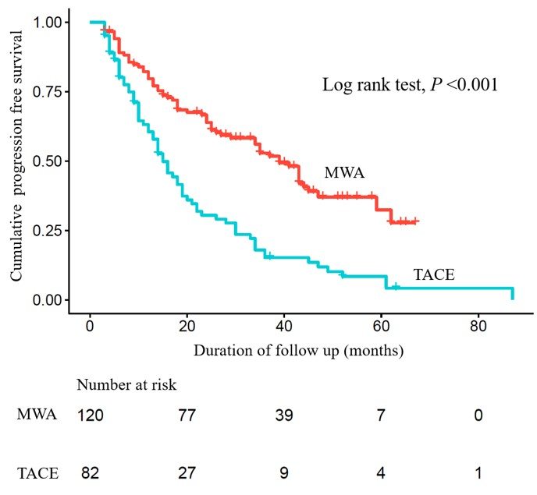
Figure S2 Comparison of the progression free survival of HCC patients between the MWA group and the TACE group before PSM. Significantly better PFS was found for HCC patients undergoing MWA.

Table S1 Outcomes of treatment response
 | Unmatched cohort |  |  |  | Matched cohort
 | MWA (n=120) | TACE (n=82) | P value |  | MWA (n=58) | TACE (n=58) | P value
Number of procedures | 1.1±0.3 | 1.2±0.5 | 0.019 |  | 1.1±0.3 | 1.3±0.6 | 0.056
1 | 109 | 65 |  |  | 51 | 43
2 | 11 | 16 |  |  | 7 | 14
3 | 0 | 1 |  |  | 0 | 1
Treatment response |  |  | <0.001 |  |  |  | <0.001
CR | 118 (98.3%) | 57 (69.5%) |  |  | 58 (100.0%) | 42 (72.4%)
PR | 2 (1.7%) | 22 (26.8%) |  |  | 0 | 15 (25.9%)
SD | 0 | 3 (3.7%) |  |  | 0 | 1 (1.7%)
PD | 0 | 0 |  |  | 0 | 0
CR, complete response (disappearance of any arterial enhancement in the lesion);
PR, partial response (decrease ≥30 % of in the diameter of viable arterial enhancement in the lesion);
PD, progressive disease (an increase of at least 20% in the diameters of viable arterial enhancement in the lesion);
SD, stable disease (all other cases)

