Supporting Information
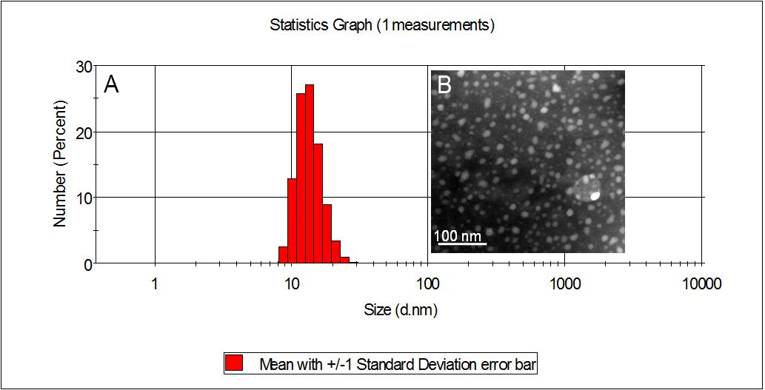
Figure S1. Size distribution (A) and TEM image (B) of IF-7-MNC after size-shrinkage.
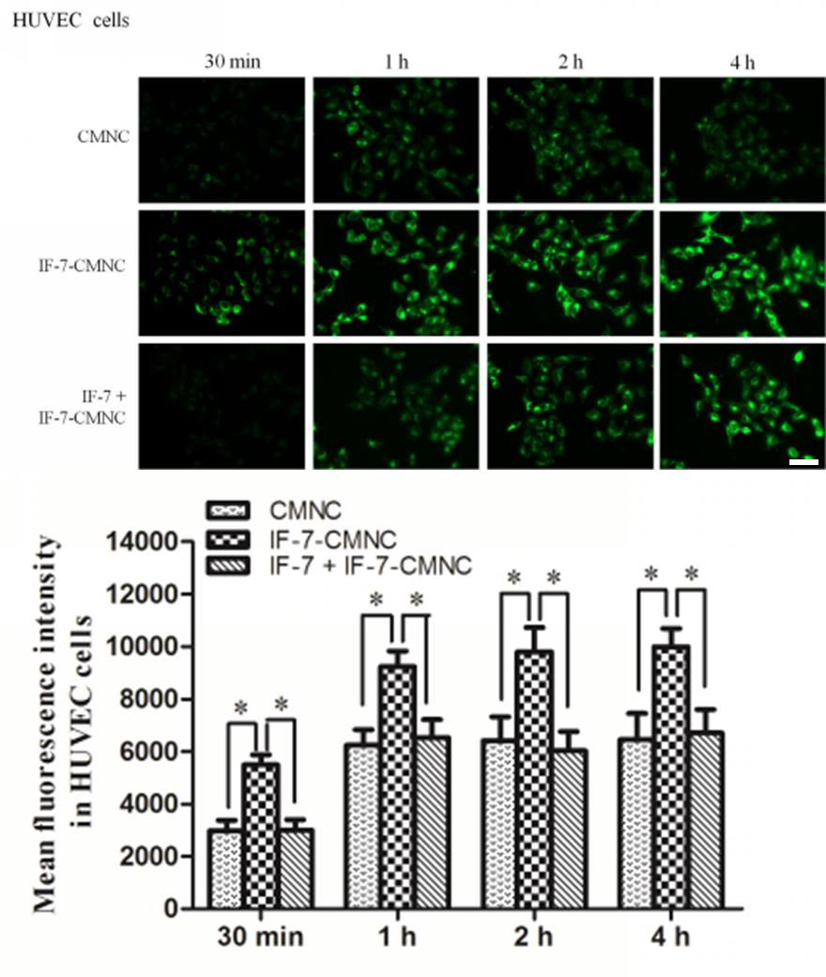
Figure S2. (A) Qualitative and (B) quantitative result of CMNC and IF-7-CMNC taken in by HUVEC cells. The cellular uptake level of IF-7-CMNC by cells pre-incubated with 100 μg IF-7 was served as control. (n = 3) * p < 0.05, ** p < 0.01. Scale bar = 100 μm.
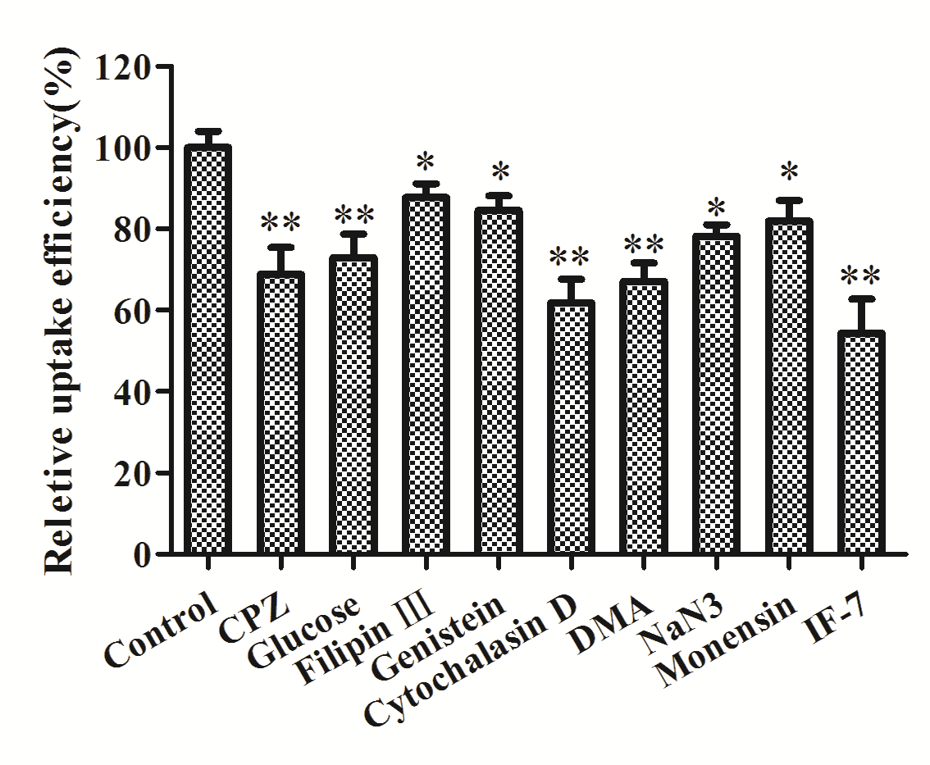
Figure S3. Effects of various inhibitors on cellular uptake of IF-7-CMNC in A549 cells. The average fluorescence intensity of IF-7-CMNC in untreated cells served as control (n=3). *p < 0.05, **p < 0.01, significantly different with that of control.

