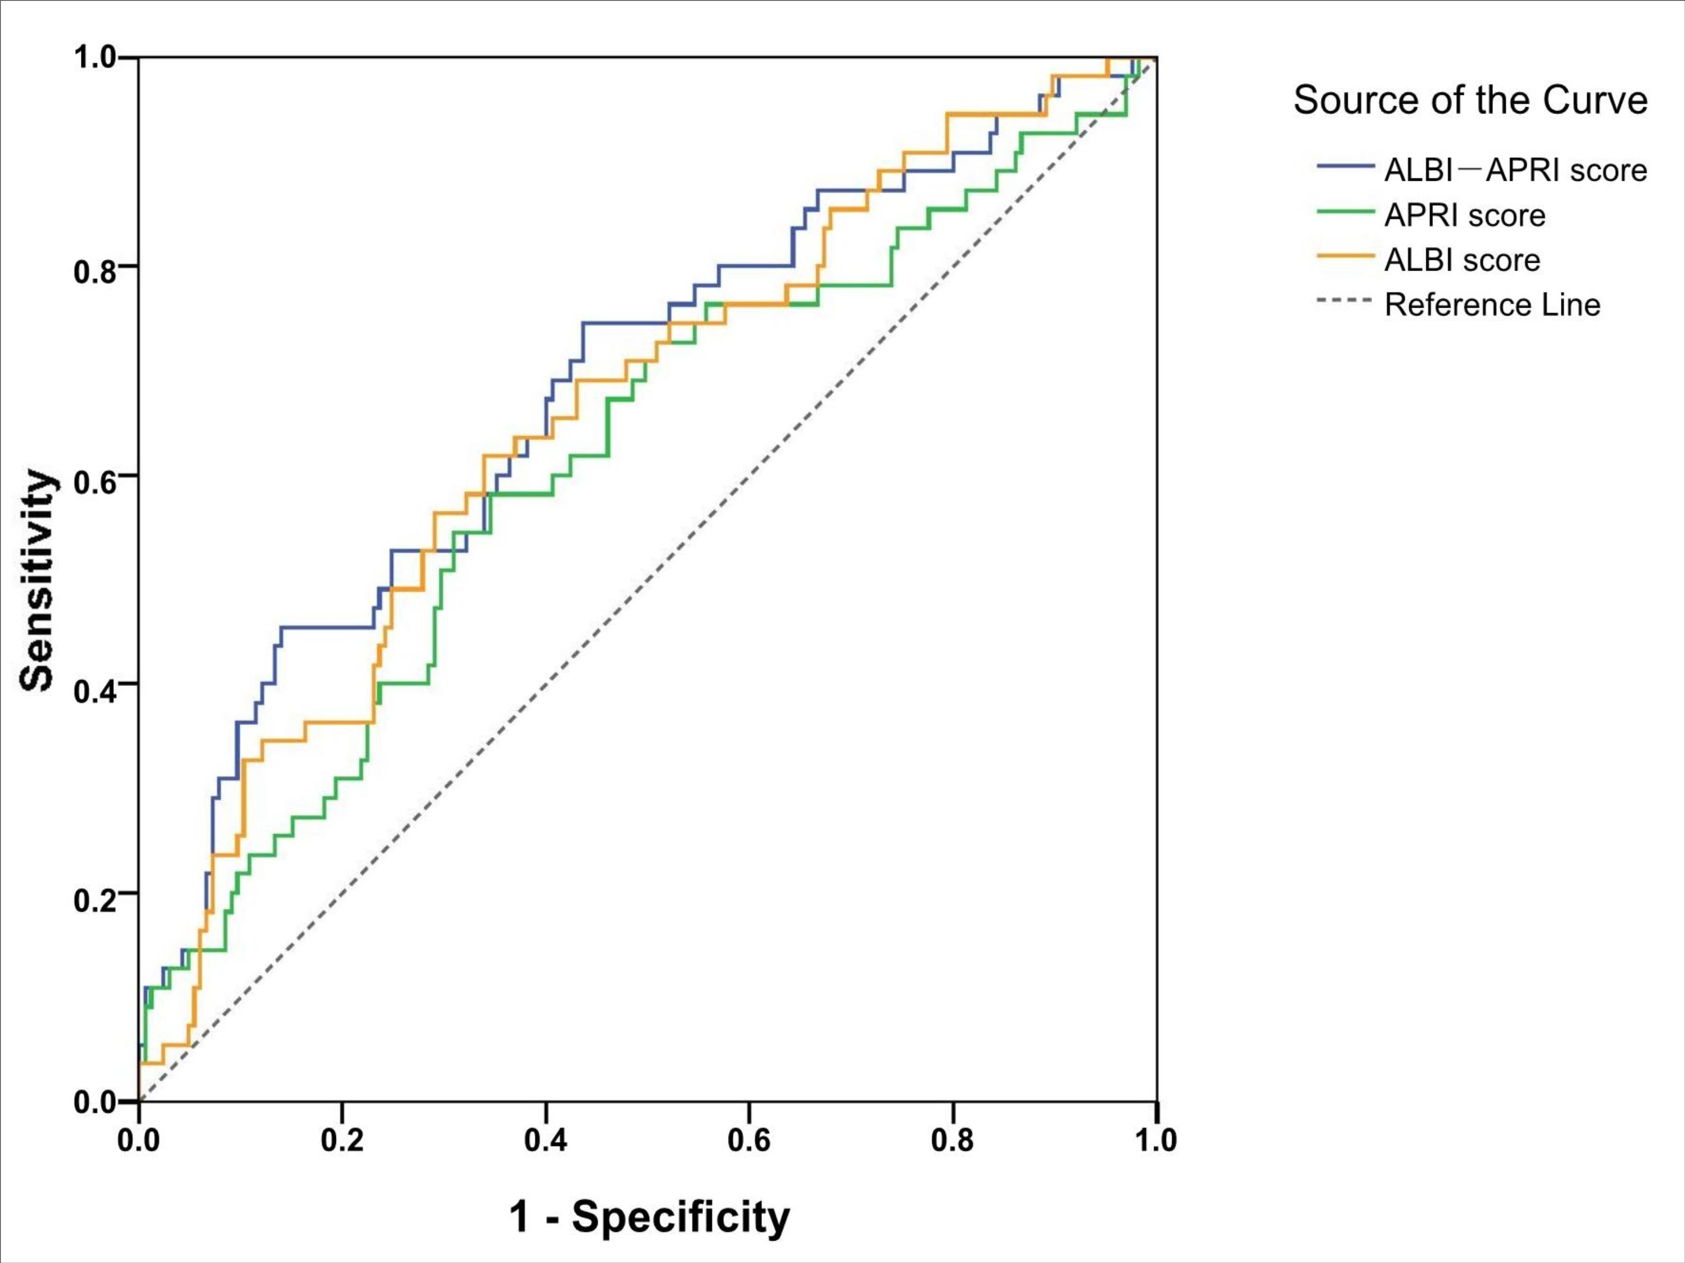Figure supplement: ROC curves for ALBI, APRI, and ALBI-APRI scores for predicting PHLF for subjects who underwent major resection.
Abbreviations: PHLF, posthepatectomy liver failure; ALBI, albumin - bilirubin; APRI, aminotransferase - platelet ratio index; ALBI-APRI, combination of ALBI and APRI.

