Supplementary Figures

Figure S1
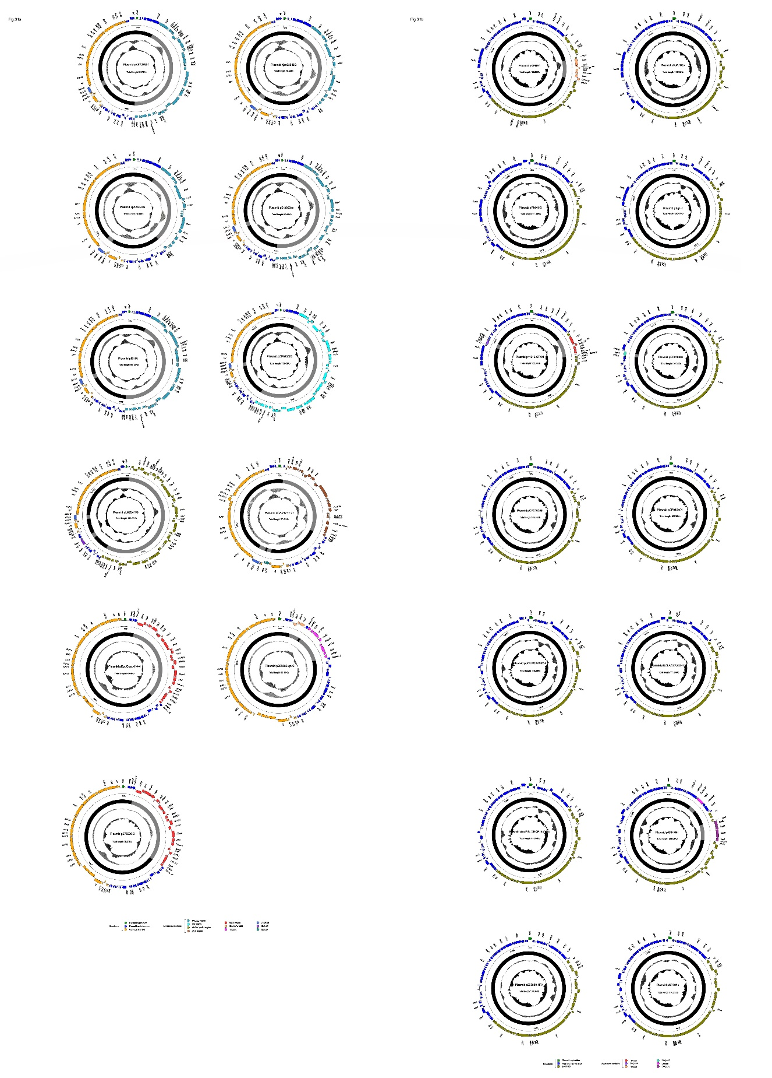
Figure S1 | Plasmid schematic maps. Included are the 11 IncFII_{pKF727591} plasmids and the 14 Inc_{pKPHS1} plasmids of are included in the comparative analysis. Genes are denoted by arrows, and the backbone and accessory module regions are highlighted in black and color, respectively. The innermost circle presents GC-skew [(G-C)/(G+C)], with a window size of 500 bp and a step size of 20 bp. The next-to-innermost circle presents GC content.

Figure S2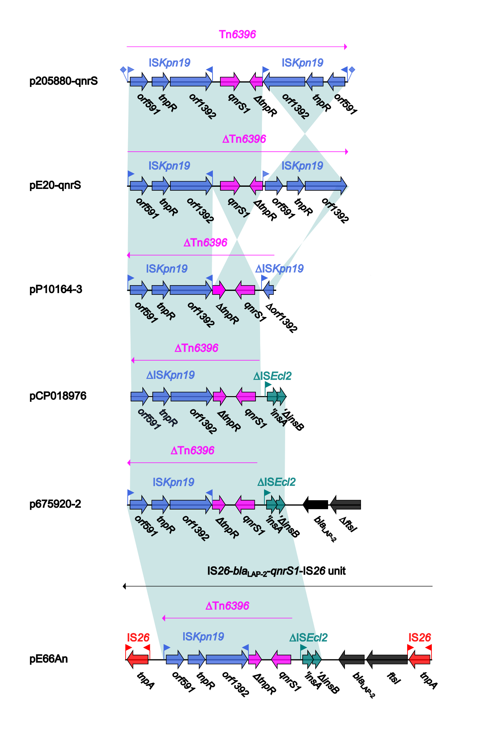
Figure S2 | Organization of Tn6396 and its derivatives. Genes are denoted by arrows. Genes, mobile elements and other features are colored based on function classification. Shading denotes regions of homology (>95% nucleotide identity). The accession numbers of pE20-qnrS, pP10164-3,²³ pCP018976 and pE66An²¹ are MG288684, KX710094, CP018976 and HF545433, respectively.

