Supplementary Table 1 Two-way repeated-measures ANOVA exploring the effects of gender (female and male) and condition (silence, music, and noise) on subjective ratings of pain intensity (PI) and unpleasantness (PU).
 | Gender |  |  |  | Condition |  |  |  | Interaction
 | F(1,28) | p | η_{p}² |  | F(2,56) | p | η_{p}² |  | F(2,56) | p | η_{p}²
PI | 0.03 | 0.867 | 0.001 |  | 2.31 | 0.109 | 0.08 |  | 1.43 | 0.248 | 0.05
PU | 0.07 | 0.793 | 0.002 |  | 6.24 | 0.004 | 0.18 |  | 0.76 | 0.474 | 0.03

Supplementary Table 2 Two-way repeated-measures ANOVA exploring the effects of gender (female and male) and condition (silence, music, and noise) on the amplitude (μV) and latency (ms) of N2 and P2 waves.
 | Gender |  |  |  | Condition |  |  |  | Interaction
 | F(1,28) | p | η_{p}² |  | F(2,56) | p | η_{p}² |  | F(2,56) | p | η_{p}²
N2_{amp} | 1.49 | 0.232 | 0.05 |  | 2.64 | 0.080 | 0.09 |  | 1.91 | 0.158 | 0.06
N2_{lat} | 0.04 | 0.838 | 0.002 |  | 0.81 | 0.450 | 0.03 |  | 0.20 | 0.818 | 0.007
P2_{amp} | 0.05 | 0.818 | 0.002 |  | 5.13 | 0.009 | 0.16 |  | 0.25 | 0.779 | 0.009
P2_{lat} | 0.93 | 0.342 | 0.03 |  | 1.02 | 0.367 | 0.04 |  | 0.25 | 0.779 | 0.009

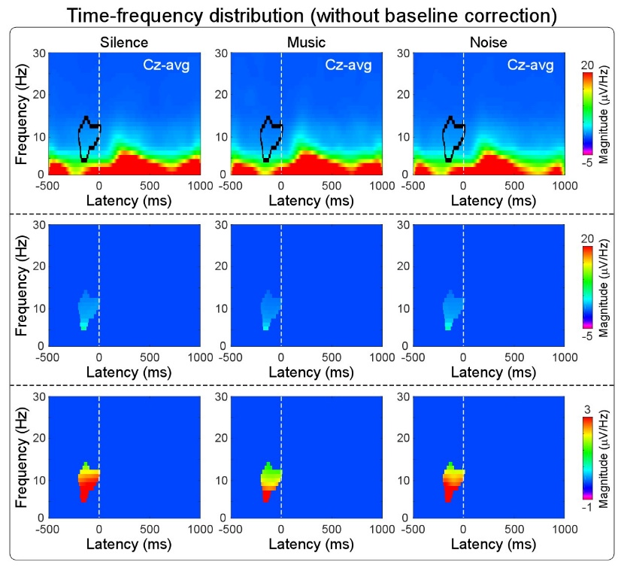

Supplementary Figure 1. The comparison of the magnitude in the prestimulus time-frequency cluster using different colorbar scales.

