Improving Longitudinal Transversal Relaxation of Gadolinium Chelate Using Silica Coating Magnetite Nanoparticles
Kai Xu^{1,2},
Heng Liu³,
Junfeng Zhang^{1,2},
Haipeng Tong^{1,2},
Zhenghuan Zhao⁴,
Weiguo Zhang^{1,2}
¹.Department of Radiology, Daping Hospital, Army Medical Center of PLA, Army Medical University, Chongqing 400042, China; ².Chongqing Clinical Research Center for Imaging and Nuclear Medicine, Chongqing 400042, China; ³.Department of Radiology, PLA Rocket Force Characteristic Medical Center, Beijing, 100088, China; ⁴. Department of Pharmaceutical Engineering, College of Pharmaceutical Sciences, Southwest University, Chongqing 400716, China

Support Information
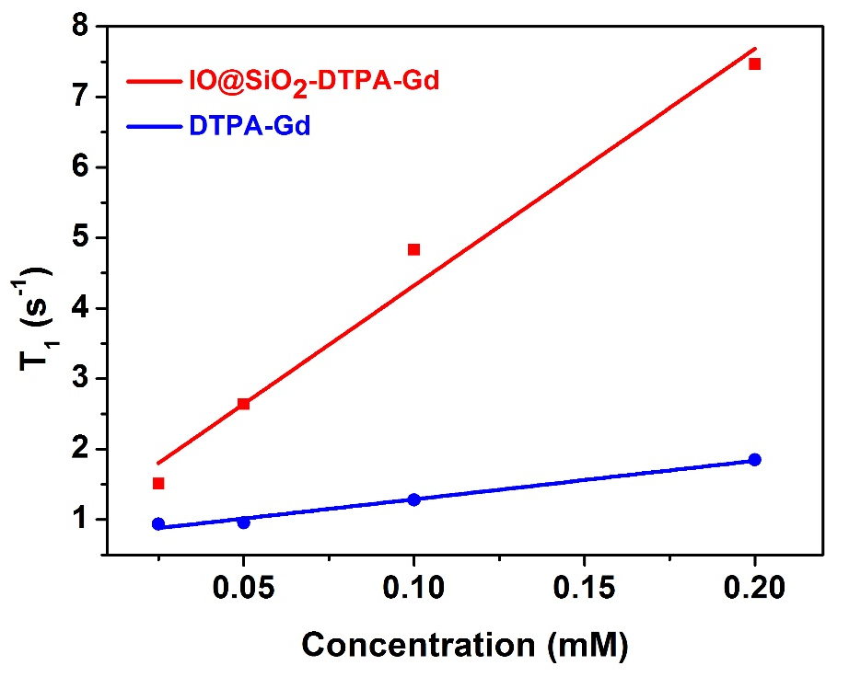
Figure S1 Analyses the r₁ of IO@SiO₂-DTPA-Gd and DTPA-Gd. The analysis of relaxation rate R₁ (1/T₁) vs Gd concentration for IO@SiO₂-DTPA-Gd and DTPA-Gd.

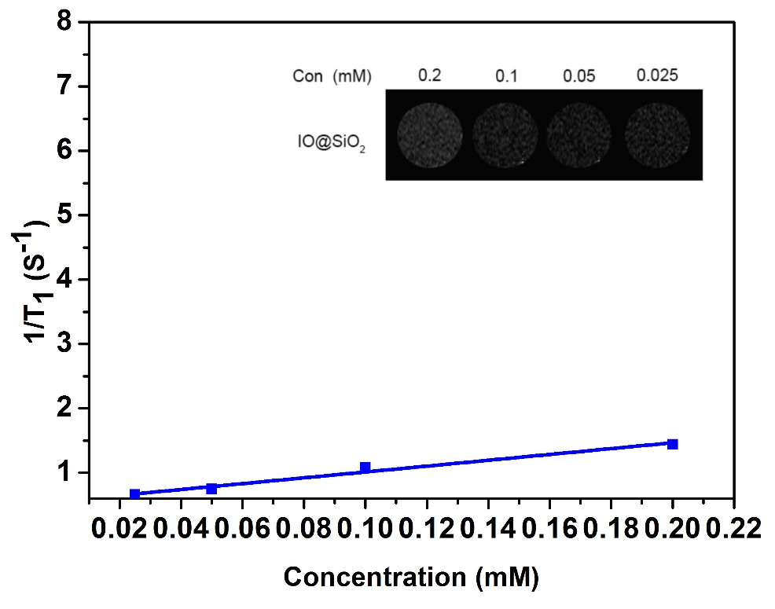
Figure S2 Analyses the r₁ of IO@SiO₂. The analysis of relaxation rate R₁ (1/T₁) vs Fe concentration for IO@SiO₂. Insert is T1 MRI phantom studies of IO@SiO₂ at different Mn concentrations (mm) in 1% agarose at 0.5 T.

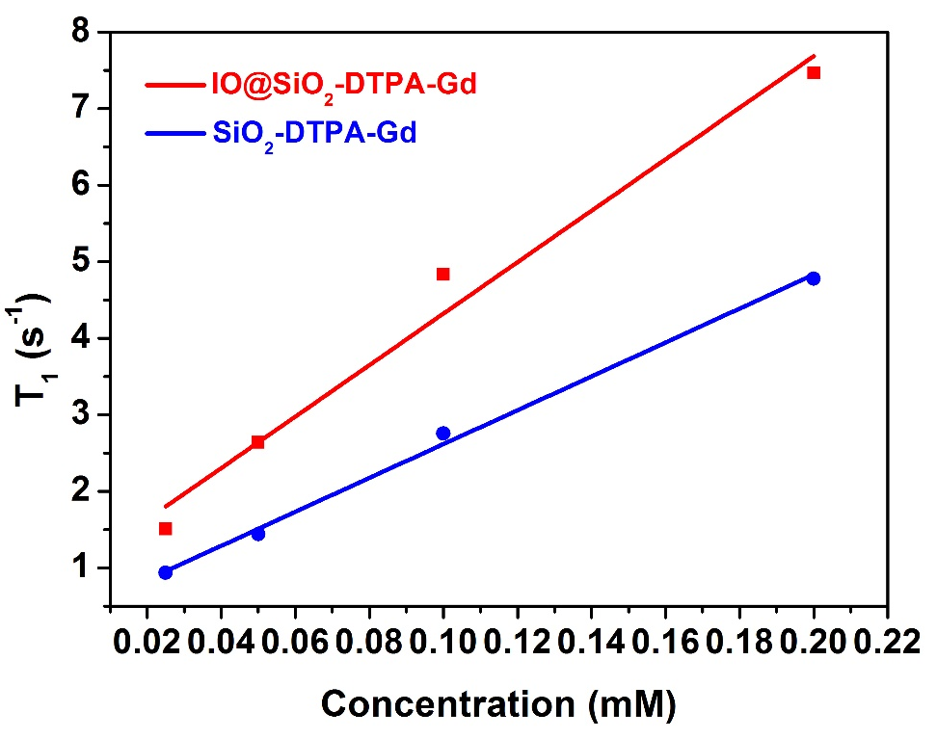
Figure S3 Analyses the r₁ of IO@SiO₂-DTPA-Gd and SiO₂-DTPA-Gd. The analysis of relaxation rate R₁ (1/T₁) vs Gd concentration for IO@SiO₂-DTPA-Gd and SiO₂-DTPA-Gd.

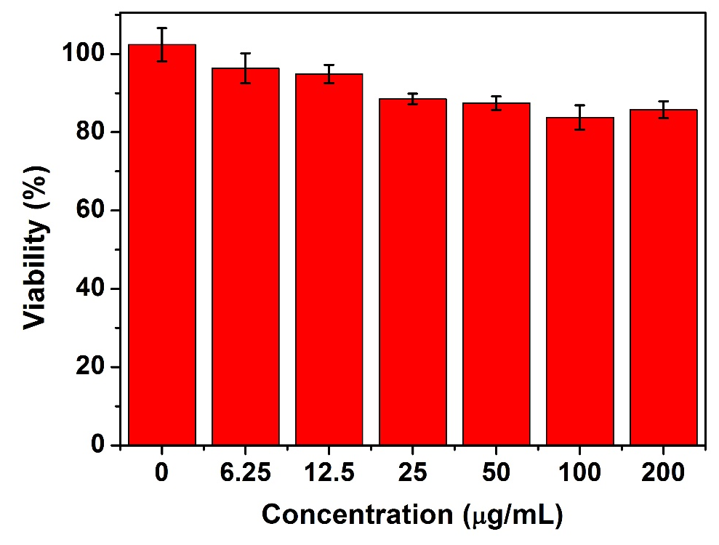
Figure S4 In vitro cytotoxicity of IO@SiO₂-DTPA-Gd. The MTT assay of HeLa cells incubated with various concentrations of IO@SiO₂-DTPA-Gd for 24 h (n = 5/group).

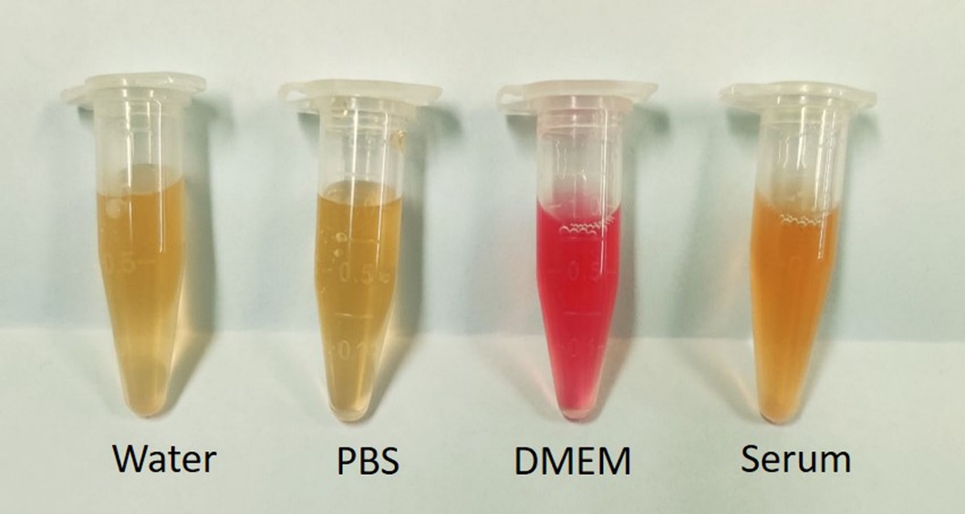

Figure S5 Stability of IO@SiO₂-DTPA-Gd in various solutions at 24 h after incubation. Neither apparent agglomeration nor precipitation was observed for IO@SiO₂-DTPA-Gd NPs after incubation for 24 h in water and different physiological media including PBS buffer, DMEM culture medium, and blood serum.

