Supplementary materials
4-methyl-N-(4-chloro-3-nitrophenyl)-3-[(4-pyridin-3-ylpyrimidin-2-yl) amino]benzamide (V)
Fig. S1. ¹H NMR (400 MHz, DMSO-d₆) of the final compound-nilotinib analogue V.

Fig. S2. ¹³C NMR (100 MHz, DMSO-d₆) of the final compound-nilotinib analogue V.

Fig. S3. High resolution ESI-MS of the final compound-nilotinib analogue V.

4-methyl-N-(4-amino-3-trifluoromethyl)-3-[(4-pyridin-3-ylpyrimidin-2-yl) amino]benzamide (VI).
Fig. S4. ¹H NMR (400 MHz, DMSO-d₆) of the final compound-nilotinib analogue VI

Fig. S5. ¹³C NMR (100 MHz, DMSO-d₆) of the final compound-nilotinib analogue VI

Fig. S6. High resolution ESI-MS of the final compound-nilotinib analogue VI

1-(4-methyl-3-[(4-pyridin-3-yl)pyrimidin-2-ylamino)phenyl]-3-(phenyl)urea (VII).
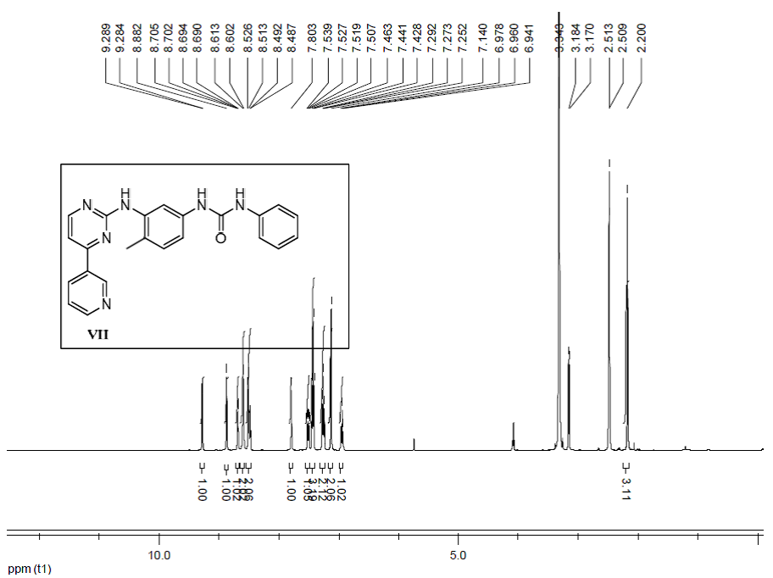
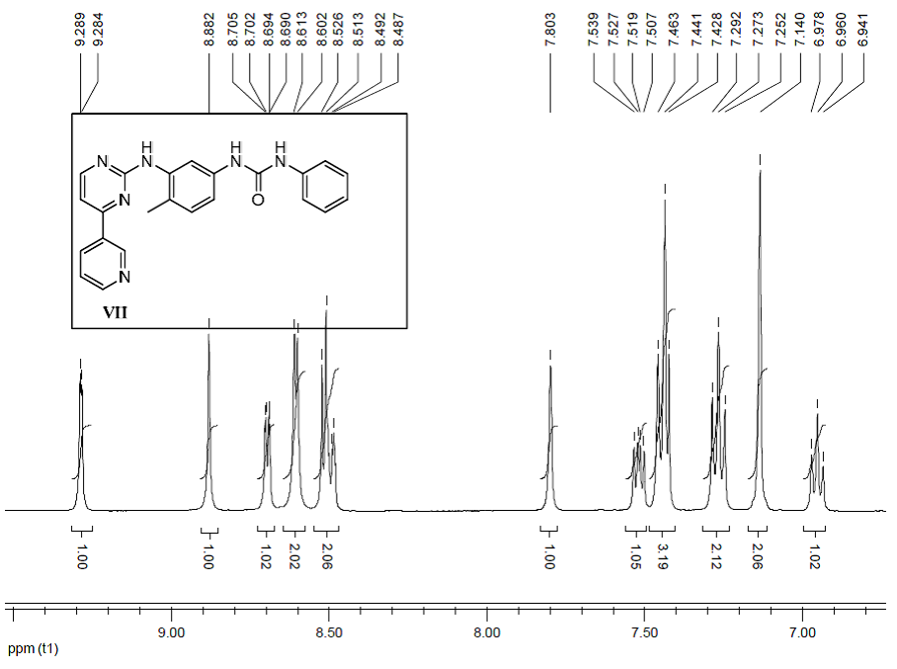
Fig. S7. ¹H NMR (400 MHz, DMSO-d₆) of the final compound-imatinib or nilotinib analogue VII
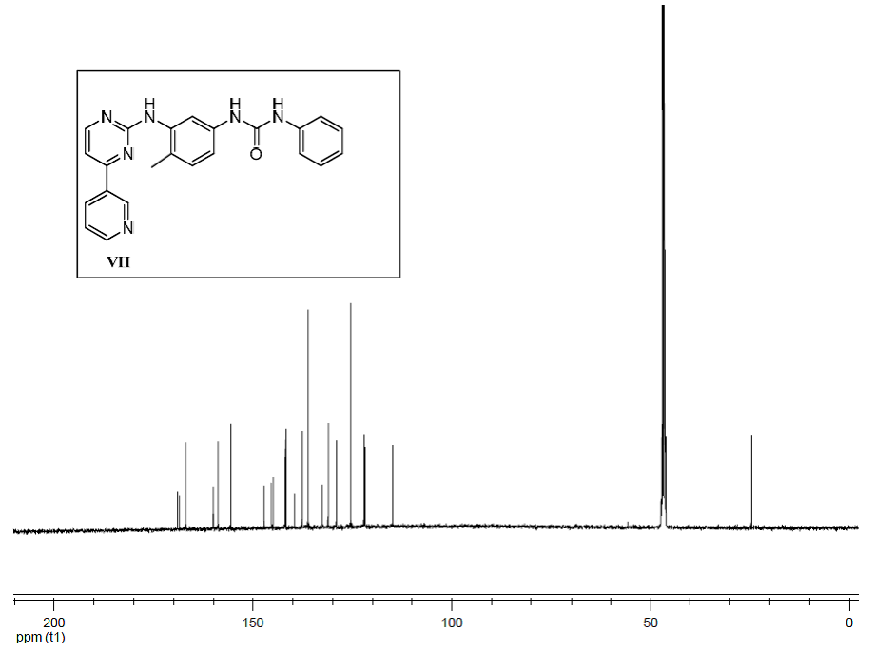
Fig. S8. ¹³C NMR (100 MHz, DMSO-d₆) of the final compound-imatinib or nilotinib analogue VII

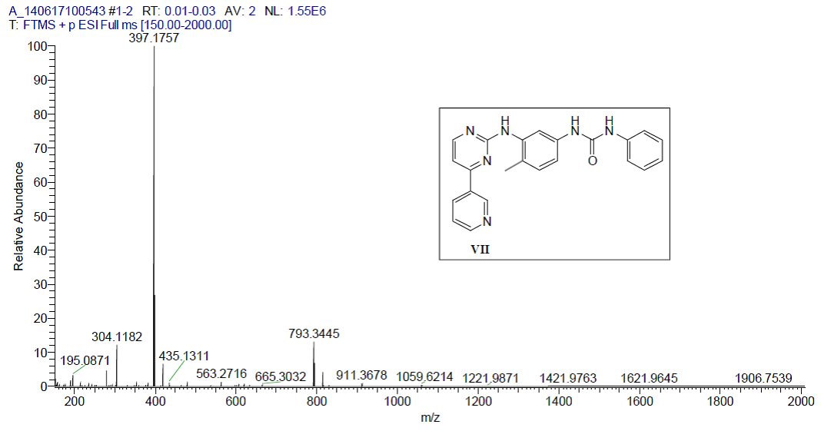
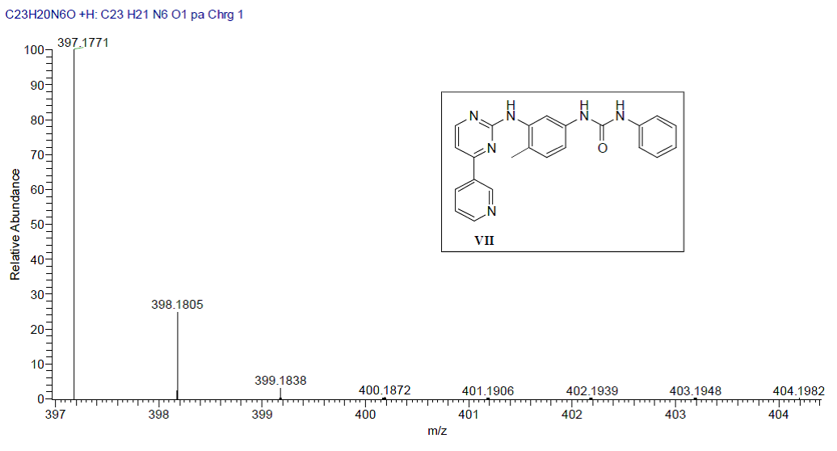
Fig. S9. High resolution ESI-MS of the final compound- imatinib or nilotinib analogue VII

1-(4-methyl-3-[(4-pyridin-3-yl)pyrimidin-2-ylamino)phenyl]-3-(4-chloro-3-nitrophenyl)urea (VIII).
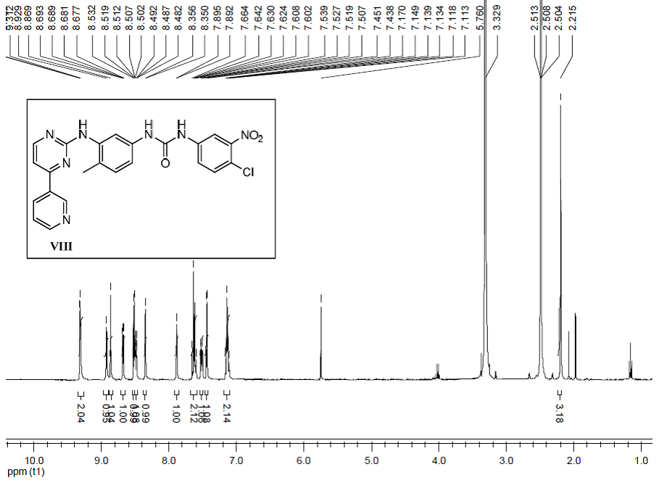
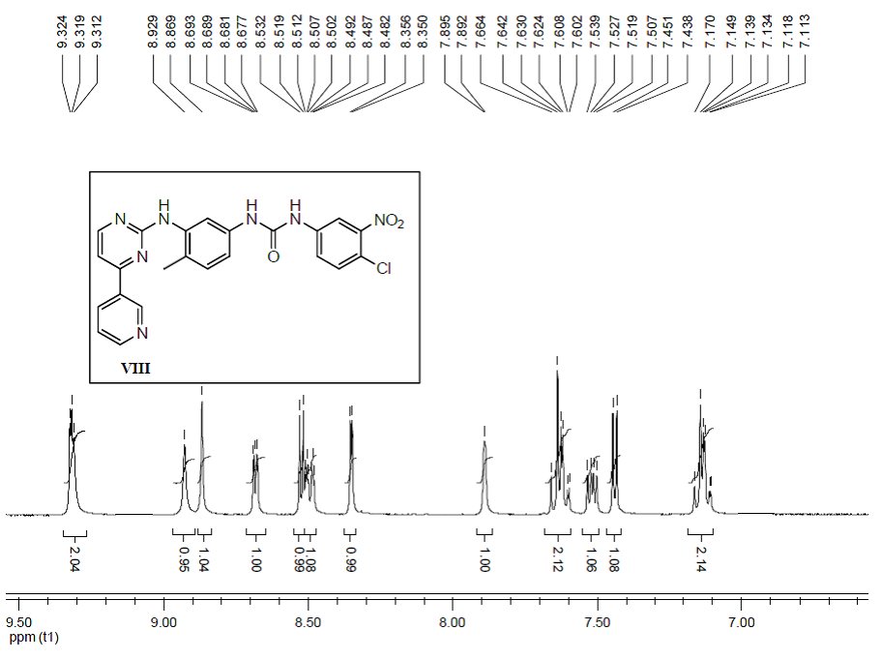
Fig. S10. ¹H NMR (400 MHz, DMSO-d₆) of the final compound-imatinib or nilotinib analogue VIII.

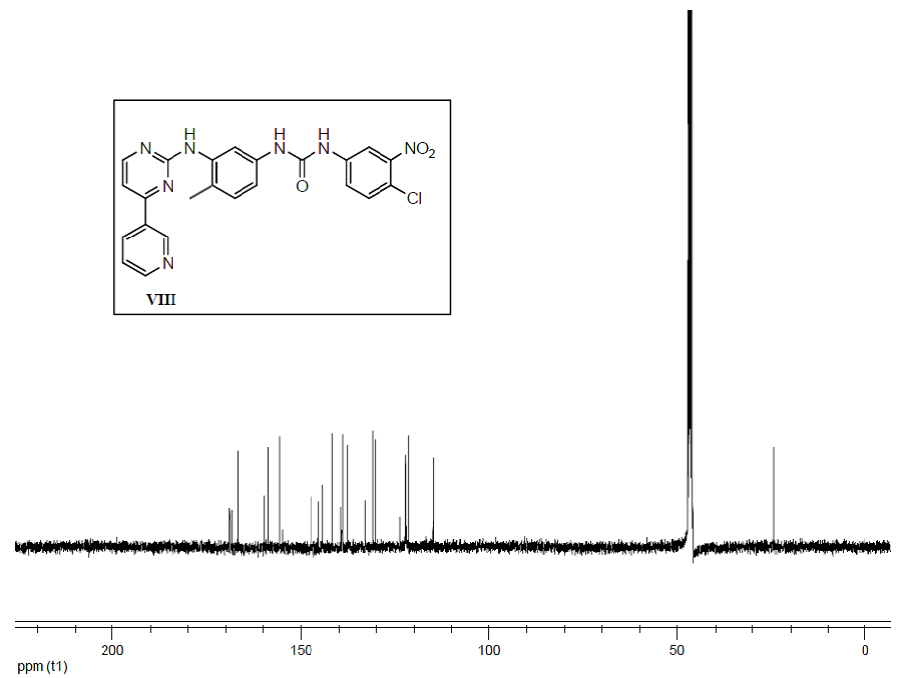
Fig. S11. ¹³C NMR (100 MHz, DMSO-d₆) of the final compound-imatinib or nilotinib analogue VIII.

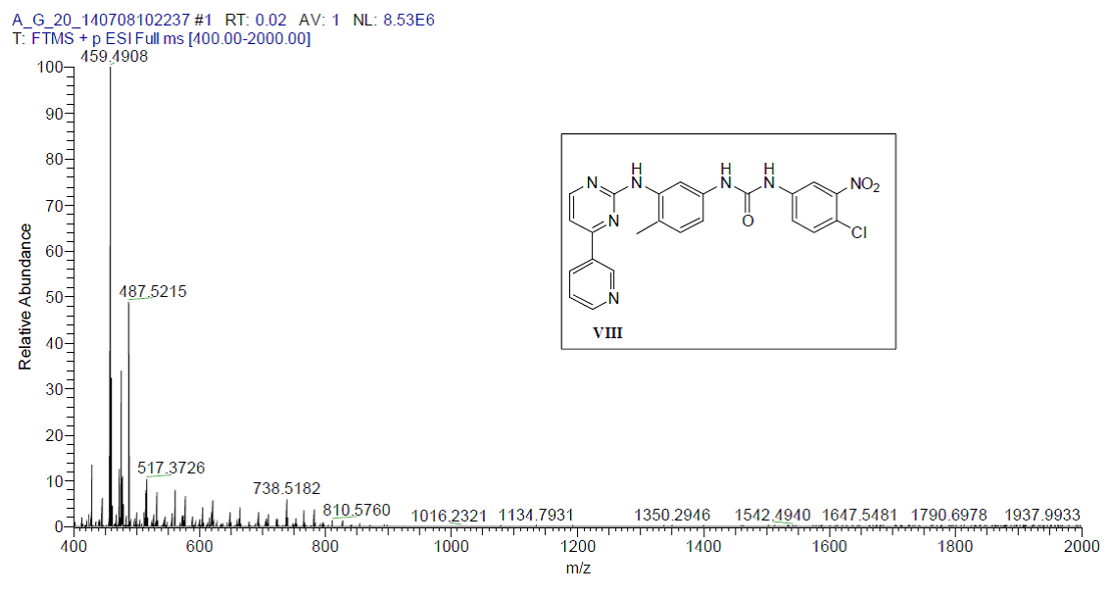
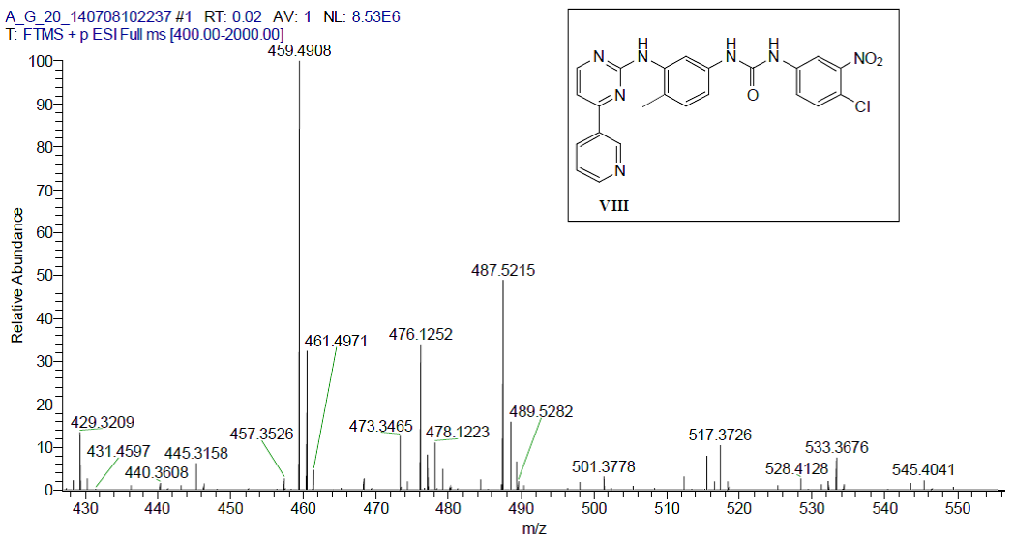
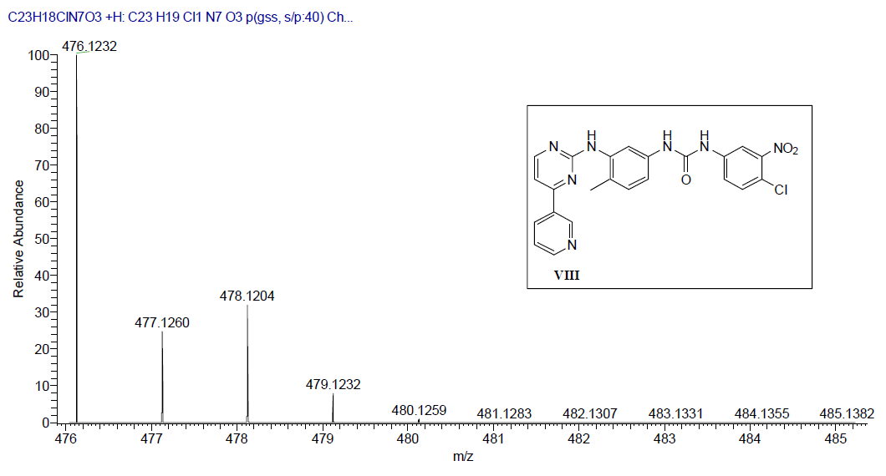
Fig. S12. High resolution ESI-MS of the final compound-imatinib or nilotinib analogue VIII.

