Supplementary materials

Synthesis and identification of CA4 prodrugs
The results about MS, ¹H-NMR, ¹³C-NMR of the synthesized of CA4-18, CA4-16, CA4-14, CA4-10, CA4-6 were shown in Tables 1-4.
Table 1s The MS, ¹H-NMR, ¹³C-NMR results of the synthesized of CA4-18
MS (ESI⁺) m/z | 583.89 [M + H]⁺ (40%), 600.80 [M + NH₄]⁺ (100%), HRMS (ESI⁺) m/z: 582.3929 [M]⁺
UV / vis λ (nm) | 286
¹H-NMR  (DMSO-d₆,  600 MHz) | δ 7.15 (dd, J = 1.71, 8.78 Hz, 1H), 7.08 (d, J = 8.89 Hz, 1H), 6.97 (d, J = 1.82 Hz, 1H), 6.55 (s, 2H), 6.52 (d, J = 12.31 Hz, 1H), 6.48 (d, J = 12.31 Hz, 1H), 3.75 (s, 3H), 3.65 (s, 3H), 3.62 (s, 6H), 1.57-1.62 (m, 2H), 1.24-1.32 (m, 30H), 0.87 (t, J = 7.16 Hz, 3H)
¹³C-NMR  (150 MHz, DMSO) | δ 171.48, 153.11, 150.56, 139.49, 137.32, 132.42, 129.95, 129.81, 128.71, 127.87, 123.05, 113.15, 106.37, 60.48, 56.31, 56.03, 33.59, 31.76, 29.48, 29.32, 29.16, 29.07, 28.69, 24.96, 22.56, 14.39

Table 2s The MS, ¹H-NMR, ¹³C-NMR results of the synthesized of CA4-16
MS (ESI⁺) m/z | 555.59 [M + H]⁺ (50%), 572.55 [M + NH₄]⁺ (100%), 1131.11 [2M + Na]⁺ (60%)
UV / vis λ (nm) | 286
¹H-NMR  (DMSO-d₆, 600 MHz) | δ 7.15 (dd, J = 2.06, 8.45 Hz, 1H), 7.08 (d, J = 8.63 Hz, 1H), 6.97 (d, J = 1.88 Hz, 1H), 6.55 (s, 2H), 6.52 (d, J = 12.20 Hz, 1H), 6.48 (d, J = 12.20 Hz, 1H), 3.75 (s, 3H), 3.65 (s, 3H), 3.62 (s, 6H), 1.57-1.62 (m, 2H), 1.25-1.31 (m, 26H), 0.87 (t, J = 6.57 Hz, 3H)
¹³C-NMR  (150 MHz, DMSO) | δ 171.44, 153.11, 150.56, 139.50, 137.32, 132.42, 129.95, 129.81, 128.69, 127.86, 123.04, 113.13, 106.38, 60.47, 56.30, 56.02, 33.59, 31.77, 29.52, 29.49, 29.43, 29.19, 29.09, 28.70, 24.97, 22.56, 14.38

Table 3s The MS, ¹H-NMR, ¹³C-NMR results of the synthesized of CA4-14
MS (ESI⁺) m/z | 527.72 [M + H]⁺ (10%), 1075.16 [2M + Na]⁺ (100%)
UV / vis λ (nm) | 286
¹H-NMR  (DMSO-d₆, 600 MHz) | δ 7.15 (dd, J = 2.16, 8.65 Hz, 1H), 7.08 (d, J = 8.56 Hz, 1H), 6.97 (d, J = 1.89 Hz, 1H), 6.55 (s, 2H), 6.52 (d, J = 12.61 Hz, 1H), 6.48 (d, J = 12.61 Hz, 1H), 3.75 (s, 3H), 3.65 (s, 3H), 3.62 (s, 6H), 1.55-1.62 (m, 2H), 1.25-1.33 (m, 22H), 0.87 (t, J = 6.75 Hz, 3H)
¹³C-NMR  (150 MHz, DMSO) | δ 171.46, 153.11, 150.56, 139.49, 137.30, 132.42, 129.95, 129.80, 128.69, 127.87, 123.05, 113.13, 106.36, 60.47, 56.29, 56.01, 33.59, 31.78, 29.54, 29.50, 29.44, 29.35, 29.20, 29.10, 28.70, 24.97, 22.57, 14.39

Table 4s The MS, ¹H-NMR, ¹³C-NMR results of the synthesized of CA4-10
MS (ESI⁺) m/z | 471.44 [M + H]⁺ (100%), 488.30 [M + NH₄]⁺ (80%), 958.05 [2M + NH₄]⁺ (50%), 963.00 [2M + Na]⁺ (90%)
UV / vis λ (nm) | 286
¹H-NMR  (DMSO-d₆, 600 MHz) | δ 7.15 (dd, J = 2.26, 8.43 Hz, 1H), 7.08 (d, J = 8.64 Hz, 1H), 6.97 (d, J = 2.06 Hz, 1H), 6.55 (s, 2H), 6.52 (d, J = 12.34 Hz, 1H), 6.49 (d, J = 12.34 Hz, 1H), 3.75 (s, 3H), 3.65 (s, 3H), 3.62 (s, 6H), 1.57-1.62 (m, 2H), 1.26-1.33 (m, 14H), 0.87 (t, J = 6.62 Hz, 3H)
¹³C-NMR  (150 MHz, DMSO) | δ 171.49, 153.10, 150.56, 139.48, 137.27, 132.43, 129.94, 129.80, 128.71, 127.88, 123.05, 113.13, 106.34, 60.48, 56.30, 56.01, 33.58, 31.75, 29.32, 29.11, 28.70, 24.97, 22.57, 14.41

Table 5s The MS, ¹H-NMR, ¹³C-NMR results of the synthesized of CA4-6
MS (ESI⁺) m/z | 415.32 [M + H]⁺ (90%), 432.15 [M + NH₄]⁺ (100%)
UV / vis λ (nm) | 286
¹H-NMR  (DMSO-d₆, 600 MHz) | δ 7.15 (dd, J = 1.93, 8.15 Hz, 1H), 7.08 (d, J = 8.15 Hz, 1H), 6.97 (d, J = 1.93 Hz, 1H), 6.55 (s, 2H), 6.52 (d, J = 12.13 Hz, 1H), 6.49 (d, J = 12.13 Hz, 1H), 3.75 (s, 3H), 3.65 (s, 3H), 3.62 (s, 6H), 1.59-1.62 (m, 2H), 1.30-1.32 (m, 6H), 0.87 (t, J = 6.88 Hz, 3H)
¹³C-NMR  (150 MHz, DMSO) | δ 171.50, 153.11, 150.56, 139.47, 137.27, 132.44, 129.93, 129.80, 128.72, 127.89, 123.06, 113.13, 106.34, 60.49, 56.30, 56.02, 33.55, 30.92, 24.65, 22.20, 14.25

Table 6s Percent conversation of CA4P, CA4-6-L, CA4-10-L, CA4-14-L, CA4-16-L, CA4-18-L after incubation with the rat plasma (n=3)
Time (h) | Percent conversion (%)
Time (h) | CA4P | CA4-6-L | CA4-10-L | CA4-14-L | CA4-16-L | CA4-18-L
0.03 | 13.16 ± 0.89 | 99.41± 0.01 | 40.69 ± 3.34 | 3.23 ± 1.24 | 9.58 ± 2.13 | 0.22 ± 0.37
0.25 | 23.98 ± 0.63 | 100.0 | 99.00 ± 2.64 | 10.60 ± 2.92 | 14.14 ± 1.65 | 0.87 ± 0.52
0.50 | 26.86 ± 2.46 |  | 100.0 | 21.57 ± 2.41 | 18.42 ± 1.92 | 1.14 ± 0.58
1.00 | 54.22 ± 1.97 |  |  | 39.47 ± 1.72 | 18.73 ± 2.56 | 1.51 ± 0.83
2.00 | 74.82 ± 2.07 |  |  | 69.19 ± 2.36 | 19.39 ± 2.18 | 3.03 ± 0.74
8.00 | 88.44 ± 2.83 |  |  | 98.20 ± 2.14 | 24.00 ± 2.01 | 10.48 ± 1.62
24.00 | 92.30 ± 3.04 |  |  | 100 | 62.29 ± 1.34 | 26.61 ± 1.87
48.00 | 96.40 ± 1.08 |  |  |  | 94.23 ± 1.75 | 40.41 ± 1.64

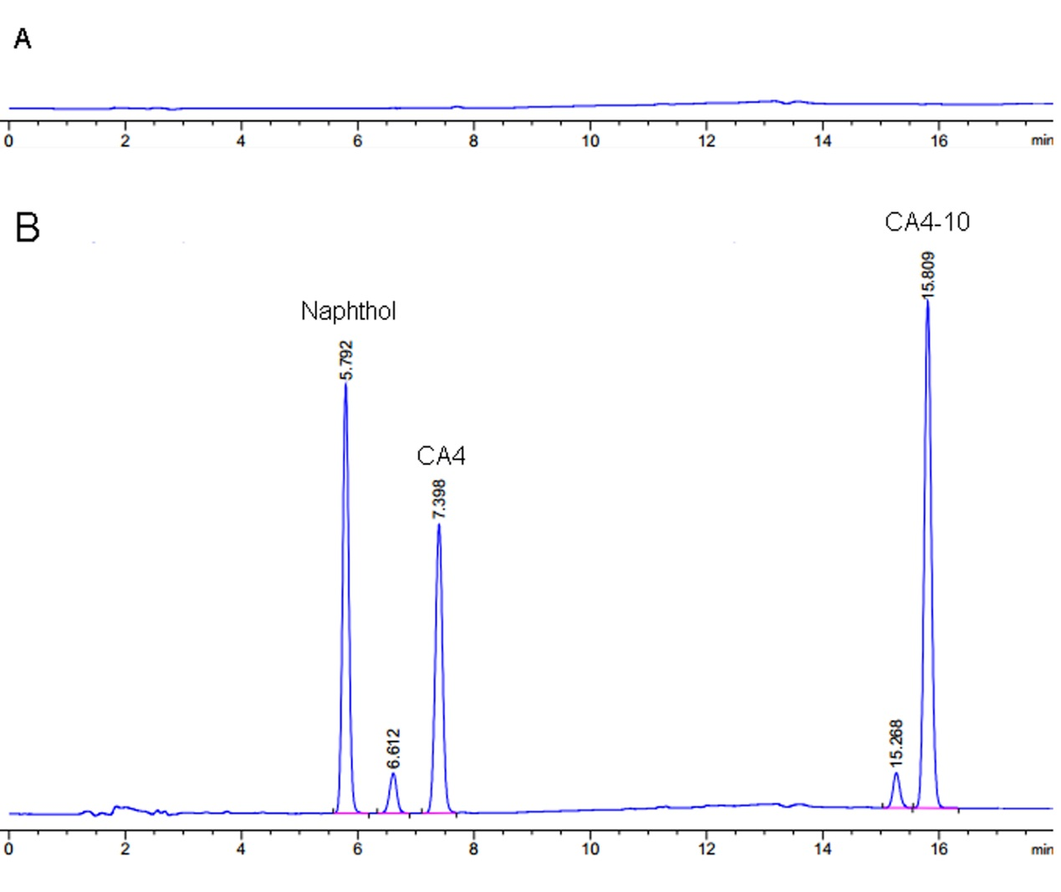Figure 1s The HPLC chromatogram of CA4-10 in plasm. A: blank rat plasma, B: blank rat plasma with CA4-10, CA4 and internal standard. 5.792, 7.398 and 15.809 min is the peak time of naphthol (internal standard substance), CA4 and CA4-P, respectively.

