Supplementary material

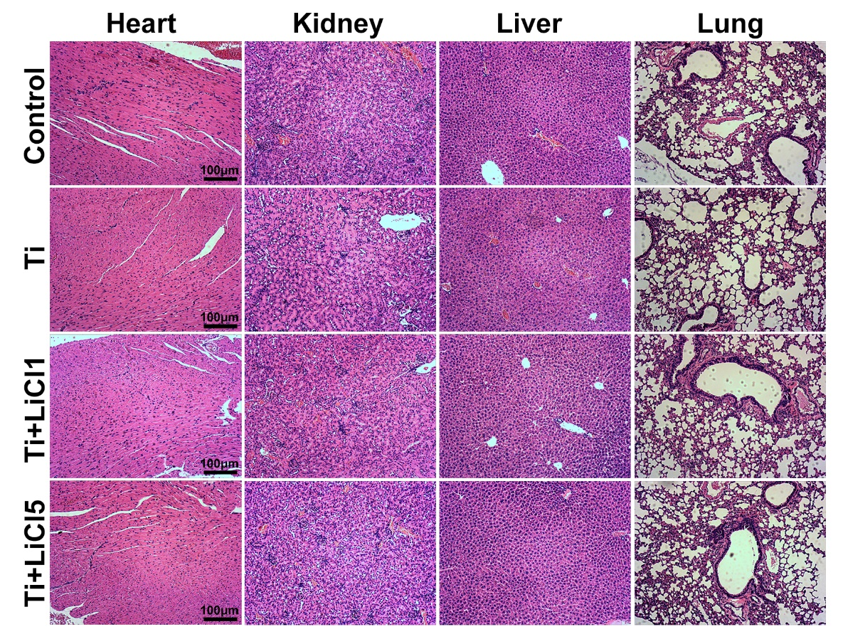
Figure S1. Hematoxylin and eosin staining images of major organs
Notes: The heart, kidney, liver, and lung of mice were harvested and fixed to evaluate the bio-safety of LiCl on major organs. Sections of major organs were subjected to hematoxylin and eosin staining; scale bar: 100 μm.
Abbreviations: LiCl, lithium chloride.

