Supplementary data
Assessment of Changes in Regional Xenon-Ventilation, Perfusion, and Ventilation-Perfusion Mismatch Using Dual-Energy Computed Tomography after Pharmacological Treatment in Patients with Chronic Obstructive Pulmonary Disease: Visual and Quantitative Analysis

Hye Jeon Hwang,¹ Sang Min Lee,¹ Joon Beom Seo,¹ Jae Seung Lee,² Namkug Kim,¹ Cherry Kim,³ Sang Young Oh,¹ Sei Won Lee,²

Departments of Radiology and Research Institute of Radiology¹, Asan Medical Center, University of Ulsan College of Medicine, 86 Asanbyeongwon-Gil, Songpa-Gu, Seoul 138-736, South Korea.
Department of Pulmonary and Critical Care Medicine, and Clinical Research Center for Chronic Obstructive Airway Diseases², Asan Medical Center, University of Ulsan College of Medicine, 86 Asanbyeongwon-Gil, Songpa-Gu, Seoul 138-736, South Korea.
Department of Radiology³, Ansan Hospital, Korea University College of Medicine, 123, Jeokgeum-ro, Danwon-gu, Ansan-si, Gyeonggi, Korea

Appendix S1. Xenon Ventilation and Iodine Perfusion Dual-energy CT
All patients were fitted with a face mask designed for delivery of positive pressure ventilation treatments (King Systems Corporation, Noblesville, IN) and were secured to the patient’s head with elastic straps. The patients inhaled 30% stable xenon (a mixture of 30% xenon and 70% O₂) using a xenon gas inhalation system. The concentrations of xenon and carbon dioxide (CO₂) in the exhaled gas were automatically determined by a xenon gas inhalation system (Zetron V; Anzai Medical, Tokyo, Japan). Xenon concentrations in the inhaled and exhaled gas and CO₂ concentrations in the exhaled gas were monitored throughout the entire study. Ten seconds (i.e., the time required for the patient to fully inspire the gas) after the concentration of xenon in the exhaled gas reached 25%, CT scans covering the full thorax at full inspiration were performed using the SOMATOM Flash CT system (Siemens Healthcare, Forchheim, Germany) with a 512 x 512 pixel matrix, 64 x 0.6 mm collimation, 55/130 eff. mAs at sn140/80 kV, pitch 0.55, and rotation time 0.28 seconds.
After xenon CT scanning, the patients breathe the room air for the elimination of xenon gas, with monitoring the xenon and CO₂ concentrations in the exhaled gas until the xenon concentration within exhaled gas reached near 0%. Patients inhaled the room air for 10 additional minutes, and then underwent contrast-enhanced perfusion CT using the SOMATOM Flash CT system (Siemens Healthcare, Forchheim, Germany) with a 512 x 512 pixel matrix, 64 x 0.6 mm collimation, 89/210 eff. mAs at sn140/80 kV, pitch 0.55, and rotation time 0.28 seconds. CT acquisition was performed in a full inspiration and single breath-hold in the craniocaudal direction covering full thorax. Each patient was administered 100 mL of an intravenous contrast agent (Ultravist 370, Bayer Schering Pharma, Berlin, Germany), followed by 50 mL of 30% contrast agent with an automated power injector at a rate of 3.5mL/sec. A fixed scan delay of 30 seconds was used (Figure S1).
The dose-length-product (DLP) was determined from the “Patient Protocol” image (Siemens Healthcare), which is an image file that includes the information about the CT protocol and amount of the radiation administered. The DLP and estimated effective dose by multiplying conversion factor (0.014 mSv/mGy/cm) to DLP were recorded in all subjects. The mean estimated effective dose was 7.3 mSv.

Appendix S2. CT Image Postprocessing
The xenon map and virtual noncontrast (VNC) image were reconstructed from the 80- and sn140-kV images of xenon ventilation CT using the “Xenon” and modified “Liver VNC” applications of Syngo Dual Energy (Siemens Healthcare), based on the 3-material decomposition theory. The iodine perfusion map and VNC image from contrast-enhanced perfusion CT were obtained using the “Lung PBV” and modified “Liver VNC” applications. All images were reconstructed with D30 kernel, 1.5-mm thickness, and 1.5-mm increment. To obtain the anatomically matched ventilation and perfusion CT images of baseline and follow-up, VNC images of xenon ventilation CT of follow-up and contrast-enhanced perfusion CTs of baseline and follow-up were coregistered to VNC image of xenon ventilation CT of baseline with the an automatic non-rigid registration method of in-house software (AView; MIL, Seoul, Republic of Korea) in which the VNC image of perfusion CT is deformed to match the VNC image of ventilation CT at every pixel level. For registration of VNC images of ventilation and perfusion CTs, we segmented the lung parenchyma and vessels. We globally aligned the surfaces of two lungs using an affine transformation. Then, a locally deformable model is used for the subsequent non-rigid registration. To confirm that the image co-registration is accurate, two radiologists directly compared the deformed VNC image of perfusion CT with VNC image of ventilation CT. With this information, the registered xenon ventilation maps of follow-up exam and iodine perfusion maps of baseline and follow-up exams were generated. For the evaluation of ventilation and perfusion imbalance with V/Qratio, normalization of xenon attenuation value (V) on xenon ventilation CT and iodine attenuation value (Q) on iodine perfusion CT was done. In this process, V and Q values in the normal-looking lung (areas with -400 to -899 HU) were pooled and transformed following a normal distribution in which the mean value was 0.5 and 99% of values were between 0 and 1. Then, V/Q value of each pixel was calculated and converted to log2 transformation to obtain V/Q_{ratio}. With these values, normalized V, Q and V/Q_{ratio} maps were generated.¹⁰

Figure S1. CT scan protocol for combined xenon-ventilation and contrast-enhanced perfusion DECT. The concentration of xenon in the inhaled gas and concentrations of xenon and CO₂ in the exhaled gas were monitored. The red and blue curves represent tidal xenon and CO₂ concentrations in the exhaled gas, respectively.
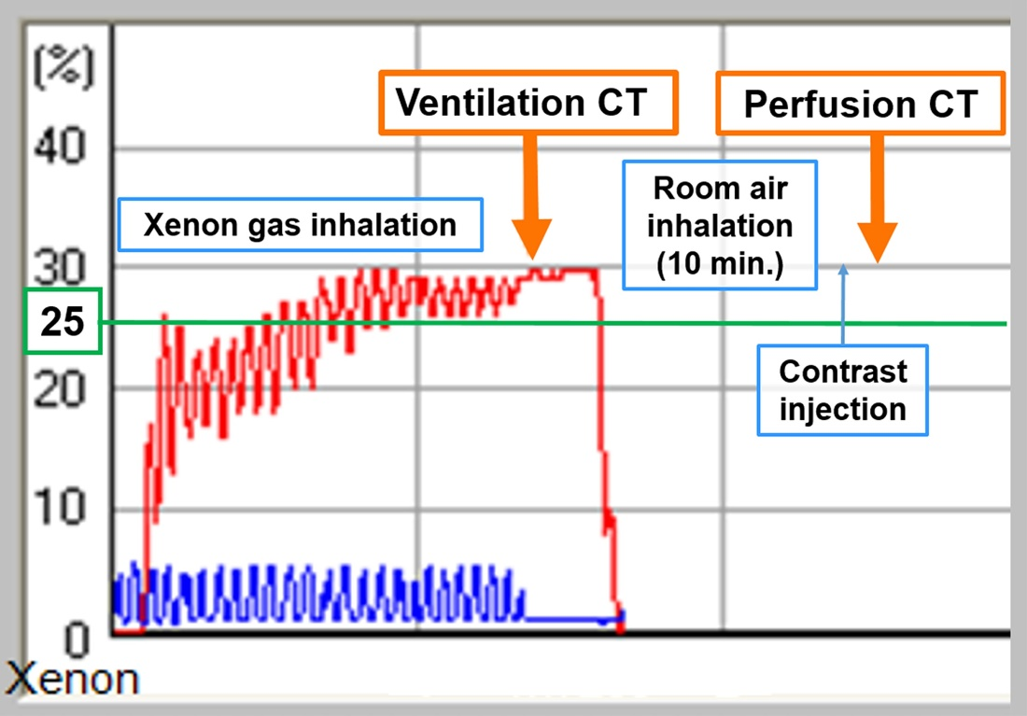

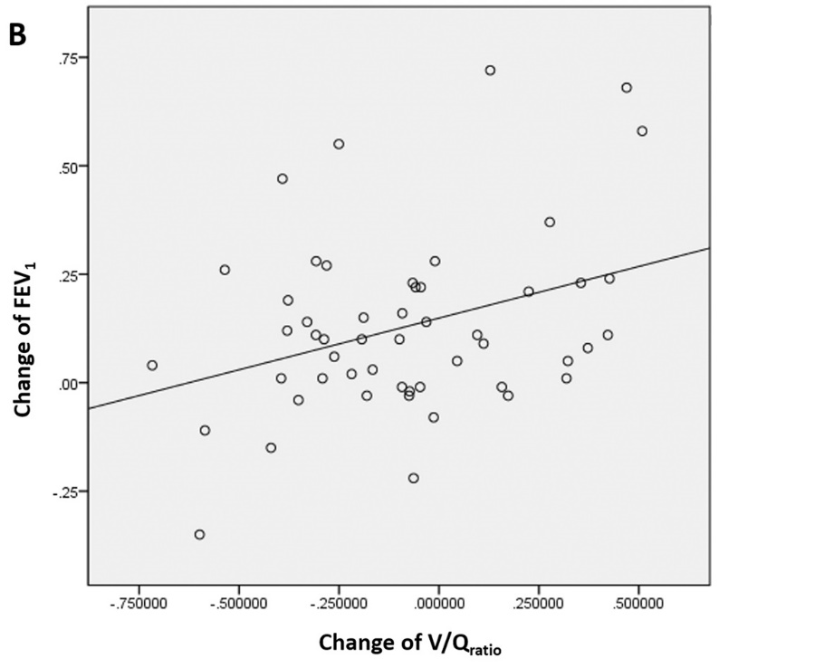
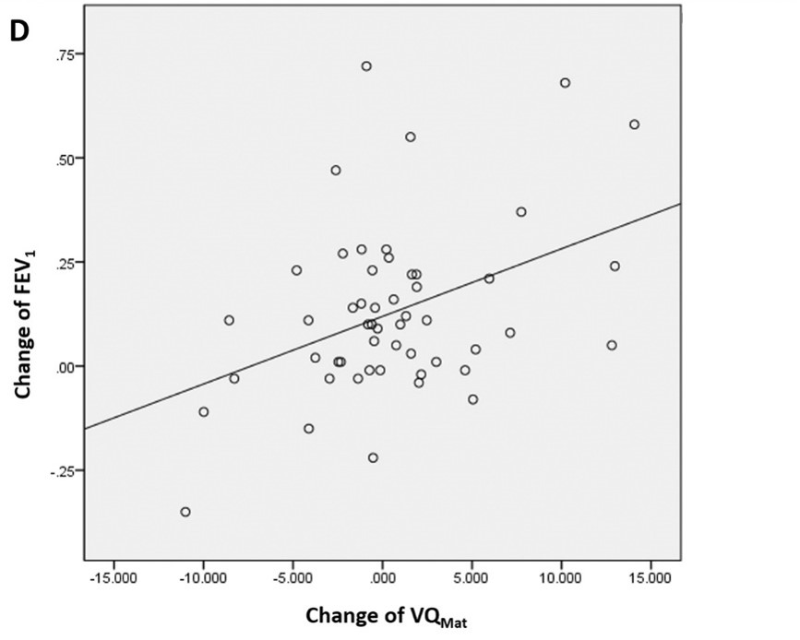
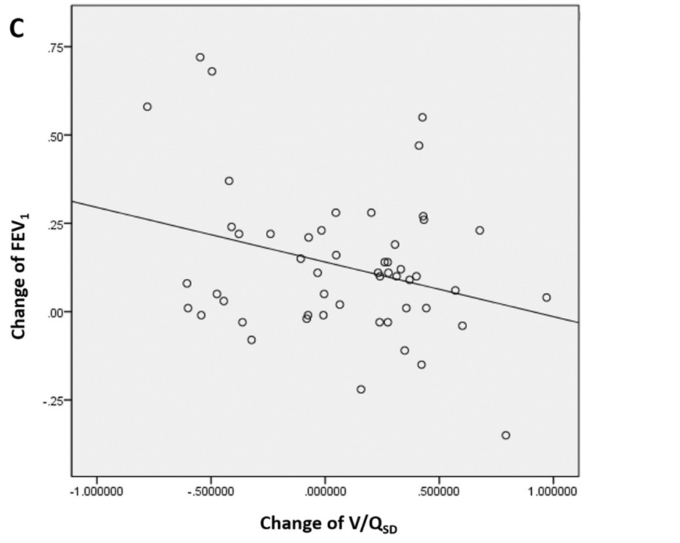
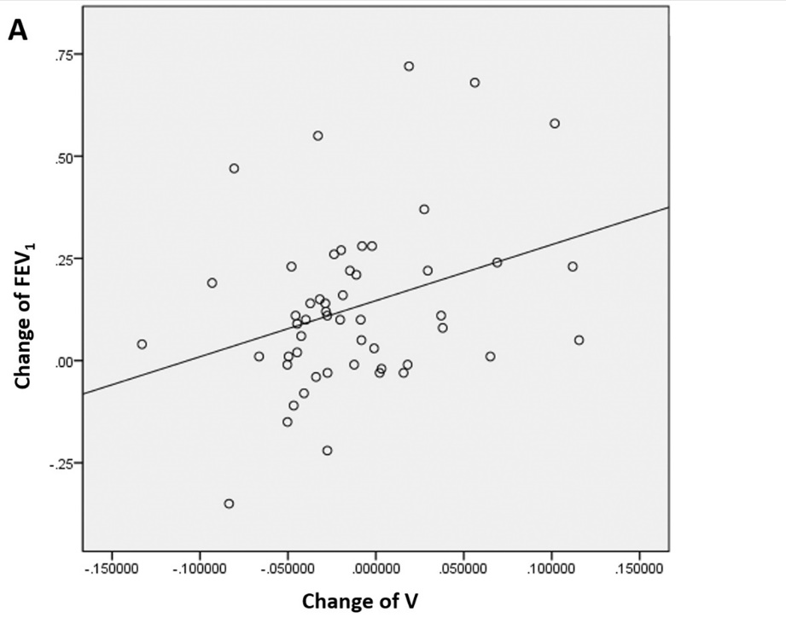
Figure S2: Correlation analyses of changes in the CT parameters and FEV₁ at baseline and on follow-up. The changes of the mean V, V/Q_{ratio,} and VQ_{Mat} show positive correlations with the change of FEV₁ (A, B and D), whereas V/Q_{SD} and VQ_{Rev} show a tendency for a negative correlation with FEV₁ (C and E).

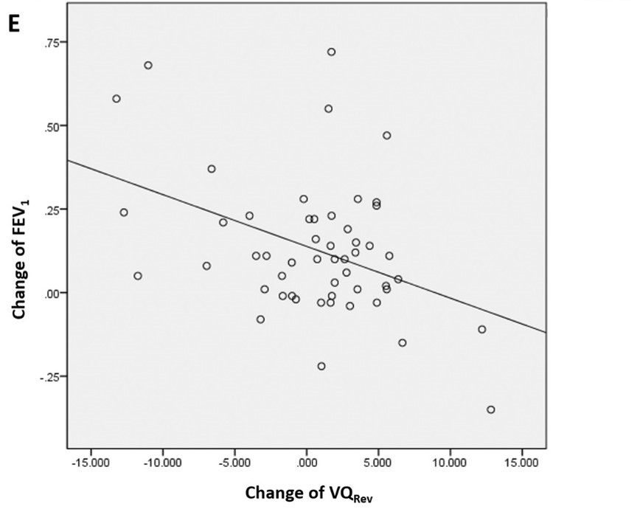
Table S1. Pulmonary Function Test Results and Quantified CT Parameters at Baseline and Follow-up
 | Baseline | Follow-up | p
%FEV₁ (%) | 52.2 ± 13.2 | 56.7 ± 14.2 | <0.001*
FEV₁ (L) | 1.57 ± 0.46 | 1.70 ± 0.49 | <0.001*
%FVC (%) | 84.4 ± 12.7 | 84.3 ± 15.5 | 0.945
FVC (L) | 3.55 ± 0.60 | 3.62 ± 0.62 | 0.093
FEV₁/FVC (%) | 44.2 ± 10.8 | 48.8 ± 13.7 | 0.005*
%DL_{CO} (%) | 65.7 ± 18.4 | 65.3 ± 17.0 | 0.664
6MWT (m) | 473.9 ± 70.7 | 472.6 ± 73.2 | 0.746
CAT score | 16.5 ± 4.0 | 14.2 ± 3.9 | <0.001*
Ventilation (V) | 0.502 ± 0.081 | 0.489 ± 0.076 | 0.403
Perfusion (Q) | 0.541 ± 0.078 | 0.531 ± 0.088 | 0.546
V/Q_{ratio} | - 0.284 ± 0.459 | -0.368 ± 0.386 | 0.314
V/Q_{SD} | 2.664 ± 0.528 | 2.739 ± 0.409 | 0.421
VQ_{Mat} | 80.52 ± 6.62 | 81.10 ± 5.97 | 0.640
VQ_{Rev} | 12.54 ± 8.35 | 13.14 ± 7.22 | 0.692
Notes: Data are means ± standard deviations. Statistically significant values are denoted by an asterisk (P < 0.05). All numbers of quantified CT parameters are the normalized values for each quantified parameter except for VQ_{Mat} and VQ_{Rev}. The V/Q_{ratio} values were log² transformed.
Abbreviations: %FEV₁, percentage of the predicted value of forced expiratory volume in 1 second; %FVC, percentage of the predicted value of the percent of forced vital capacity; FEV₁/FVC, calculated by dividing the measured FEV₁ value by the measured FVC value; %DL_{CO}, percentage of the predicted value of the carbon monoxide diffusing capacity corrected for hemoglobin concentration; 6MWT, six-minute walk distance test; CAT score, COPD Assessment Test.
Table S2. Correlation Analysis between Quantified CT Parameters and Pulmonary Function Test Results in Baseline and on Follow-Up.
CT | Baseline PFT |  |  |  | CT | Follow-Up PFT
Baseline | %FEV₁ | FEV₁/FVC | %DLco | 6MWT | Follow-Up | %FEV₁ | FEV₁/FVC | %DLco | 6MWT
Ventilation (V) | 0.578* | 0.624* | 0.354* | 0.237 | V | 0.504* | 0.395* | 0.333* | 0.201
Perfusion (Q) | 0.252 | 0.320* | 0.193 | 0.136 | Q | 0.328* | 0.413* | 0.342* | 0.058
V/Q_{ratio} | 0.475* | 0.433* | 0.168 | 0.152 | V/Q_{ratio} | 0.301* | 0.058 | -0.013 | 0.120
V/Q_{SD} | -0.531* | -0.502* | -0.259 | -0.188 | V/Q_{SD} | -0.381* | -0.234 | -0.176 | -0.185
VQ_{Mat} | 0.534* | 0.519* | 0.393* | 0.332* | VQ_{Mat} | 0.358* | 0.231 | 0.325* | 0.334*
VQ_{Rev} | -0.541* | -0.508* | -0.261 | -0.243 | VQ_{Rev} | -0.355* | -0.118 | -0.112 | -0.244
Notes: Data are Pearson correlation coefficients with r values. Statistically significant values are denoted by an asterisk (P < 0.05).
Abbreviations: %FEV₁, percentage predicted value of forced expiratory volume in one second; FEV₁/FVC, calculated by dividing the measured FEV₁ value by the measured FVC value; %DL_{CO}, percentage predicted value of carbon monoxide diffusing capacity corrected for hemoglobin concentration; 6MWT, six-minute walk distance test; V/Q_{SD}, standard deviation of the V/Q_{ratio}; VQ_{Mat}, the proportion of lung area with matched V/Q_{ratio}; VQ_{Rev}, the proportion of lung area with reversed mismatched V/Q_{ratio}.

